NEA – Maria K.

Table of Contents

1. Analysis 3

1.1 Background and Introduction 3

1.2 Interview 3

1.2.1 Interview 1 3

1.2.2 Summary 1 4

1.2.3 Interview 2 4

1.2.4 Summary 2 6

1.3 Current System 7

1.3.1 Observation 7

1.3.2 Workflow diagrams 9

1.3.3 IPSO Chart 12

1.3.4 Data Dictionary 12

1.3.5 Data Volume Table 13

1.4 User(s) 13

1.4.1 Prospective User(s) 13

1.4.2 User Needs 13

1.5 Objectives 14

1.5.1 Acceptable Limitations 14

1.5.2 Final Objectives List 14

1.6 Solutions 15

1.6.1 Languages 15

1.6.2 Chosen Solution 15

2. Documented Design 16

2.1 Database Design 16

2.1.1 Pre-Normalization 16

2.1.2 Normalization Process 17

2.1.3 Post-Normalization 18

2.1.4 Data Dictionaries 19

2.1.5 SQL Statements 21

2.1.6 Data-flow Diagram 23

2.2 Overall System Design 25

2.2.1 Top-Down Diagram 25

2.2.2 IPSO Chart (Input, Process, Storage, Output) 25

2.3 Data Structures 27

2.3.1 Stacks 27

2.3.2 Hashing 28

2.3.3 Dictionary 28

2.4 OOP Class Design 29

2.4.1 Login Files 29

2.4.2 Inventory Files 30

2.4.3 Experiment Files 31

2.5 Interface Design 31

2.5.1 Login and Registration 31

2.5.2 Inventory GUI 36

2.5.3 Suppliers Table 38

2.5.4 Experiment 38

2.6 Algorithms 39

2.6.1 Merge Sort 39

2.6.2 SQL statements 40

2.6.3 Validating Password Format 41

2.6.4 Getting Equipment Stack 41

3. Testing 42

3.1 Test Plan 42

3.2 Test Results 47

4. Technical Solution 67

4.1 Tables and Relationships 67

4.2 System Overview 71

4.2.1 System Overview Diagram 71

4.2.3 Class Diagram 71

4.3 Code and UI 79

4.3.1 Main.py 79

4.3.2 Login_GUI.py 80

4.3.3 Login_Validations_and_Connections.py 96

4.3.4 Inventory_System_GUI.py 103

4.3.5 Inventory_System_Validations_and_Connections.py 140

4.3.6 Experiment_Calculator_GUI.py 156

4.3.7 Experiment_Validations_and_Connections.py 171

4.3.8 Reference File for creating tables and database 177

5. Evaluation 181

5.1 Comparing Performance against Objectives 181

5.2 Getting and Analyzing Independent Feedback 186

5.2.1 Interview 186

5.2.2 Comments 187

5.2.3 Improvements 187

5.2.4 Things I would do differently 188

References 189

# 1. Analysis

## 1.1 Background and Introduction

GEMS Founders School is a FS1 – Y13 school which is split into a primary and secondary building. In total, there are twelve science labs, 6 in each of the buildings.

The science department is expansive, and it has varied equipment and materials throughout different classes and storage/prep rooms. Science lab technicians are assigned to manage these rooms as well as organize experiments. The equipment are distributed between the science lab cupboards while the chemicals are stored in the main storage room (one in every building). Each building has a main storage room that caters to the 6 science labs in every building.

Each storage room has two-three lab technicians that oversee the science labs’ functioning. They organize the logistics of the experiments that teachers want to organize for their students. This involves planning the experiment materials, measuring out chemicals, locating corresponding equipment, distributing them to the respective classrooms, returning them to correct locations, and updating stock. The technicians are also charged with restocking materials that run short.

## 1.2 Interview

### 1.2.1 Interview 1

Date: *21/02/22*

Interviewee: *Ms. Divya*

**1) *Can you briefly introduce your current system?***

* When a teacher requests an experiment to conduct for their class, I’ll be the one to prepare the chemicals, the apparatus, and the number of trays for the experiment that are required. Most of the stock-tracking happens on this Excel sheet. After I have prepared them, I will update the amounts that I have used up into this Excel sheet manually.

**2) *What improvements do you think need to be addressed to your existing system? Are there any specific problems you face?***

* At the end of the week, I'd like to see a report of the items that are out of stock, so I know what to reorder.

Ideally, for common experiments, I'd like it to automatically tell me the amounts of every chemical and apparatus I need in a report based on the number of students conducting the experiment.

My current system only works for the Phase 3 science labs*, while this new system should accommodate both science labs.

**3) *Roughly how many different apparatuses are over here?***

* Around 100.

**4) *Have you considered installing third-party software to improve efficiency? The library downstairs has its own library management system.***

* Yes, I have. In fact, I had a few options ready to go, but I decided against it. It would just be an extra cost on the school that was not exactly necessary, so I let it go.

***5) Where do you store your data related to your existing stock-management system?***

* It’s either on a physical piece of paper, like a notebook; or this Excel sheet, which is stored on this desktop computer.

***6) Are there any security features in your current stock-tracking system?***

* Not for the Excel sheet specifically. I mean, all the stock-tracking activities occur in this room, which students do not have access to. Also, this desktop is locked with a password to log in.

***7) How often do you back up this Excel sheet?***

If you’re asking about how often I save my changes to the spreadsheet, it’ll be right after every update I make. That is around once a day. I do not back up these spreadsheets anywhere else from this desktop because they contain some sensitive stock and supply information.

### 1.2.2 Summary 1

After speaking with Ms. Divya for the first time, I had quite a few ideas running through my head that I needed to research to inquire about during our next meeting, including questions about specific features that she would benefit with relation to experiment-planning.

### 1.2.3 Interview 2

Date: *28/02/22*

Interviewees: Ms. Divya, Ms. Cristine, Ms. Mabel, Ms. Melissa

**1) *How do you keep track of your stock of chemicals?***

* For chemicals, we do not have an inventory list, but we do have a chemical checklist with the cupboards in which we can find the chemicals. We’d have to count how much we use for every experiment, in mL, for example 100 mL. We’d also, in our existing stock-tracking system, store the number of remaining bottles.

**2) *For a login system for the software, would you benefit from having different permissions based on the user? If so, what information would be needed to have a secure login?***

* Yes, the teachers can view the stock, but it’d be better if they did not have access to edit the remaining stock. The technicians would be the only ones that have access to manipulate the stock number.

About your second question, I guess our email addresses, our name, and a password? Unless you think there may be some better method, that is what comes to my mind.

**3) *For common experiments, would you like the program to automatically calculate the number of apparatus and chemicals needed based on the sets of experiments required?***

* Yes, that would be great, as long as we can create new experiments ourselves in the application.

**4) *Are there any other features you think would benefit you?***

* there must be an easy way for us to view which items need restocking, perhaps in the form of a report that we can export.

*\*NOTE:* *GEMS Founders School newly underwent an expansion to the campus during the summer of 2021, so their old system no longer suited their needs. The school used to host FS1-Y13 students in one building, with one set of 6 science labs on the top floor. With the expansion, another set of 6 science labs were added, distributed over two buildings. Ms. Divya then explains further:*

* I think I should point out that this Excel sheet system was newly introduced at the beginning of this school year (September 2021), after the expansion. Before the expansion, we kept track of our equipment and chemical stock in a simpler system.

It worked fine for when we only had six science labs to organize and just three science lab technicians. However, with the expansion of equipment and chemicals every year, keeping track of our stock became complicated.

In the old building, we had six science labs: two for every science. For example, we had two physics rooms, two chemistry rooms, etc. One room’s worth of cupboards would often be enough to store all the equipment for physics. I stuck papers on the face of every cupboard, with the equipment names and their corresponding stock number.

However, there were a couple of problems with this paper-based stock management system.

For new technicians that joined the team, it was time-consuming to train them to a point where they were familiar with the general location for each of the equipment.

***Yes, I think I remember those sheets of paper. They were sometimes ripped out or scribbled on, I remember my physics teacher mentioning that issue often in our lessons.***

* Yes, you’re right. Behind the scenes, there would be a lot of work to rectify this damage. Firstly, we would have to draft a new document that had the table with the equipment name and stock columns.

Next, I would print a new copy (which at worst took hours because of waiting times). I would also hope that between the time that we notice this vandalism and the time that we have a new copy no other experiments would be conducted.

Anyways, updating the stock was often a hassle. I had to walk around to each classroom and write on the vertical surface of the cupboard to update the stock numbers manually. Sometimes, I would have to walk back and forth between the classroom and the storage room to refer to the new stock number coming in for every corresponding apparatus.

***I imagine that the students can write new stock values themselves because the papers are exposed on the cupboards. Obviously, that’s incorrect data for you to calculate with.***

* Yes, that’s an important security issue to consider, but fortunately that did not occur.

***And I assume that once the space for the stock column filled out, a new paper would have to be printed.***

* Exactly so. It was not very sustainable.

***One more question, how proficient are you in programming?***

* I – and I think I speak for my team – have absolutely no knowledge in programming.

***Are you familiar with using basic programs such as Outlook, Facebook, or Word? I am asking this because I will likely include some functionality to draft emails or generate stock reports into the system. The interface will likely resemble the aesthetic of popular social media websites, namely Facebook: mostly white with a side menu for quick-access functions.***

* Yes, I think I am comfortable with them. As long as everything is well-labeled, I think we’ll be alright.

***What is your process of restocking?***

* Around every month, I go through the Excel sheet to identify any items that have 0 stock. When I locate them, I add them to the restocking list alongside the quantity that I want to restock with.

Normally, I do not restock everything that has 0 stock. I’ll restock based on the urgency of restocking of that chemical or equipment. If the item that needs restocking is of great value, then I will normally run that by the head of the science department for approval.

When the restocking list is ready, I will forward it to the head of science for approval and then I’ll simply send the order directly to the correct supplier.

***How do you think that this can be translated to an application?***

* I think that the program should be able to output a report of all items that need restocking in a text file. Maybe even in a format that can be sent directly by email.

I do not want the program to send the email itself just for security purposes. A text file that I can save and copy into my email application should be enough.

### 1.2.4 Summary 2

With the second meeting completed, a lot of my questions were addressed, and I started to have a clear picture of what my client desired.

## 1.3 Current System

The next obvious thing for me to do was for me to observe how the current stock-keeping system works. I requested that I shadow Ms. Divya in her processes to better understand her workflow. After observing this first-hand, I can confirm that her current system has a lot of room for improvement in relation to efficiency and time.

I also noted that the technicians’ ICT skills were generally proficient with the way that they demonstrated how they used Microsoft Excel, Google Chrome, and Microsoft Word.

### 1.3.1 Observation

Date: *28/02/22*

1. A teacher requests Experiment X to the science lab technician team. This is normally a couple of days before the lesson is planned.
2. **SCENARIO A**: The teacher specifies the amounts of chemicals as well as the specific apparatus needed for Experiment X.
   1. The science lab technician will informally take note of the details on a notebook or a word document. The information may be unclear to understand by another technician or lost. It often takes time for the technicians to retrieve this information in the desktop file system.

**SCENARIO B:** The teacher only shares the name of the experiment with the technician. No other information is shared.

1. The technician will conduct research to calculate the amounts of chemicals required for the experiment.
   1. If the students are GCSE or A-Level students, the technicians will refer to the practical handbook documents* for the specific science and the level.
   2. If the experiment is not for GCSE or A-Level students, the technicians will look up the experiment online or in textbooks to plan a suitable experiment for the size of the class. This is often very time-consuming.
2. The technician notes down how many sets of experiments are desired based on the size of the class. Alternatively, the teacher may wish to demonstrate the experiment themselves, in that case only one set of the experiment is required.
3. The technician will refer to these notes when they prepare the apparatus for the experiment in trays. The notes include (in no particular order):
   * Date of experiment
   * Experiment name
   * Name of teacher
   * Number of students in class
   * Number of sets of experiments
   * Chemical(s) name(s)
   * Apparatus(es) name(s)
   * Amount of Chemical X required for one experiment (this is repeated for every type of chemical)
   * Number of Apparatus X required for one experiment (this is repeated for every type of apparatus).
   * Where Chemical X can be found (cupboard location).
   * Where Apparatus X can be found (cupboard location).
4. The technician multiplies the amount of chemicals required by the sets of trays per classroom. This value will signify the amount of chemical used up.
5. The technician calculates how many sets of apparatus are required in total.
6. The technician will open the Excel sheet to locate where stock for this equipment is located. They may be spread across different cupboards.

**On the day of the experiment:**

1. The technicians will retrieve the notes of which apparatus are required for Experiment X.
2. For equipment that are used up after the experiment, the stock is updated onto the Excel sheet after the equipment is laid out.
3. For equipment that are reused after an experiment, such as flasks and tubes, their stock is reduced on the excel sheet (while they are being laid out in the trays).

**After the experiment:**

1. After the reusable equipment are washed or handled correctly, they are counted and returned to their cupboards. This new count will signify the new stock number for the corresponding equipment in the cupboard (if this number has been reduced, this means that some apparatus may have been damaged or destroyed).

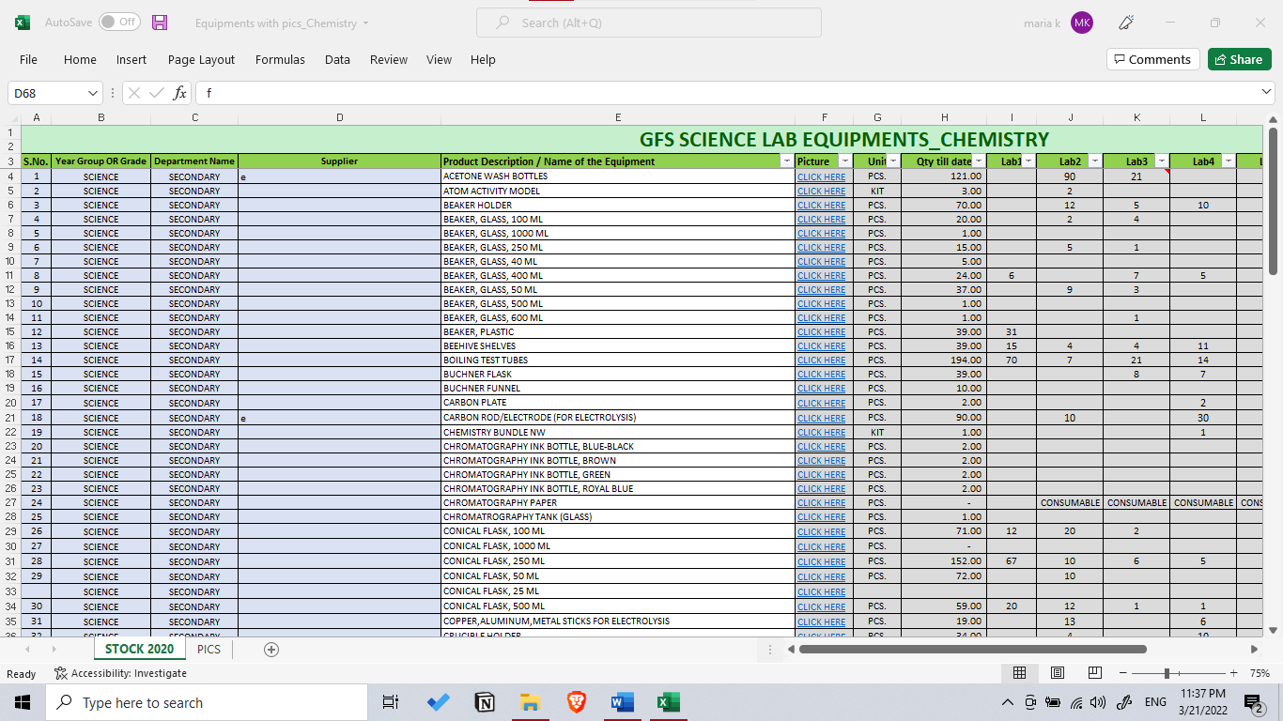

### 1.3.2 Workflow diagrams

#### 1.3.2.1 Planning

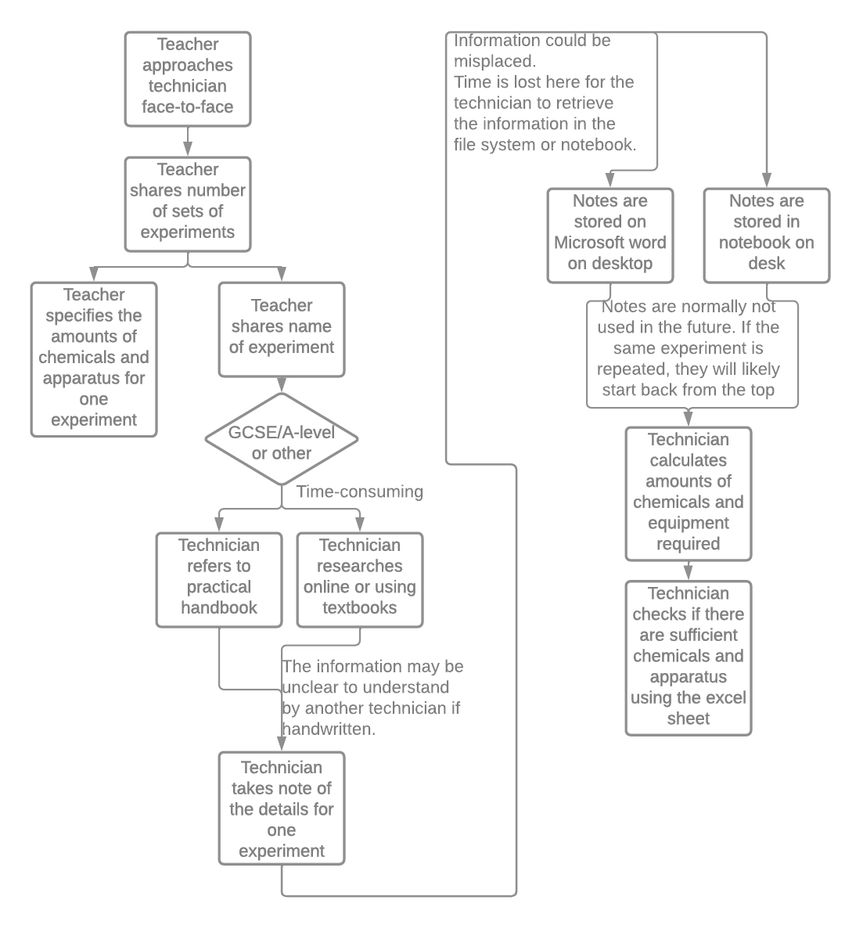

Planning workflow

In planning an experiment from start to finish, there are a few streamlining issues that are visible, especially with relation to planning and timing. Firstly, with experiments whose details have not been shared by a teacher, a lot of time went into determining the right amounts of chemicals and apparatus. The technician must consider other factors in calculating the right amounts of chemicals. For example, Ms. Divya had to add in excess chemical amount in the total. This is to accommodate for spillages caused by the students or incorrect execution of the experiment (by mixing incorrect chemicals/proportions).

Additionally, all the time that went into planning the amounts of this experiment is essentially lost because of poor record organization, mainly because the notes are stored both digitally and on paper. Written notes can occasionally be illegible, un-editable, time-consuming, and can even be bad for the environment.

Even if these records are stored correctly, the recorded amounts of chemicals are often tailored to the specific number of students in a class (or specific to the number of sets of experiments that are conducted), which unfortunately means that Ms. Divya must redo the calculation even for slightly smaller/larger classes. Because these experiments are often on a yearly rotation (with each year group), the notes will likely be forgotten with every academic year, so spending time locating and deciphering these written notes is quite inefficient.

Little details, such as the number of students in a specific class, for example, must be asked for with every experiment as the technicians do not have access to this information easily.

#### 1.3.2.2 Stock management

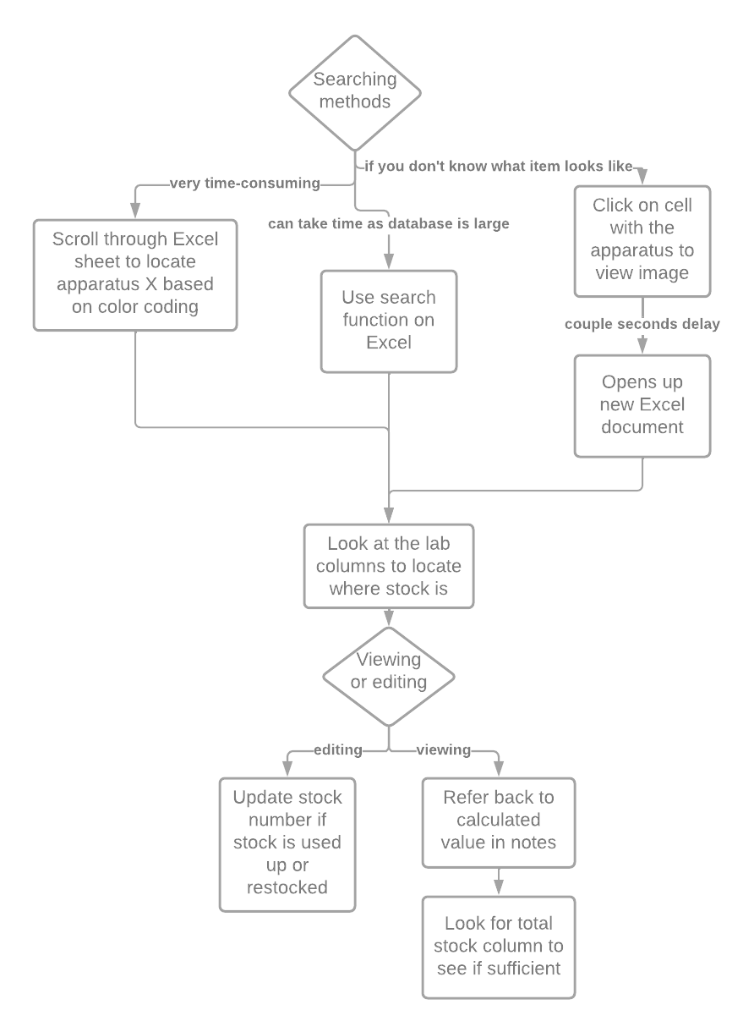

Stock-tracking

The stock-management aspect of this problem is the main issue that Ms. Divya and the science lab technician team wanted to improve. This stock-management system is certainly better in terms of security and reliability in comparison to their paper-based model, mainly because all the stock-tracking is centralized on one main Excel spreadsheet.

The Excel sheet, from my observation, was not the most streamlined method of stockkeeping. Firstly, I could see that the Excel program was lagging quite significantly when loaded up on the school desktop, simply because there were so many records.

The apparatus are not ordered in any particular order. Excel could potentially sort them alphabetically, but Ms. Divya did not benefit from this function as much as she thought she would. I took note of this, especially since I think Ms. Divya would benefit more from being able to filter by science or by location.

The records were color coded by science, but when Ms. Divya demonstrated her scrolling through the Excel sheet to look for a specific apparatus, it had taken her around 2-3 minutes, which was entirely inefficient.

The Excel sheet was painstakingly filled out entirely manually at the beginning of the year. She explained that this had taken up a couple of days to complete.

### 1.3.3 IPSO Chart

|  |  |  |
| --- | --- | --- |
| Input, Process, Storage, Output (IPSO) | Information | Evidence |
| Input | Login Information   * Username * Password | Interview 2 |
| Input | Registration Information   * School-issued email address * Password * Repeat Password * Hash key * Salt * Teacher or technician | Interview 2 |
| Input | Equipment Information   * Equipment name * Science (phy/chem/bio) * Remaining stock * Location * Consumable | Observation |
| Input | Experiment Information   * Number of sets * Equipment amount required * Chemical amount required | Observation |
| Process | Hashing   * Login system can use hashing to secure the private information | Interview 2 |
| Process | Calculate amount of equipment/chemicals required and verify whether sufficient stock exists. | Observation |
| Output | Generate report with stock that runs short. | Interview 1 |

### 1.3.4 Data Dictionary

|  |  |  |  |
| --- | --- | --- | --- |
| Data Item | Data Type | Validation | Sample Data |
| Username | String |  | Maria.k1 |
| Password | String | >= 8 characters | 12345678 |
| Salt | String | =32 bytes |  |
| Hash Key | String |  |  |
| Email Address | String | Ends with “_gfs@gemsedu.com” | [Maria.k1_gfs@gemsedu.com](mailto:Maria.k1_gfs@gemsedu.com) |
| Repeat Password | String | Must match with Password | 12345678 |
| Teacher or Technician | Boolean |  | 1 or 0 |
| Equipment name | String |  | Glass flask |
| Consumable | Boolean |  | A nichrome wire can be consumable whereas a glass flask is reusable, hence NOT consumable. |
| Science | String | Either ‘chem’ and/or ‘bio’ and/or ‘physics’ | Chem and bio |
| Remaining stock | Integer |  | 14 |
| Location | Integer |  | 1 (represents science lab 1) |
| Experiment Name | String |  | Young’s Modulus Practical |
| Number of sets | Integer |  | 4 |
| Equipment amount required | Integer |  | 1 (for 1 set) |
| Chemical amount required | Real |  | 14.5 mL or 5.0g |

### 1.3.5 Data Volume Table

|  |  |
| --- | --- |
| Data Object | Volume of Data |
| Chemistry Equipment | 79 items |
| Physics Equipment | 135 items |
| Biology Equipment | 78 items |
| General Sciences Equipment | 195 items |
| Total Equipment | 551 items (includes 64 repetitions where items belong to several sciences) |
| Number of Experiments | Average 12 every month |
| Supplier Orders Generated | Around 6 every year |
| Total technicians | Around 5 every year |
| Total Teachers | Around 15 every year |
| Number of items in an Experiment | Average 5 |

## 1.4 User(s)

### 1.4.1 Prospective User(s)

Ms. Vinju overlooks all the science lab technicians, so I will be consulting her for development ideas. However, the system will be used by all science lab technicians as well as science teachers occasionally.

Science technicians and teachers have a reasonable ICT skill level, but not nearly as advanced as to be able to handle errors generated by the code. For this reason, the user interface complexity and type must be simple, clean, easy to work with, and require minimal training.

### 1.4.2 User Needs

* The program should have an easy, simple interface that requires minimal training and upkeep.
* Technicians should be able to edit the stock numbers, but teachers cannot.
* The program must be able to filter equipment and chemicals by location and by science.
* The program must be able to view all the stock in a spreadsheet format or by record format.
* The program should be able to export items that need restocking into a report format for printing.
* The program should be able to calculate the total amount of equipment and chemicals needed in a usable experiment calculator interface for a specific class.
* The program should be able to save the formatting for that equipment and chemicals under an experiment name to be reused later.
* The program must be able to be installed in both the old and the new science lab storage rooms.
* The program must be able to run using the school-provided desktops, keyboards, and mice.
* Could potentially store the number of students in every class to be referred to.

## 1.5 Objectives

### 1.5.1 Acceptable Limitations

* Due to the strict time constraint, I may not be able to get all the program to be bug-free and fully functional. For this reason, I have decided to approach development by tackling different units/modules so that the individual aspects can run to the extent with which they were developed.
* The program will only be able to run on the school desktop computers. It will not be able to run on mobile devices. This is to limit the program to no extra cost on the school for extra storage/processing equipment.
* Learning an entirely new programming language for my GUI in such a strict time schedule may limit how far and developed my application’s functionality may be.
* The program will have to import minimal Python libraries due to administrative limitations on school desktops.

### 1.5.2 Final Objectives List

|  |  |  |
| --- | --- | --- |
| No | Objective | Performance Criteria |
| 1 | Design a user-friendly graphical user interface. | Must be straightforward and intuitive to use and  disguises complexity of the operations executed in the background in order to be easy to navigate. |
| 2 | A secure login system | A separate view for login, registration, and deletion of accounts.  Robust use of validation for formatting of passwords and email addresses.  Generate a hash key as well as a salt for every password and store only the hash key and salt on the database.  Must be able to create and delete accounts easily. |
| 3 | Create a secure program to store stock and location information securely in the database. | Uses separate permissions for teachers and technicians about database editing and viewing.  Must be secure enough so that only the end user can access the contents of the database. |
| 4 | Using SQL queries; filter, search, delete, insert, and view equipment data. | Uses a central database system to contain all information about stock.  Filters by location or by science.  Searches for specific equipment names and corresponding locations and stocks.  Technicians must be able to insert and delete records to the equipment list.  Same functionality extended to Location and Chemicals tables.  Equipment statistics table to smartly distribute stock between locations. |
| 5 | Create experiment calculator feature to calculate amounts of chemicals and apparatus needed for a class. | Allows user to input numbers of sets of experiments.  Allows user to input name of chemical alongside the predicted volume.  Allows user to input name of equipment alongside the predicted number.  Checks against database to see whether there is sufficient stock.  Outputs where to find equipment and chemicals.  View and delete existing experiment details. |
| 6 | Create a feature to output a report of all items that need restocking | Outputs list of all items that need restocking alongside the suppliers that supply them. |

## 1.6 Solutions

### 1.6.1 Languages

For my programming language, I have considered Python and Visual Basic. According to python.org, the initial install size of Python (3.8.3) is around 18 MB (Python 3.8.3, 2020). Visual Studio’s install size, on the other hand, is 850 MB (Visual Studio 2022 Product Family System Requirements, 2022). Additionally, our school desktop systems already have the python application installed, which simply means that less administrative issues will have to be handled than with the installation of Visual Studio. Visual basic is translated from high-level language to an intermediate code, and finally to object code (View disassembly code in the Visual Studio debugger (C#, C++, Visual Basic, F#), 2021); whereas Python is interpreted (Subasi, 2020), which may pose a security issue with reverse engineering. Therefore, I have decided to use Python mainly for the installation size and convenience.

For my database management (SQL) language, I have decided against using specific libraries that do not allow me to utilize SQL queries/statements. For that reason, I have considered SQLite and MySQL. I have gathered that MySQL is a web-based option, whereas SQLite can be run fully offline, which meets my client’s requirements. Furthermore, SQLite’s size is 250 KB as compared to MySQL’s 600 MB initial installation size. Although SQLite lacks in relation to security features, I am confident that I can make up for that using significant login security measures, so that should not be an issue. I have thus concluded that I will be using SQLite for my database development language.

Speaking of security, I will incorporate hashing into my login system to ensure that the passwords of technicians cannot be accessed

### 1.6.2 Chosen Solution

After exploring the systems that my client has tried, tested, (and sometimes discarded); I have eliminated a few solutions that do not meet the client’s requirements and the project limitations.

Using pen and paper to handle stock-tracking could not meet my client’s requirements of a stock management system. Although it made stock-tracking low start-up cost and customisable, it was inefficient, not secure, and was prone to human error. Moreover, it made searching for individual equipment impossible without physically going to the locations, which was simply slow for new recruits and with increased equipment locations.

Ideally, I could create a fully web-based system with cloud storage and mobile device capabilities. These features cannot be implemented simply because of time constraints and my skills. The system should run exclusively on the school desktop computer, as specified by Ms. Divya, to reduce costs. This also means that there would be absolutely no need to have an online version of this application simply because it will run locally permanently.

Therefore, I have come to the conclusion that I will create a multi-purposed application with stock-tracking, experiment planning, and restocking capabilities.

# 2. Documented Design

## 2.1 Database Design

### 2.1.1 Pre-Normalization

Entity Relationship Diagram – Pre-normalization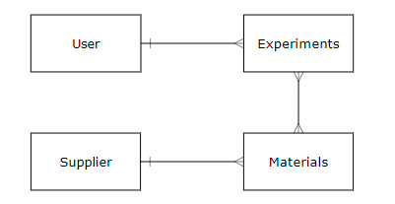

Entity Attribute Model – Pre-normalization

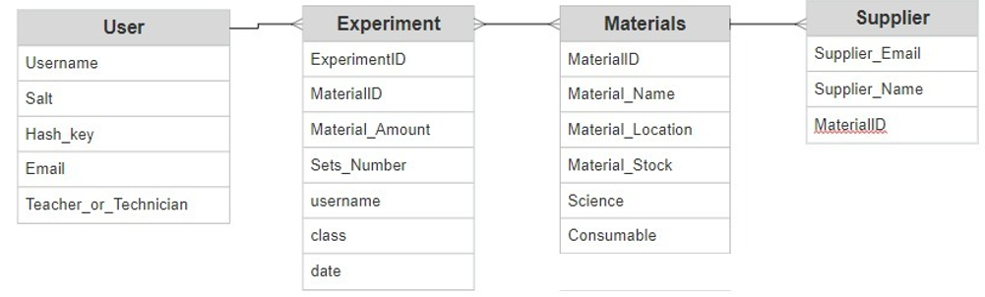

### 2.1.2 Normalization Process

Began process by displaying attributes about every entity above into its standard notation for database tables.

**tbl**User(**Username**, Salt, Hash_key, Email, Teacher_or_Technician)

**tbl**Materials(**MaterialID**, Material_Name, Material_Location, Material_Stock, Science, Consumable)

**tbl**Experiment(**ExperimentID**, MaterialID, Material_Amount, Sets_Number, Username, class, date)

**tbl**Supplier(**Supplier_Email**, Supplier_Name, MaterialID)

However, every Experiment will have several Materials. To achieve first normalized form, I must ensure that there are no multivalued fields. Hence, I have separated the Experiment table into two tables.

The first table, Experiment_Material, will include the Material and which Experiment it is part of. The second table, Experiment_Sets, will include attributes related to the Number of Sets that are needed for a specific instance of the Experiment.

In the Materials table, a specific MaterialID can be part of many sciences. For example, a stopwatch may be used for experiments in both physics and chemistry. This is another case of multivalued fields.

Therefore, we can further split the Materials table so that everything remains intact except for the Science attribute, which we can take out to form another table: Materials_Science.

Additionally, a Material may be in several locations, so we will need to split it further into another table Material_Location. The Material_Stock available is specific to a location, so we will move this attribute to the Material_Location table.

Hence, we have therefore achieved 1NF by establishing no multivalued fields and no repeating groups.

**tbl**User(**Username**, Salt, Hash_key, Email, Teacher_or_Technician)

**tbl**Materials(**MaterialID**, Material_Name)

**tbl**Material_Location(**Location**, MaterialID, Material_Stock)

**tbl**Materials_Science(**MaterialID**, Science)

**tbl**Experiment_Material(**MaterialID,** **ExperimentID,** Material_Amount)

**tbl**Experiment_Sets(**ExperimentID**, Sets_Number)

**tbl**Supplier(**Supplier_Email, MaterialID**, Supplier_Name)

I then concluded that it would be more normalized to split the Materials table into a Chemicals table and an Equipment table since they have different qualities. In splitting them, I can specifically assign the ‘Consumable’ attribute to equipment only, since all chemicals are consumable. All chemicals are stored in the same storage location, so there is no need to specify the location of a chemical.

I then decided to update the Experiment tables system. Since every experiment has attributes related to the size of the class as well as attributes related to the materials, I will split them into two separate tables: one Experiment_Materials (related to which materials are needed for one set), and one Experiment_Details (displaying the number of sets for a certain class and the experiment name).

Additionally, I will further split the Supplier table into two separate ones. The first will link the specific equipment ID to the supplier’s email address. The second will have attributes that are specific to the supplier, such as their name and contact number. Both tables will be linked using the supplier’s email address.

**~~tbl~~**~~User(~~**~~Username~~**~~, Salt, Hash_key, Email, Teacher_or_Technician)~~

**~~tbl~~**~~Chemicals(~~**~~ChemicalID~~**~~, Chemical_Name, Chemical_Stock)~~

**tbl**Equipment(**EquipmentID**, Equipment_Name, Consumable)

**tbl**Equipment_Location(**LocationID**, Equipment_ID, Equipment_Stock)

**tbl**Equipment_Science(Equipment_ID, Science)

**tbl**Experiment_Equipment(**EquipmentID, Experiment_ID,** EquipmentAmount)

**tbl**Experiment_Chemicals(**ChemicalID, Experiment_ID,** ChemicalAmount)

**tbl**Experiment_Sets(**Experiment_ID**, ExperimentName, Sets_Number)

**tbl**Equipment_Supplier(**EquipmentID**, Supplier_Email)

**tbl**Supplier_Details(**Supplier_Email**, Supplier_Name)

### 2.1.3 Post-Normalization

Post-normalization Entity Relationship Diagram

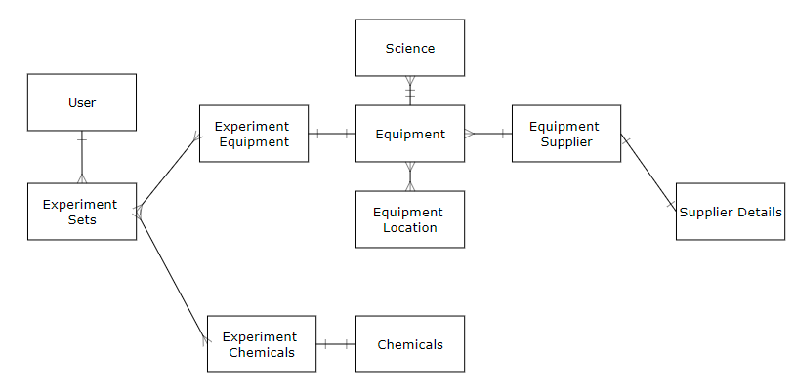

### 2.1.4 Data Dictionaries

|  |  |  |  |  |
| --- | --- | --- | --- | --- |
| Table Name | | Users | | |
| Primary Key(s) | | Username | | |
| Foreign Key(s) | | N/A | | |
| Data Item | Data Type | | Validation | Sample data |
| Username | String | | starts with a letter of the alphabet.  Includes all other characters, which can be alphabets, numbers or an underscore.  The length constraint of the username must be between 8 and 20 characters. | ella.k1_gfs |
| Password | String | | The password must be between more than 8 characters.  The password must have one special character, one number, one capital letter, and one lower case letter | okijY9?? |
| Salt | Text | |  | ��Vzi���vS��'1&-���(��(ce5F<� |
| Hash | Text | |  | )鿫4�^����  �O�[������L�IVHG1� |
| Email | String | | Ends with “_gfs@gemsedu.com” | Yara.o3_gfs@gemsedu.com |
| Teacher_or_Technician | Integer | |  | 0 or 1 |

|  |  |  |  |  |
| --- | --- | --- | --- | --- |
| Table Name | | Experiment_Sets | | |
| Primary Key(s) | | Experiment_ID | | |
| Foreign Key(s) | | N/A | | |
| Data Item | Data Type | | Validation | Sample data |
| Experiment_ID | Integer | |  | 14 |
| Experiment_Name | String | | Only letters of the alphabet and ‘space’ | Distillation of sodium hydroxide |
| Experiment_Sets | Integer | | Between 1-10 | 4 |

|  |  |  |  |  |
| --- | --- | --- | --- | --- |
| Table Name | | Experiment_Equipment | | |
| Primary Key(s) | | Experiment_ID, Equipment_ID | | |
| Foreign Key(s) | | Experiment_ID, Equipment_ID | | |
| Data Item | Data Type | | Validation | Sample data |
| Experiment_ID | Integer | |  | 14 |
| Equipment_ID | Integer | |  | 12 |
| Equipment_Amount | Decimal/Real | | 1-1000 | 3 |

|  |  |  |  |  |
| --- | --- | --- | --- | --- |
| Table Name | | Experiment_Chemicals | | |
| Primary Key(s) | | Experiment_ID, Chemical_ID | | |
| Foreign Key(s) | | Experiment_ID, Chemical_ID | | |
| Data Item | Data Type | | Validation | Sample data |
| Experiment_ID | Integer | |  | 14 |
| Chemical_ID | Integer | |  | 12 |
| Chemical_Amount | Decimal | | 1-2000 | 140 |

|  |  |  |  |  |
| --- | --- | --- | --- | --- |
| Table Name | | Equipment_Science | | |
| Primary Key(s) | |  | | |
| Foreign Key(s) | | Equipment_ID | | |
| Data Item | Data Type | | Validation | Sample data |
| Science | Integer | |  | 1 |
| Equipment_ID | Integer | |  | 14 |

|  |  |  |  |  |
| --- | --- | --- | --- | --- |
| Table Name | | Equipment_Location | | |
| Primary Key(s) | | Location_ID, Equipment_ID | | |
| Foreign Key(s) | | Location_ID, Equipment_ID | | |
| Data Item | Data Type | | Validation | Sample data |
| Location_ID | Integer | | Between 1 & 7 | 3 |
| Equipment_ID | Integer | |  | 14 |
| Equipment_Stock | Integer | | Between 1 & 100 | 70 |

|  |  |  |  |  |
| --- | --- | --- | --- | --- |
| Table Name | | Equipment | | |
| Primary Key(s) | | Equipment_ID | | |
| Foreign Key(s) | | N/A | | |
| Data Item | Data Type | | Validation | Sample data |
| Equipment_Name | String | | Up to 50 characters long.  Includes alphanumeric characters as well as parantheses and dash | Conical flask (100 mL) |
| Consumable | Integer | | 1 or 0 | 1 |
| Equipment_ID | Integer | |  | 14 |

|  |  |  |  |  |
| --- | --- | --- | --- | --- |
| Table Name | | Chemicals | | |
| Primary Key(s) | | Chemical_ID | | |
| Foreign Key(s) | | N/A | | |
| Data Item | Data Type | | Validation | Sample data |
| Chemical_Name | String | | Up to 50 characters long.  Includes alphanumeric characters as well as parantheses and dash | Sodium hydroxide 100 moldm-3 |
| Consumable | Integer | | 1 or 0 | 1 |
| Equipment_ID | Integer | |  | 14 |

|  |  |  |  |  |
| --- | --- | --- | --- | --- |
| Table Name | | Equipment_Supplier | | |
| Primary Key(s) | |  | | |
| Foreign Key(s) | | Equipment_ID, Supplier_Email | | |
| Data Item | Data Type | | Validation | Sample data |
| Equipment_ID | Integer | |  | 14 |
| Supplier_Email | String | | Email address format | alpha@supply.com |

|  |  |  |  |  |
| --- | --- | --- | --- | --- |
| Table Name | | Supplier_Details | | |
| Primary Key(s) | | Supplier_Email | | |
| Foreign Key(s) | | N/A | | |
| Data Item | Data Type | | Validation | Sample data |
| Supplier_Email | String | | Email address format | alpha@supply.com |
| Supplier_Name | String | | Between 1 and 40 characters | Chemicals Corp. |

### 2.1.5 SQL Statements

A DDL statement to create the Command_Lab database at first runtime.

CREATE DATABASE Command_Lab

Using SQLite3, the imported module for python SQL statements, which creates or connects to the Command_Lab database.

conn = sqlite3.connect("Command_Lab.db")

A DDL statement to create the Experiment_Equipment table at first runtime. It has a composite primary key using the Experiment_ID from the Experiment_Sets table as well as the Equipment_ID from the Equipment table, which are both foreign keys.

CREATE TABLE Experiment_Equipment (

Experiment_ID INTEGER REFERENCES Experiment_Sets (Experiment_ID),

Equipment_ID REFERENCES Equipment (Equipment_ID),

Equipment_Amount DECIMAL,

PRIMARY KEY (

Experiment_ID,

Equipment_ID);)

The select statement selects all the equipment’s names and their corresponding stock that are present in the specified location. The select statement references the Equipment_Location table based on the common key: Equipment_ID. The selected location will be passed as a parameter to the search during runtime.

“SELECT Equipment.Equipment_Name, Equipment_Location.Equipment_Stock, Equipment.Equipment_ID

FROM Equipment INNER JOIN Equipment_Location ON Equipment_Location.Equipment_ID = Equipment.Equipment_ID

WHERE Location_ID=(?)”,

(self.LocationConfirm)

Inserts a new record in the equipment table by passing in values using a dictionary. The primary key entry is left blank because it is an autoincrement value assigned upon creation of this table.

"INSERT INTO Equipment VALUES (:Equipment_Name, :Consumable, NULL)",

{

"Equipment_Name" : self.Entered_EquipmentName,

"Consumable" : self.Entered_Consumable

})

Updates the equipment name and its Consumable property based on the selected entry in the python table, which are all passed in as parameters in the update query.

“UPDATE Equipment

SET Equipment_Name=?, Consumable=?

WHERE Equipment_ID=?”,

(self.Entered_EquipmentName, self.Entered_Consumable, self.Entered_EquipmentID)

Deletes the entire record from the Equipment table based on the primary Equipment_ID field.

“DELETE from Equipment WHERE oid=” + self.Entered_EquipmentID

### 2.1.6 Data-flow Diagram

Login system data flow diagram – Level 1.

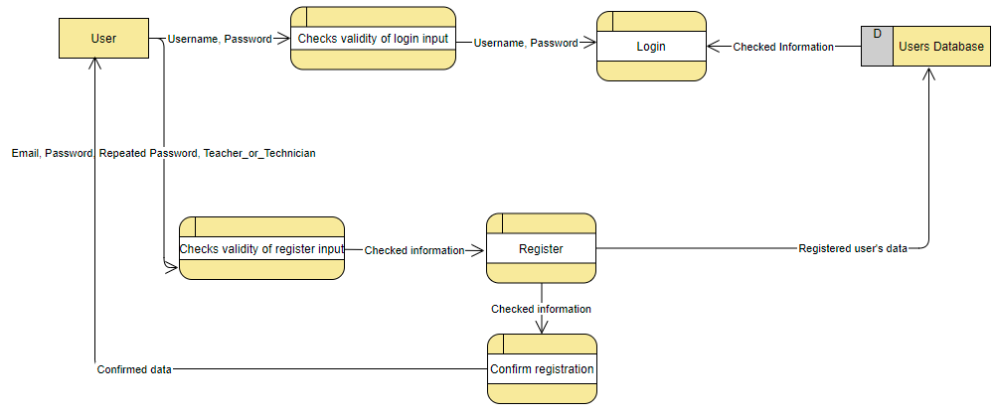

Inventory system Data Flow Diagram – Level 1.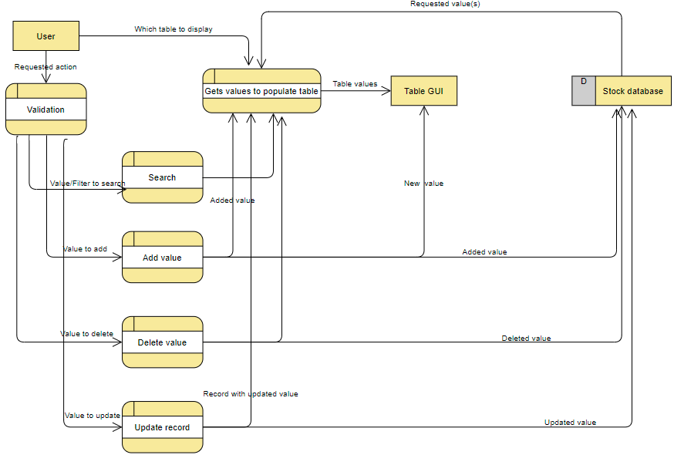

## 2.2 Overall System Design

### 2.2.1 Top-Down Diagram

### 2.2.2 IPSO Chart (Input, Process, Storage, Output)

|  |  |  |
| --- | --- | --- |
| IPSO | Program Section | Item |
| Input | Login of User | Username  Password |
| Registration of User | School-issued email  Password  Repeated password  Teacher or Technician status |
| Delete User | Username |
| Adding New Equipment | Equipment Name  Consumable status |
| Delete Existing Equipment | Equipment ID |
| Updating Existing Equipment | Equipment Name  Consumable Status |
| Equipment table according to science | Science Selection |
| Search Equipment | Equipment Name |
| Adding New Chemical | Chemical Name  Chemical Stock |
| Updating Existing Chemical | Chemical Name  Chemical Stock |
| Delete Existing Chemical | Chemical ID |
| Search Chemical | Chemical Name |
| Opening Location Table | Location Number |
| Update stock/location of existing equipment | Equipment ID  Stock  Location ID |
| Displaying suppliers for equipment that are below specified threshold | Stock |
| Adding a Supplier for a specific Equipment | Equipment ID  Supplier Email  Supplier Name |
| Creating a new Experiment | Experiment Name  Experiment Sets  Number of Equipment for experiment  Equipment Name  Equipment Amount  Number of Chemicals for experiment  Chemical Name  Chemical Amount |
| Open existing Experiment | Experiment Name |
| Processing | Logging in | Does user exist in database?  Is password correct?  Passes permissions through to the program to limit editing permissions |
| Registration | Create a hash key and salt  Generates a username out of the entered email |
| Delete | Does user exist? |
| Adding/Update/Delete/Search in Equipment/Chemicals/Locations tables | Is user’s input in GUI valid? |
| Equipment Stats | Outputs all equipment in order of increasing order to better plan distribution of stock among storage locations |
| Manipulating Suppliers tables | Is user’s input in GUI valid? |
| Experiments | Calculating the total amount of the equipment and chemicals based on the number of sets. |
| Storage | Save registered user information | Username, hash key, salt, teacher/technician permissions in database |
| Save Equipment/Chemicals/Location information | Stores names, stocks, and locations in database |
| Save supplier information | Stores email and name of equipment suppliers in database |
| Save experiment information | Stores experiment name, experiment chemicals/equipment names, chemical/equipment amounts |
| Output | Equipment Table | Displays all equipment in alphabetical order  Displays searched Equipment  Displays updated tables after alterations |
| Chemical Table | Displays all chemicals in alphabetical order.  Displays searched chemical.  Displays updated tables after alterations. |
| Equipment Location table | Displays all equipment in the selected Location  Displays searched Equipment in a particular Location  Displays updated tables after alterations |
| Equipment stats | Outputs all equipment in order of increasing stock to better plan distribution of stocks. |
| Suppliers table | Displays all equipment that are below specified stock number and their corresponding suppliers |
| Existing Experiment Details | Displays existing experiment details on the GUI for reference |

## 2.3 Data Structures

### 2.3.1 Stacks

A section of my project involves creating a new experiment and assigning certain quantities of equipment and chemicals for that experiment. To improve the user’s experience, I will include a feature to quickly glance at the selected amounts of equipment and chemicals and the availability and location of that stock throughout the science labs. I will be using a LIFO stack’s append function to store the selections and the stack’s pop function to display the user’s selections.

The advantage of using the python’s in-built list function in building a python stack is that I can utilize the advantages of both stacks and lists wherever applicable. Namely, the advantage of selecting the LIFO characteristic from stacks as well as the incremental and dynamic characteristics of lists in the ideal scenarios.

Empty stack:

|  |
| --- |
|  |
|  |
|  |
|  |
|  |
|  |
|  |
|  |

“Pushing” (appending) items to the stack:

|  |
| --- |
|  |
|  |
|  |
|  |
|  |
| Pencil |
| Ruler |
| Flask |

Entered items: Flask -> Ruler -> Pencil

Popping items from the stack:

|  |
| --- |
|  |
|  |
|  |
|  |
|  |
|  |
|  |
| Flask |

Outputted items: Pencil -> Ruler

### 2.3.2 Hashing

Hashing is going to be used to hash the passwords in the login system. The initial data (the entered password) is passed through the hash function.

* Hash key generated using imported hashlib's pbkdf2_hmac function
  + Convert entered password to bytes
  + 32-byte salt is randomly generated
* Outputs salt and hash key for storing
  + Hashing process iterated 100,000 times.

### 2.3.3 Dictionary

Dictionaries are going to be used when many items are being passed through the select/insert queries when manipulating my inventory tables.

An example of a dictionary is as follows:

"INSERT INTO Users VALUES (:username, :salt, :hash_key, :email, :teacher_or_technician)",

{"username" : self.username,

"salt" : self.salt,

"hash_key" : self.hash_key,

"email" : self.email,

"teacher_or_technician" : self.teacher_or_technician

})

The enclosed code is the dictionary used to map each of these values to the parameters in the SQL query.

## 2.4 OOP Class Design

### 2.4.1 Login Files

### 2.4.2 Inventory Files

### 2.4.3 Experiment Files

## 2.5 Interface Design

I have opted to utilize windows interface exclusively because of the client’s requirement to keep all aspects of the program user-friendly.

All the user’s entries are validated before being passed through for processing by the program.

### 2.5.1 Login and Registration

Login

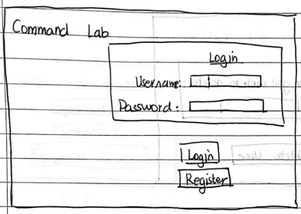

* + 1. When the program loads, the user is prompted to login if they already registered.
    2. Upon clicking this button, the register page is brought up to prompt the user to register.
    3. Login button sends the entered password, encodes it using the hash function, and compares it to the hash key stored in the database. A successful login will automatically redirect the user to the inventory window.

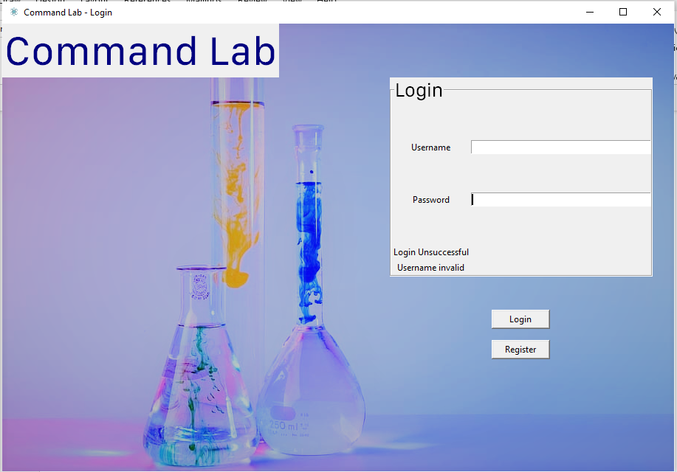

* + 1. An error message is displayed if the formatting of either entry (password/username) is valid. Also, a message is outputted if there is an error in the username and password matching.

Registration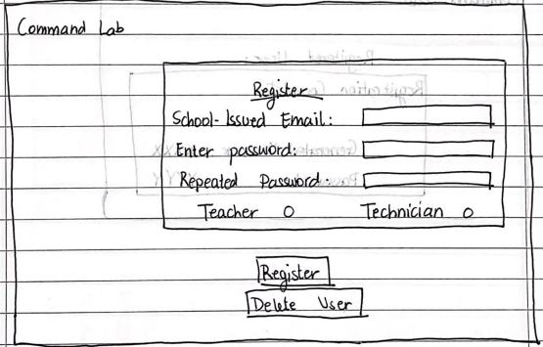

1. User enters their values, with a corresponding error message with invalid input in the position 1.
2. Sends the validated values to the database to be stored.
3. The delete user button is situated here as deleting a user is related to the registration of users.

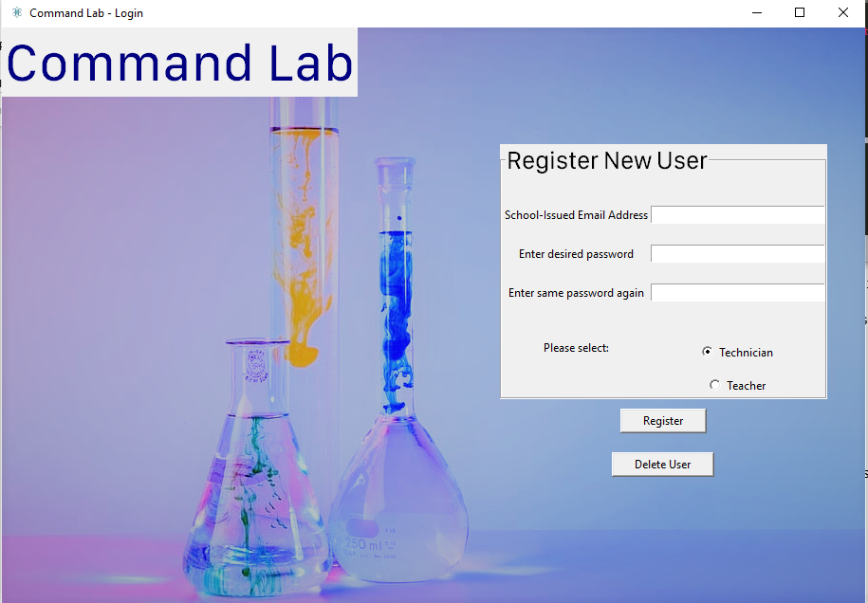

1. Radio buttons are embedded in the tkinter GUI, where their selection is returned to the database to be stored under the Teacher_or_Technician variable.

Registered User

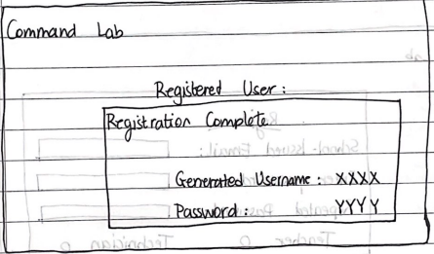

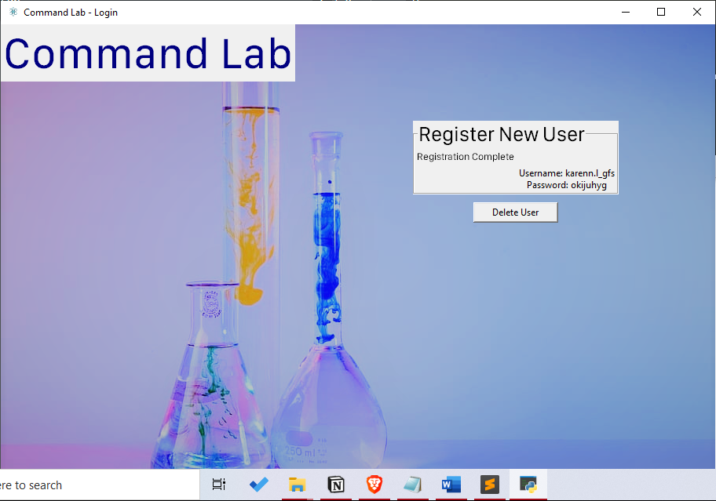

1. After the user presses the register button, the page clears and outputs the generated username as well as the user’s password, which they can then use to log back in.

Delete User

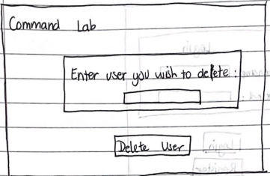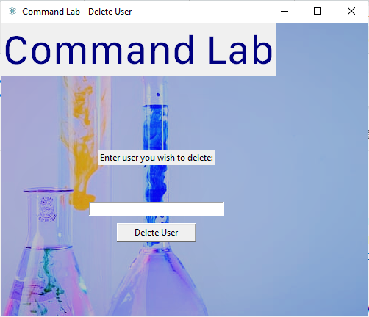

1. Searches for the user to delete in the database. If the user is not found, then an appropriate error message is displayed.

### 2.5.2 Inventory GUI

The first window after logging in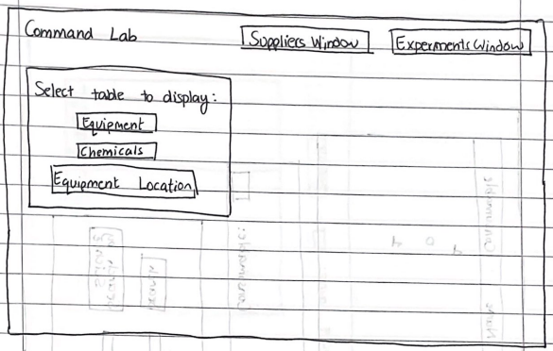

1. When the user logs in, the program redirects them to the inventory window, passing along the permissions with which they logged in. They will then be prompted to select which table they wish to view, which they can select in the indicated pane.
2. The ‘Suppliers Window’ button will redirect the to the window for suppliers contacts.
3. The ‘Experiments Window’ button will redirect the user to the window to create and view experiments.

Equipment Table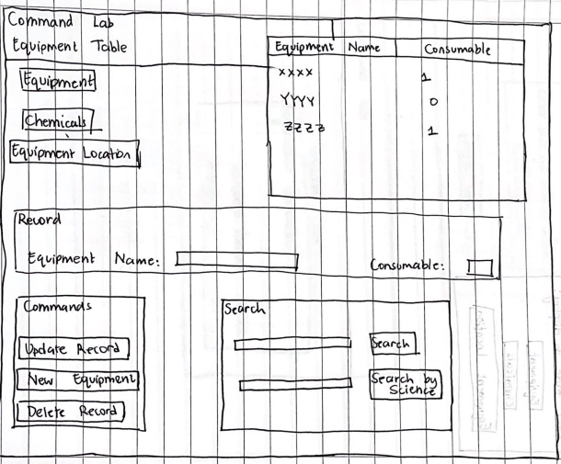

1. After the user has selected (in this example) the Equipment table, a table with the equipment’s names and attributes will be populated by calling SQL queries.
2. Whenever the user selects (by clicking) a record in the table, the entries in the frame are populated with their corresponding values. This is where the user can enter a new equipment/update an existing one or delete one entirely.
3. The Commands pane will take the values in the entries above and send them off to the database, where they will perform their respective commands.
4. The search entry allows the user to search for an equipment based on its name in the table.
5. The search button gets the value in the search entry and sends it off for handling by the program. The table is then updated to display all matches to that equipment name.
6. The ‘Search by Science’ entry allows the user to filter all the equipment that correspond to the selected science.
7. The ‘Search by Science’ button then submits the selection to the program for searching, and then repopulates the table to match the user’s query.

It is a similar concept for all three tables: Equipment, chemicals, and Equipment Location tables.

### 2.5.3 Suppliers Table

Suppliers Table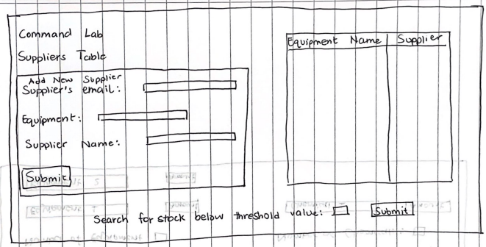

1. To add a new supplier to the database, the user fills in the entries enclosed.
2. The submit button sends off these values to the database to be added.
3. The table is then populated with all the suppliers that exist.
4. The user may want to display all the equipment that are low in stock (or below a specified value). In that case, the user can submit this query to the program, and the table will repopulate accordingly.

### 2.5.4 Experiment

Creating a new experiment

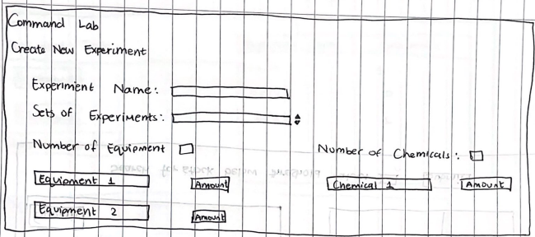

1. The experiment name for a new experiment can be included is entered here.
2. The number of sets of the experiment can be entered there. The arrows pointing up and down signify a scroller, to only allow integers between the allocated boundaries validated.
3. The number of separate equipment for a specific experiment can be entered here.
4. The amount of that equipment. It is the same case for the chemicals.

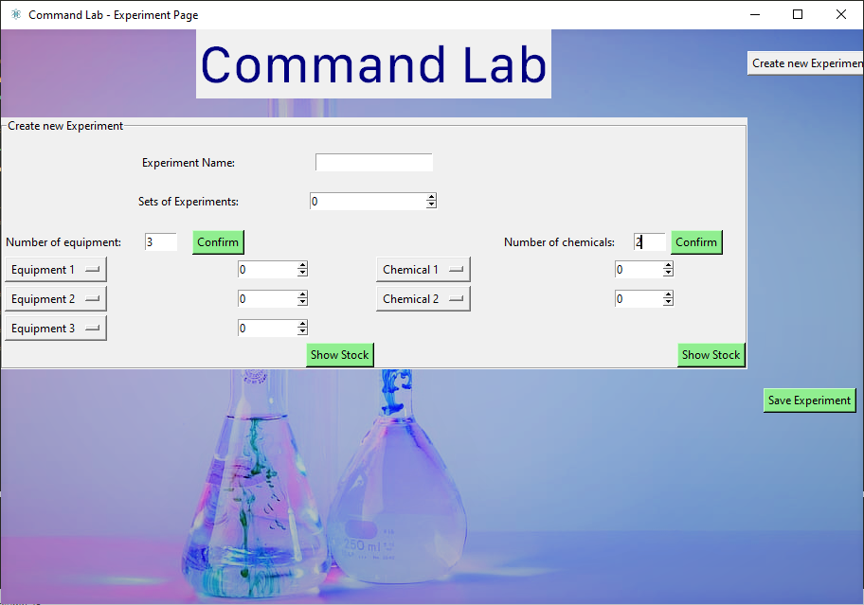

1. The experiment details are then saved and submitted to the database to be viewed later.

## 2.6 Algorithms

### 2.6.1 Merge Sort

Below is the pseudocode for the merge sort function. The merge sort function will be used when the technician requests for information about the equipment statistics. For example, if the technician sees that a certain ‘Equipment A’ has 100 pieces, nearing the top of the equipment statistics list, then the technician can see that statistic and distribute/concentrate storage of the equipment accordingly.

merge_sort(data, rightside, leftside):

IF leftside > rightside

return

middle_of_list = (leftside+rightside)/2

merge_sort(data, leftside, middle_of_list)

merge_sort(data, middle_of_list+1, rightside)

merge(data, leftside, middle_of_list, rightside)

end

### 2.6.2 SQL statements

Creating the Chemicals table, which will store the chemical ID (which autoincrements), chemical name, and chemical stock values.

CREATE TABLE Chemicals

(

Chemical_ID AUTOINCREMENT integer,

Chemical_Name varchar(255),

Chemical_Stock integer,

PRIMARY KEY (Chemical_ID)

);

Inserting a new chemical into the Chemicals table:

The value for the Chemical_ID is empty as the table will generate one that increments with every new chemical added to the table.

I will be using a dictionary to map the values to the corresponding table columns.

INSERT INTO Chemicals (Chemical_ID, Chemical_Name, Chemical_Stock) VALUES

{“Chemical_ID”: null,

“Chemical_Name”: “Hydrochloric Acid”,

“Chemical_Stock”, 500

};

Updating the stock property of a chemical in the Chemicals table.

UPDATE Chemicals SET Chemical_Stock = 300 WHERE Chemical_ID = 14;

Deleting a chemical from the Chemicals table.

DELETE FROM Chemicals WHERE Chemical_ID = 14;

Selecting the chemical stock value for a specific chemical.

SELECT Chemical_Stock FROM Chemicals WHERE Chemical_Name = "Hydrochloric Acid";

### 2.6.3 Validating Password Format

Regular expressions are used to validate the password formatting when registering a new user. A password must include at least one lower case letter, one upper case letter, one special character amd one number. A password must have at least 8 of the accepted characters.

password_format=

"^(?=.*[a-z]) *at least one lower case letter*

(?=.*[A-Z]) *at least one upper case letter*

(?=.*\d) *at least one decimal digit character*

(?=.*[@$!%*?&]) *at least one special character*

[A-Za-z\d@$!%*?&]{8,}$" *8 or more of the enclosed characters*

Pseudocode for verifying the formatting of a password:

myPasswordString= “Jenna1988?”

password_format= "(?=.*[a-z])(?=.*[A-Z])(?=.*\d)(?=.*[@$!%*?&])[A-Za-z\d@$!%*?&]{8,}"

IF fullmatch (password_format,myPasswordString):

Return True

ELSE:

Return False

### 2.6.4 Getting Equipment Stack

The Equipment Stack is going to store all the user-selected equipment when creating a new experiment.

equipment_dropdown_list <- []

equipment_dropdown_list.append(“Metric Ruler”)

When the contents of the stack need to be accessed to be stored in the database:

FOR i <- 0 to LEN(equipment_dropdown_list):

OUTPUT equipment_dropdown_list.pop()

# 3. Testing

## 3.1 Test Plan

|  |  |  |  |  |  |  |
| --- | --- | --- | --- | --- | --- | --- |
| Test No. | Section | Purpose | Test Data | Expected Result | Type | Result |
| 1 | Login | Checks that valid username and password can be used to log in | *Username:* kendall.k_gfs  *Password:*  Plokijuh | Redirect to Inventory Page (meaning log in was successful) | Normal | Pass |
| 2 | Login | Checks that invalid username cannot be used to log in | 123 | Error message to say login was unsuccessful because username formatting was incorrect | Erroneous | Pass |
| 3 | Login | Checks that a value for username on the validation boundaries is handled correctly | i.k_gfs | Redirect to Inventory Page even though it is boundary data | Boundary | Failed |
| 4 | Login | Checks that invalid password cannot be used to log in | qsde | Error message to say login was unsuccessful | Erroneous | Pass |
| 5 | Login | Does not allow values directly under the boundary | 1234567 | Error message to say login was unsuccessful | Boundary | Pass |
| 6 | Register | Valid email address, password, and teacher_or_technician selection goes through | *Email*:  Lara.c_gfs@gemsedu.com  *Password:*  qawsedrf  *teacher_or_technician:*  teacher | Redirects to display confirmed registration | Normal | Pass |
| 7 | Register | Checks that an invalid email address shows an appropriate error message | *Email*:  Olga  *Password:*  Ijuhygtf  *teacher_or_technician:*  teacher | Displays an error message to say that the email address format is invalid. Should clear out entry box to allow user to enter new vaue. | Erroneous | Pass |
| 8 | Register | Checks that mismatches entries for the password entry boxes would display an error message | *Email:* inaya.e_gfs@gemsedu.com  *Password:* ok7Y?9tr  *Repeated Password:* ok7Y?9tr3 | Should display password error message and clear out password entry boxes | Erroneous | Pass |
| 9 | Register | Checks that a password right below the length boundary is rejected | *Email:* inaya.e_gfs@gemsedu.com  *Password:* ok7Y?9t  *Repeated Password:* ok7Y?9t | Should display password error message and clear out password entry boxes | Boundary | Pass |
| 10 | Deleting User | Checks that a username that exists is correctly deleted. | *Username*:  olga.g_gfs | Should delete user from database and display appropriate confirmation message | Valid | Pass |
| 11 | Deleting User | Checks that a username that does not exist in the database displays an appropriate error message. | Lara.t_gfs | Should display an error message to say that no user with that username was found. | Erroneous | Failed |
| 12 | Inventory | Checks that the appropriate menus are open based on the teacher/technician permissions |  | Opens editing menus if permissions are set to technician.  Opens viewing menus if permissions are set to teacher. | Valid | Pass |
| 13 | Inventory | Checks that the search function for the equipment table works | LEIBIG CONDENSER | Should update the treeview with information about the searched value. | Valid | Pass |
| 14 | Inventory | Checks that the search function for the chemical table works | Hydrochloric Acid | Should update the treeview with information about the searched value. | Valid | Pass |
| 15 | Inventory | Checks that boundary data right below the boundary is not accepted for the science lab selection | 0 | Should open the table and show the equipment that are found in that location | Valid | Failed |
| 16 | Inventory | Checks that the filter function works for the equipment chart | Biology | Should update the treeview to display the equipment specific to the specified subject | Valid | Passed |
| 17 | Inventory | Checks that a valid update for the selected equipment can be processed | *Equipment Name*:  Ammeter -> Ammeter1 | Should update in both the treeview and the database. | Valid | Passed |
| 18 | Inventory | Checks that a invalid update for the selected equipment will be blocked | *Equipment Name*:  AMMETERRRRRRRRRRRRRRRRRRRRRRRRRRRRRRRRRRRRRRRRRRRR | Should display error message | Erroneous | Passed |
| 19 | Inventory | Checks that valid record to be added is added to the equipment list and database correctly | *Equipment Name:*  Measuring Tape  *Consumable:*  1 | Should update in both treeview and database | Valid | Passed |
| 20 | Inventory | Checks that deleting selected records works |  | Should update in both treeview and database | Valid | Passed |
| 21 | Inventory | Checks that adding a record in the chemicals table works | *Chemical Name*: Nitric Acid  *Chemical Stock*: 150 | Should add in both treeview and database | Valid | Passed |
| 22 | Inventory | Checks that adding an invalid record in the chemicals table is rejected | *Chemical Name*: *blank*  *Chemical Stock*: 150 | Should display error message | Erroneous | Passed |
| 23 | Inventory | Checks that updating a record in the chemical table works | *Chemical Stock:* 130 -> 260 | Should update in both treeview and database | Valid | Passed |
| 24 | Inventory | Checks that updating an invalid record in the chemical table is rejected | *Chemical Stock:* 130 -> ‘apple’ | Should display error message | Erroneous | Passed |
| 25 | Inventory | Checks that deleting selected records works | *Chemical to be deleted:* Nitric Acid | Should update in both treeview and database | Valid | Passed |
| 26 | Inventory Page | Checks that displaying inventory specific to the location works | *Location*: 1 | Should display the correct treeview | Valid | Passed |
| 27 | Inventory Page | Checks that updating record function works with valid data works. | *Stock:* 16->17 | Should update the treeview and the database. | Valid | Passed |
| 28 | Inventory Page | Checks that updating record function works and invalid data is rejected | *Stock:* 16 -> ‘pepper’ | Should display error message | Erroneous | Passed |
| 29 | Inventory Page | Checks that adding a record to the location works with valid data | *Equipment Name:* BULB HOLDER  *Stock*: 160  *Equipment ID*: 16  *Location:* 1 | Should add in treeview as well as database | Valid | Passed |
| 30 | Inventory Page | Checks that deleting a record from the location works with valid data | *Equipment Name:* BULB HOLDER  *Equipment ID*: 16 | Updates treeview and the database | Valid | Failed |
| 31 | Equipment Statistics | Checks that the merge sort function applied on the equipment stocks works |  | Should output the list alongside its stock number in descending order for the user | Valid | Passed |
| 32 | Create new experiment | Checks that creating a new experiment with valid data works | *Experiment Name:* Mass Invenstigation 1  *Sets of Experiments*: 6  *Number of Equipment:* 3  *Number of Chemicals:* 1  *Equipment 1:* Electricity Board  *Equipment 2:* B Robotic Kit  *Equipment 3:* Chips  *Chemical 1:* Sulfuric Acid  *Equipment 1 Amount:* 3  *Equipment 2 Amount:* 2  *Equipment 3 Amount:* 1  *Chemical 1 Amount:* 5 | Should save these values to the database | Valid | Passed |
| 33 | Create New Experiment | Checks that program rejects invalid experiment name | *Experiment Name:* *blank* | Should display the error message that the experiment name is invalid | Erroneous | Passed |
| 34 | Create New Experiment | Checks that program rejects invalid experiment sets | *Experiment sets:* *blank* | Should display the error message that the experiment sets is invalid | Erroneous | Passed |
| 35 | View Existing Experiment | Check that program can show details about an experiment | *Experiment Name:* Mass Investigation 1 | Should display details about the selected experiment | Valid | Passed |
| 36 | View Existing Experiment | Check that program can delete an experiment | *Experiment Name:* Mass Investigation 1 | Should delete the experiment from the database | Valid | Passed |
| 37 | Supplier | Checks that the program can show stock below certain threshold and their corresponding supplier | *Threshold stock:* 14 | Should display the equipment that fall short of this threshold | Valid | Passed |
| 38 | Supplier | Checks that the program rejects an invalid value for the threshold stock | *Threshold stock:* apple | Should display error message | Erroneous | Passed |
| 39 | Supplier | Checks that the program can correctly add a supplier to both the treeview and the database using valid data | *Supplier email:* omicron@gmail.com  *Equipment ID:* 17  *Supplier Name:* omicron suppliers | Should correctly update treeview and database | Valid | Passed |
| 40 | Supplier | Checks that an invalid data entry is rejected for adding a new supplier | *Supplier email:* phi  *Equipment ID:* gamma  *Supplier Name:* triessupplies | Should display error message | Erroneous | Passed |
| 41 | Main | Checks that running the main code file automatically starts up the login page |  | Should display login page | Valid | Passed |
| 42 | Register window | Checks that clicking the ‘register’ button redirects to register window |  | Should redirect to the register window | Valid | Passed |
| 43 | Create New Experiment | Checks that breakdown of equipment location stock window works | *Equipment Name:* Ammeter | Should display breakdown of the stock number and location for the selected equipment | Valid | Passed |

## 3.2 Test Results

Test 1:

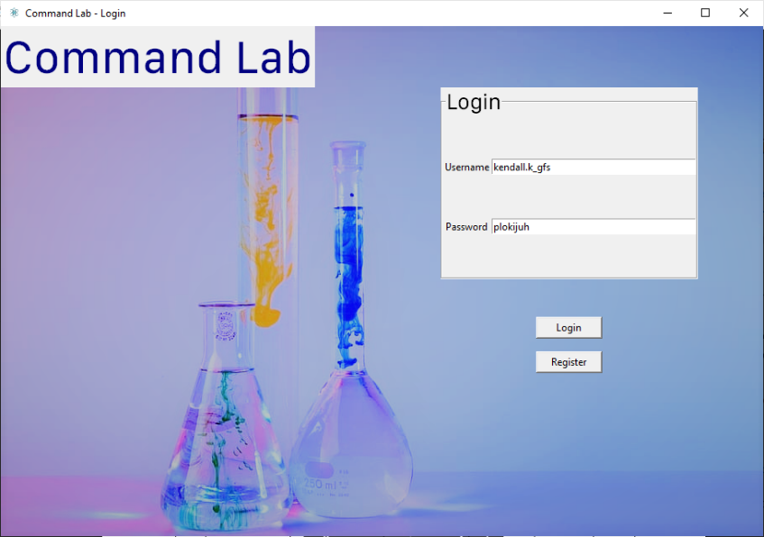

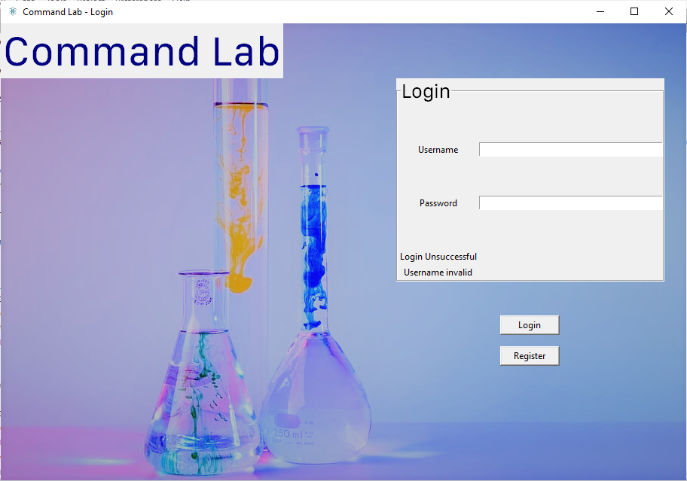Test 2:

Displays that message because the username must be between 7 and 29 characters long.

Test 3:

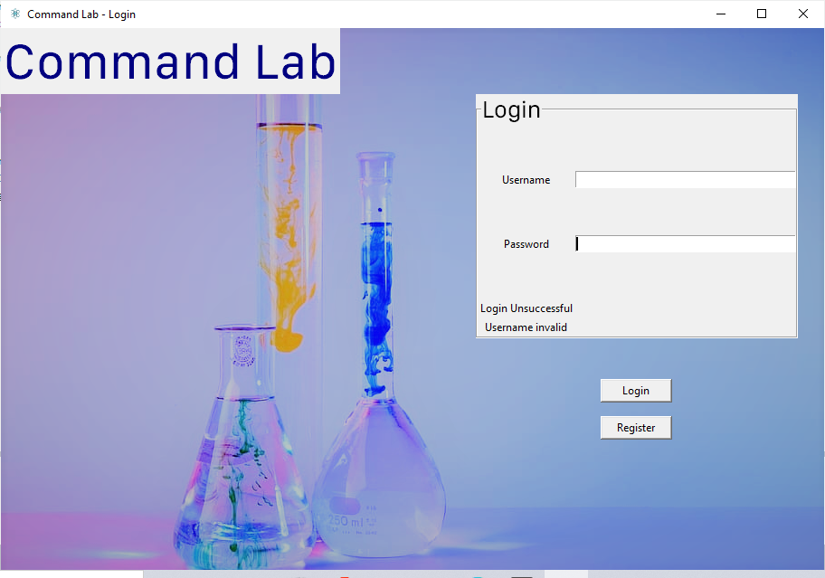

Displays the error message even though the username is fine.

In fact, this issue is because the regular expression for the validation of the username was incorrect.

I added a ‘.’ to the possible accepted. I also misunderstood the function of the curly brackets in regular expressions, which I now understand signifies that whatever is enclosed in the small brackets can be repeated however many numbers is enclosed in the curly brackets.

The original code was: username_format = "^[A-Za-z][A-Za-z0-9_]{7,29}$" *#ensures that the username format starts with an alphabet. The username can include all other characters, which can be alphabets, numbers or an underscore. The length constraint is {7,29}.*

The corrected one is: username_format = "^[a-zA-Z0-9\._-]{7,29}$" *#ensures that the username format starts with an alphabet. The username can include all other characters, which can be alphabets, numbers or an underscore. The length constraint is {7,29}.*

Test 4:

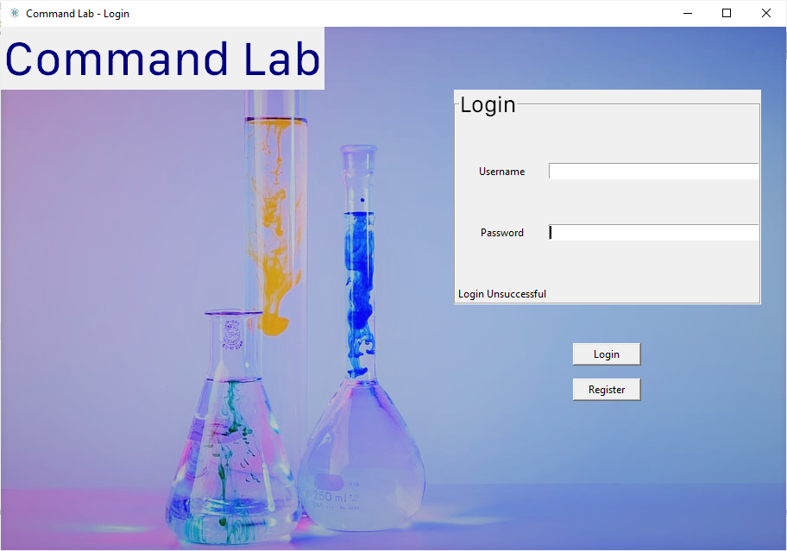Appropriate error message displayed when password formatting is incorrect.

Test 5:

Appropriate error message displayed to explain that the password did not go through.

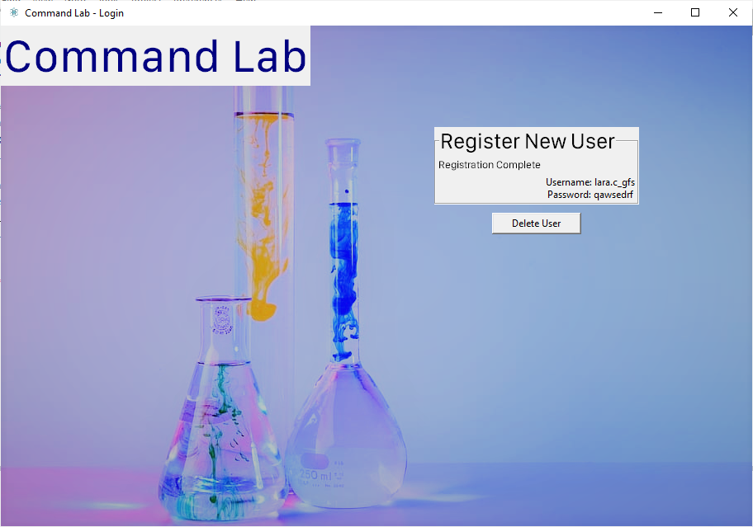Test 6:

The ‘completed register’ window is displayed with the generated username and the password. The registration process goes through several levels of validaton.

Firstly, the email address entered is validated

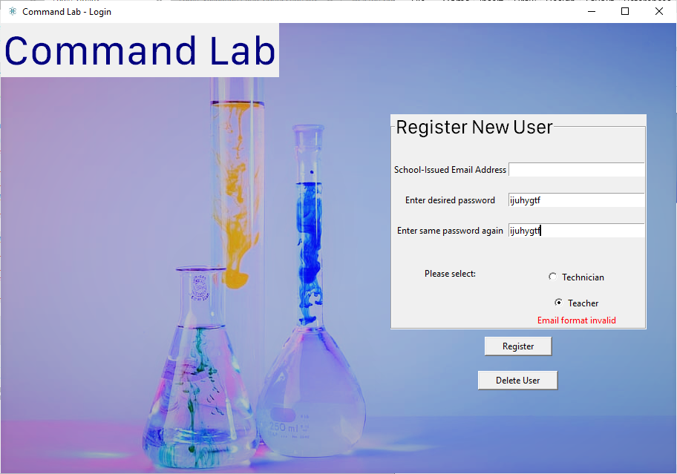Test 7:

Test 8:

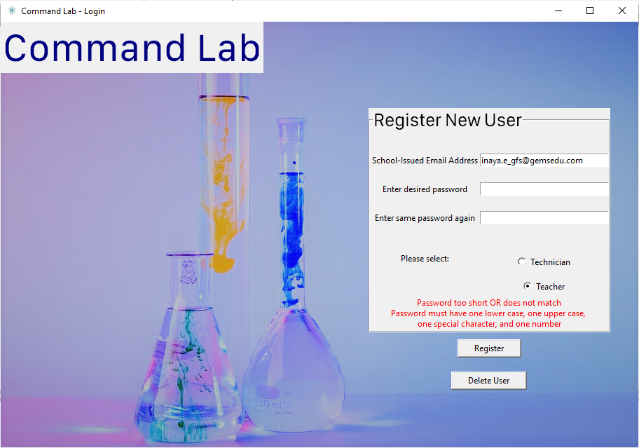

Displays appropriate error message.

Test 9:

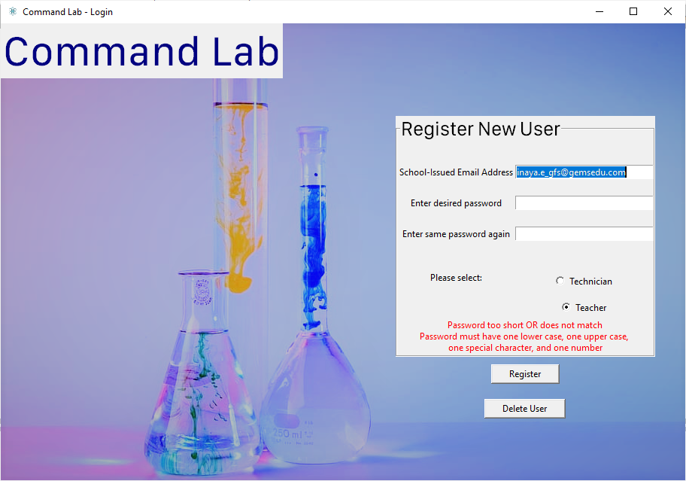Displays appropriate error message.

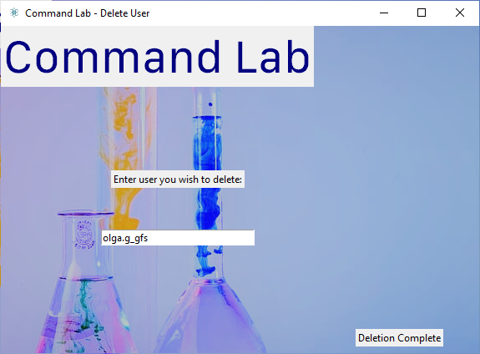Test 10:

Displays confirmation for user after deletion.

Test 11:

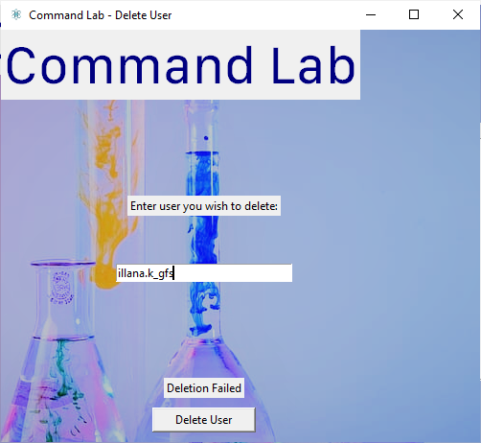

There was an error in my code where I used the string ‘user_entry’ as the condition for the SQLite query instead of passing the user_entry as a parameter.

I have also failed to include a piece of code to display an error if there is no match to the entered username.

The original code from the delete_record function is:

user_entry=self.username

c.execute("DELETE from Users WHERE username = 'user_entry'") *#deletes the record in the database that matches the username that the user entered*

This is the new code:

user_entry=self.username

check_to_see_if_username_exists = c.execute("SELECT username from Users WHERE username=(?)", (user_entry,)) *#checks to see if a user with that username exists*

**if** len(check_to_see_if_username_exists.fetchall())==0: *#if not, then the function returns false*

deletion_successful=False

**else**:

c.execute("DELETE FROM Users WHERE username = (?)", (user_entry,)) *#deletes the record in the database that matches the username that the user entered*

deletion_successful=True

Test 12:

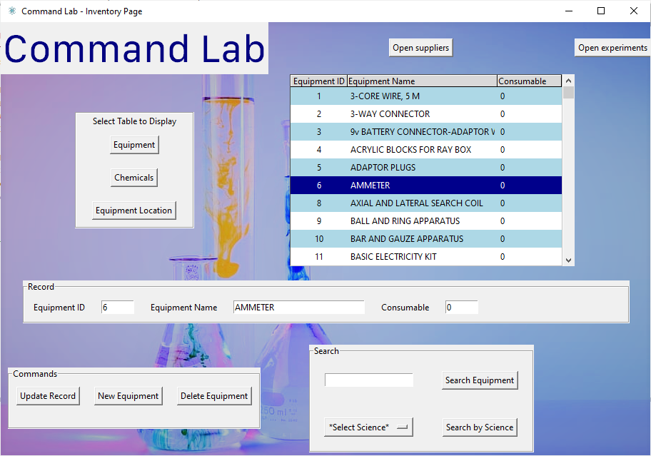Shows editing menus and supplier button.

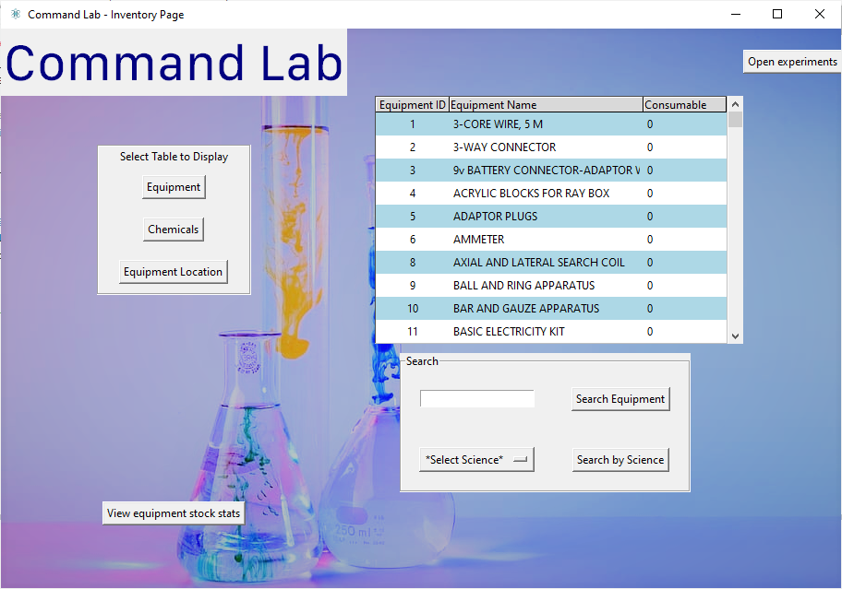With teacher permissions, it only shows the table, search, and the experiments button.

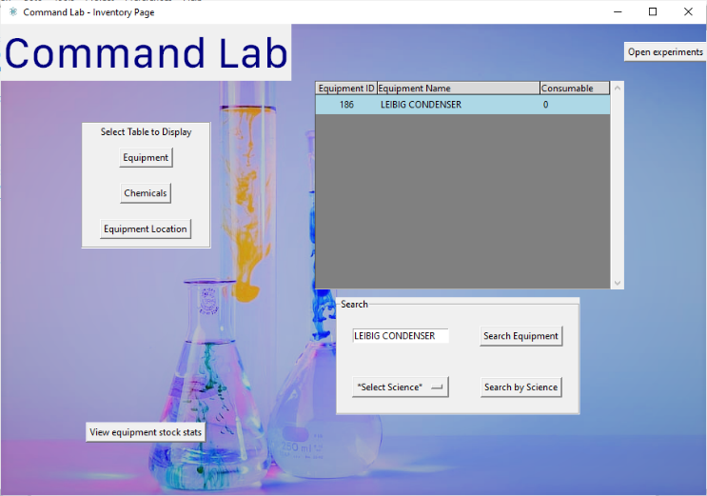Test 13:

Test 14:

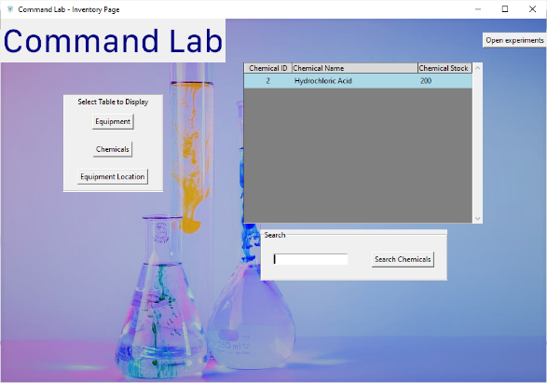

Test 15:

The procedure initially accepted a lab number of 0, which is an error in the regular expression.

The original regular expression was:

Location_Format = "^[0-7]$" *#checks that location is included in the seven science labs*

The updated regular expression is:

Location_Format = "^[1-7]$" *#checks that location is included in the seven science labs*

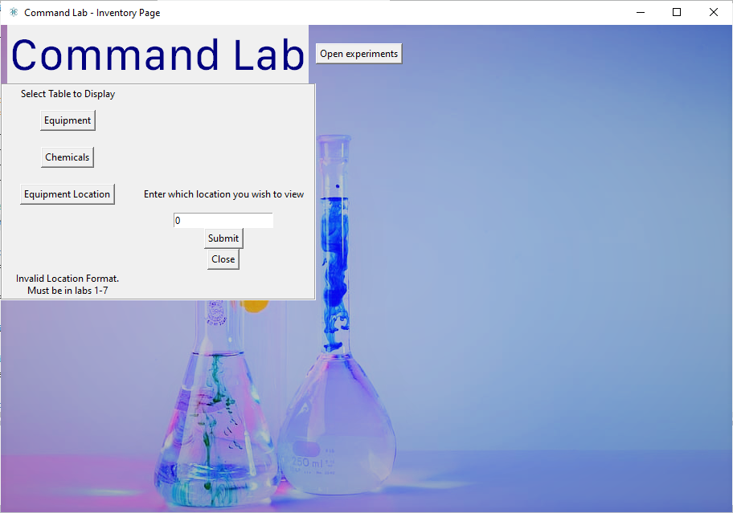Testing this edit yields:

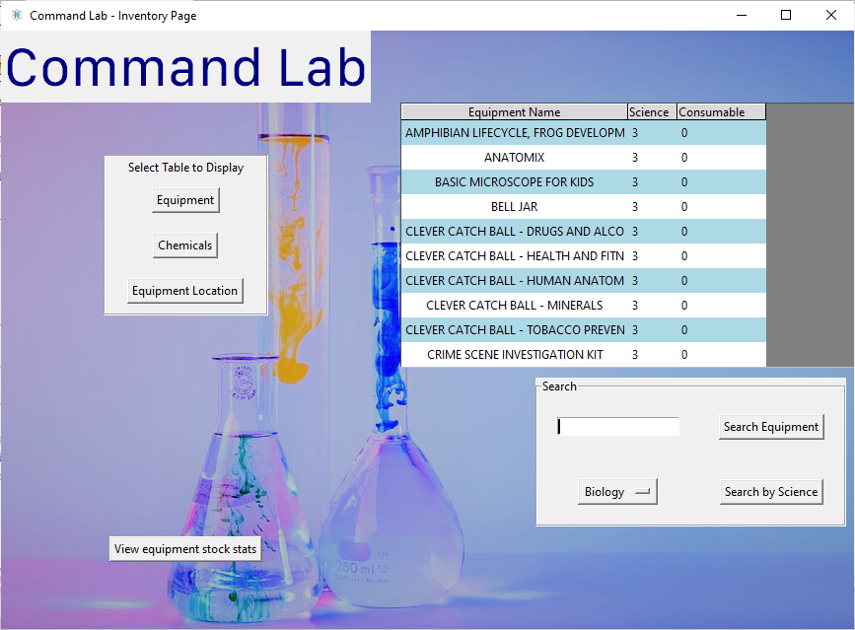Test 16:

Test 17:

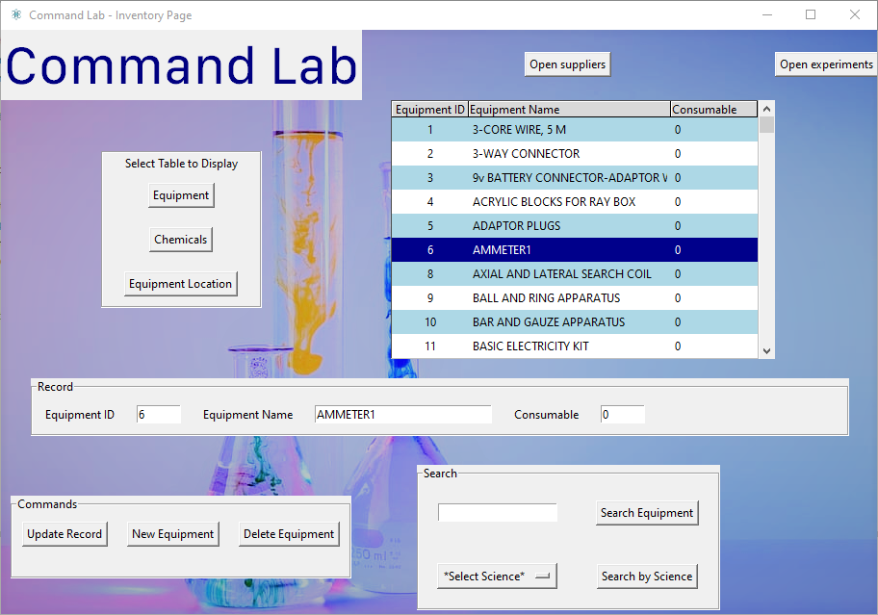Updates.

Test 18:

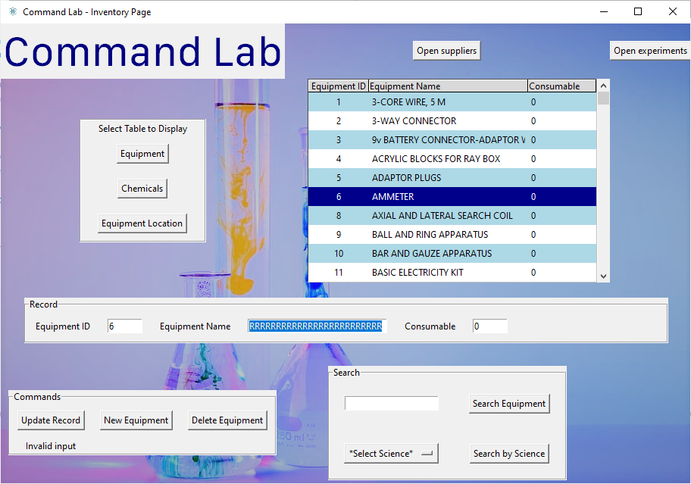Displays error message.

Test 19:

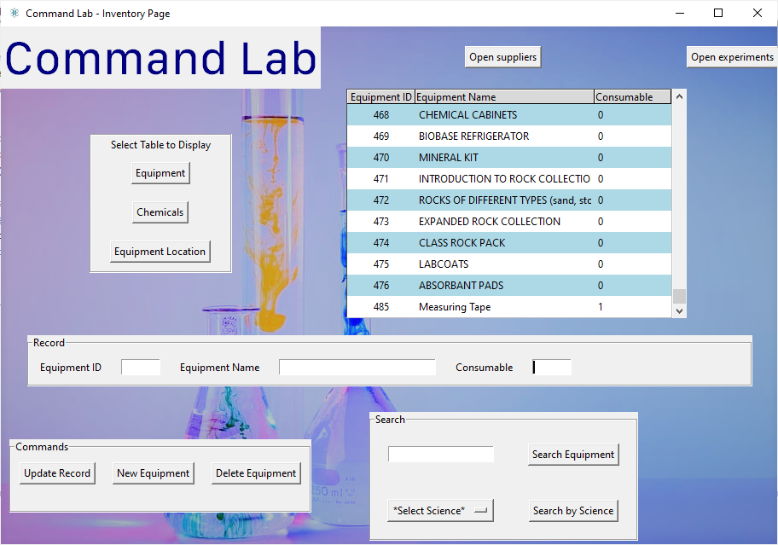Generated equipment ID for the new equipment and added the new record to the database.

Test 20:

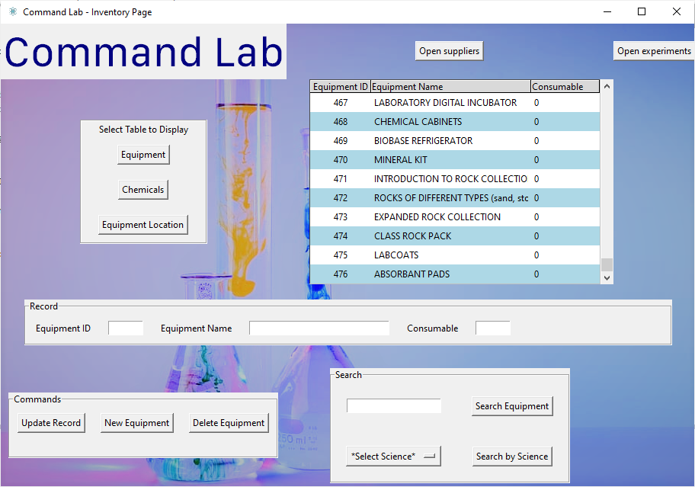Deleted ‘measuring tape’ record.

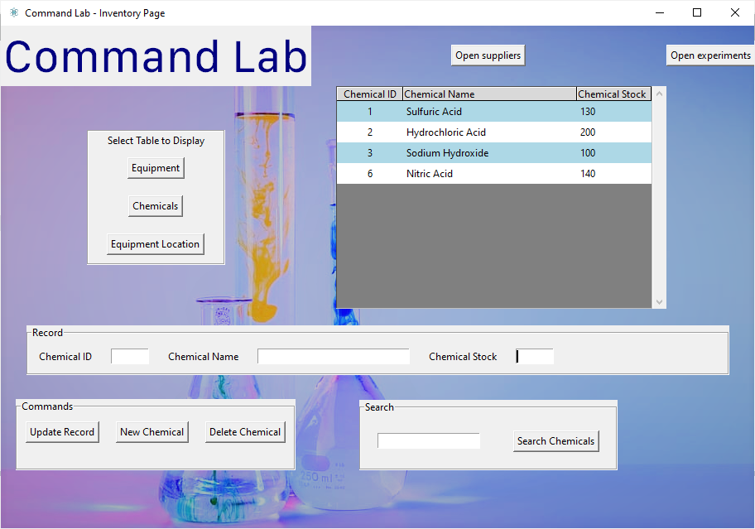Test 21:

Added ‘Nitric Acid’.

Test 22:

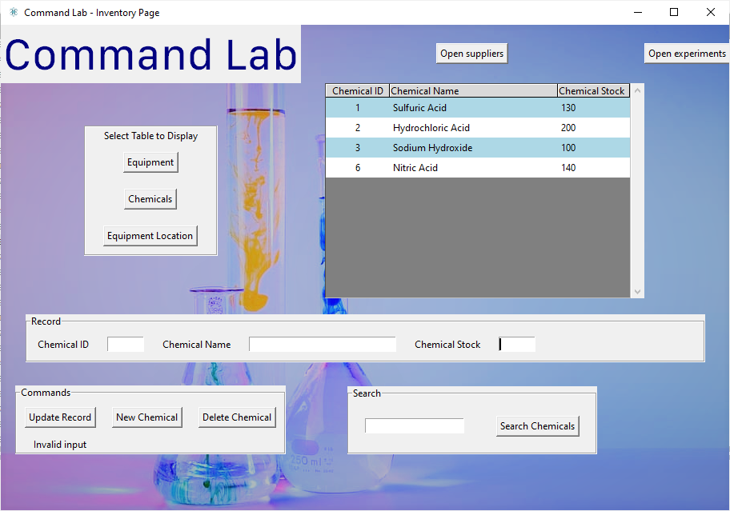

Displays error message

Test 23:

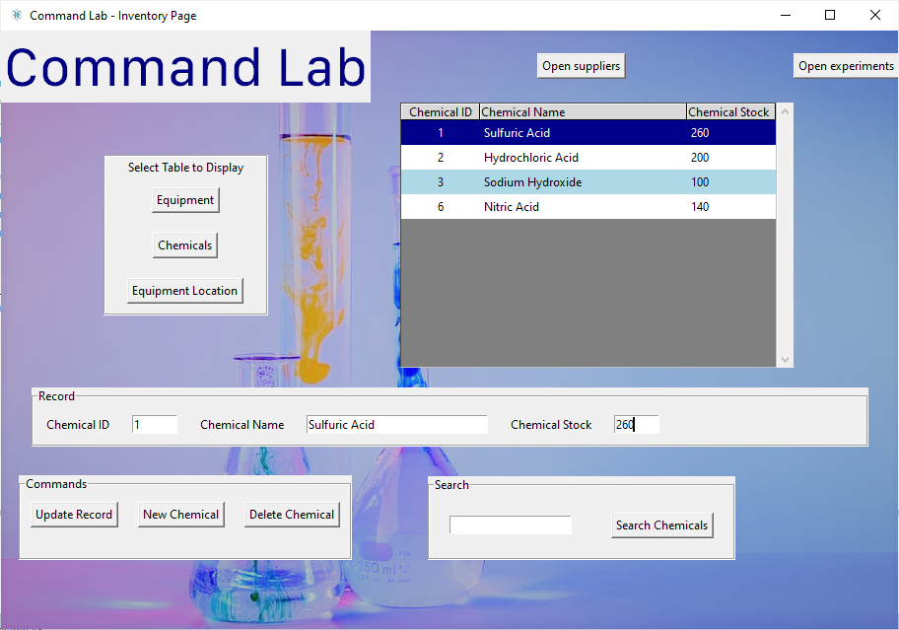 Updates the value

Test 24:

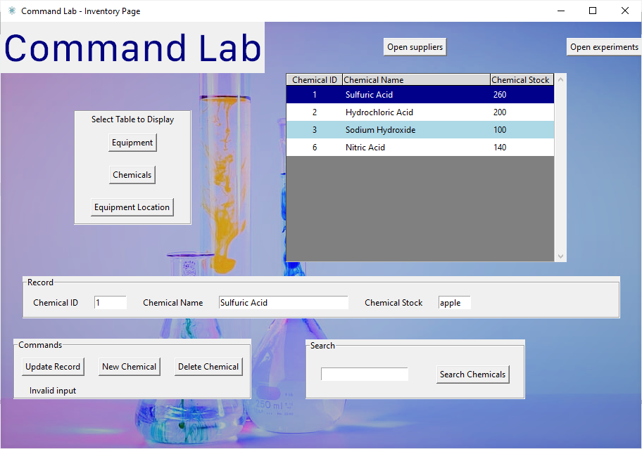

Displays error message.

Test 25:

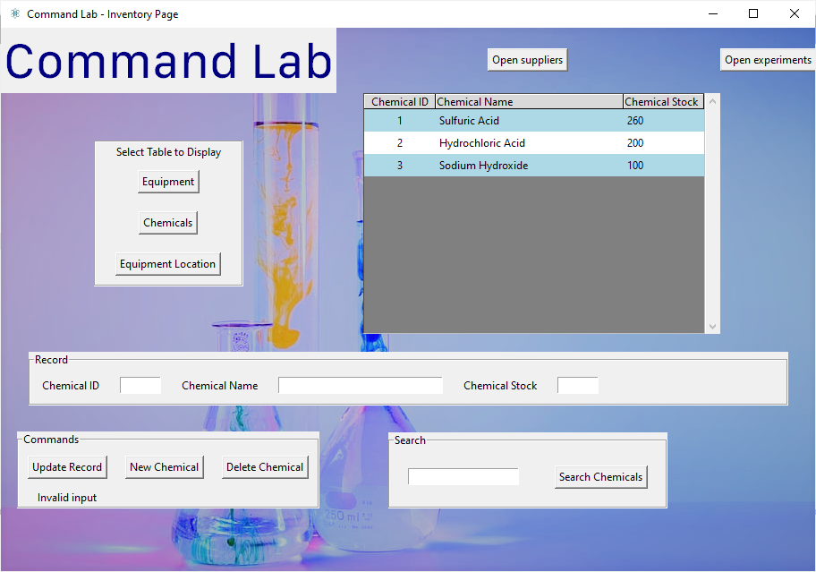Deleted nitric acid record

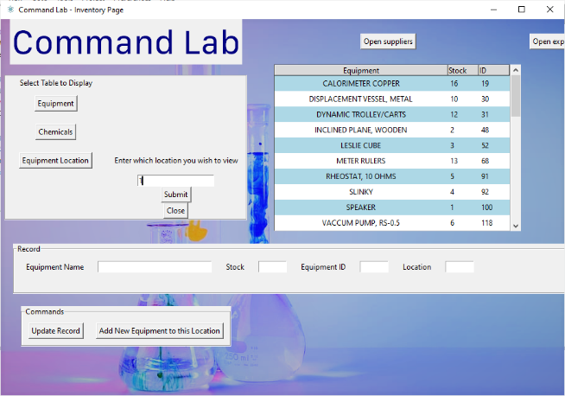 Test 26:

Correctly displays the equipment according to location ID

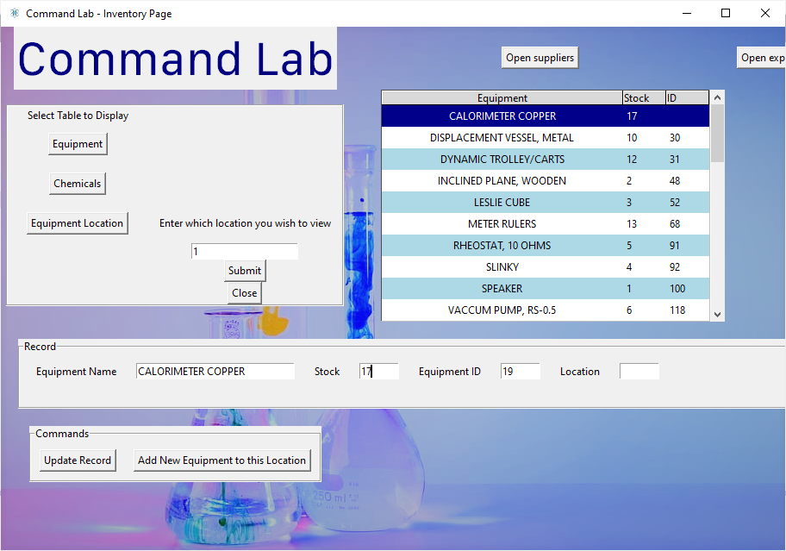Test 27:

Updates in treeview and in database.

Test 28:

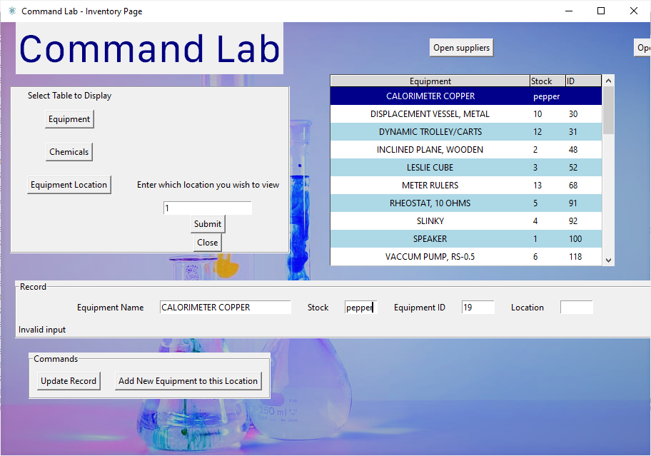Displays error message

Test 29:

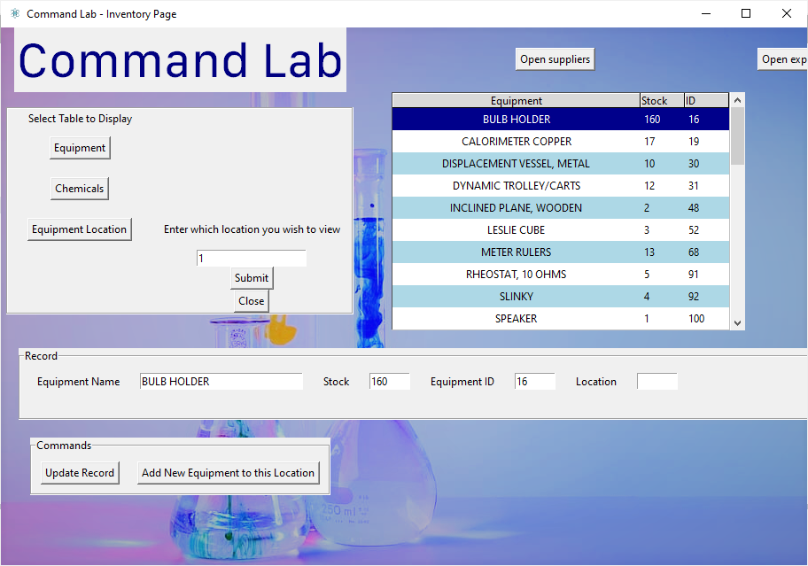Updates treeview and database

Test 30: Added a ‘Delete’ Button and the corresponding function to remove an equipment from that location.

**def** delete_from_location(self):

self.Entered_Stock = self.Stock_Entry.get()

self.Entered_EquipmentID = self.EquipmentID_Entry.get()

self.Entered_Location = self.Location_Entry.get()

**print**(self.Entered_Location)

u3=Equipment_Location_Validate(self.Entered_Location,"","","",self.Entered_EquipmentID)

self.Location_Valid=u3.validate_Location(self.Entered_Location)

self.EquipmentID_Valid=u3.validate_equipmentID(self.Entered_EquipmentID)

**if** self.Location_Valid==True **and** self.EquipmentID_Valid==True:

u2=Location_get_values("", "", "", self.Entered_EquipmentID, self.Entered_Location)

u2.delete_from_Location_db()

*# Clear The Treeview Table*

self.table_tree.delete(*self.table_tree.get_children())

*# Run to pull data from database on start*

self.show_Equipment_Location(self.inventory_page, self.LocationConfirm)

**else**:

self.errorLabel.configure(text="Invalid input")

*I realised that the variable that I passed in corresponded to Location_Confirm, and not the Location ID that was the entry from the edit records frame.

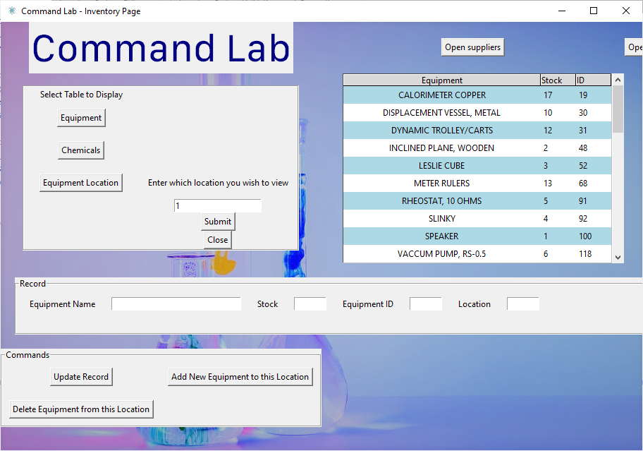

Entered_Location

Location_Confirm

Now, the function works, and the BULB HOLDER that was supposed to be deleted is now deleted from location 1, as shown below.

Test 31:

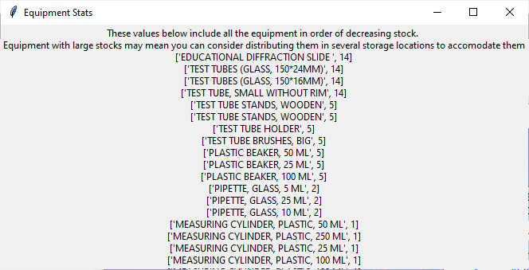Displays list as separate window

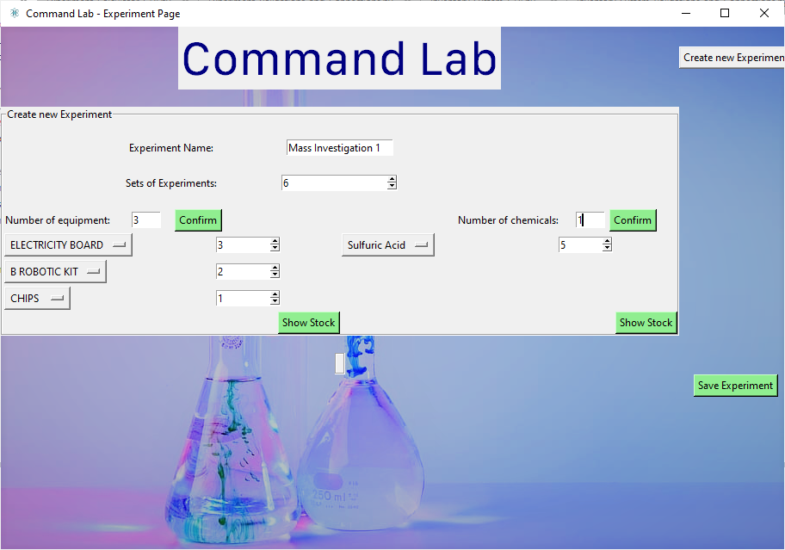Test 32:

Adds to database.

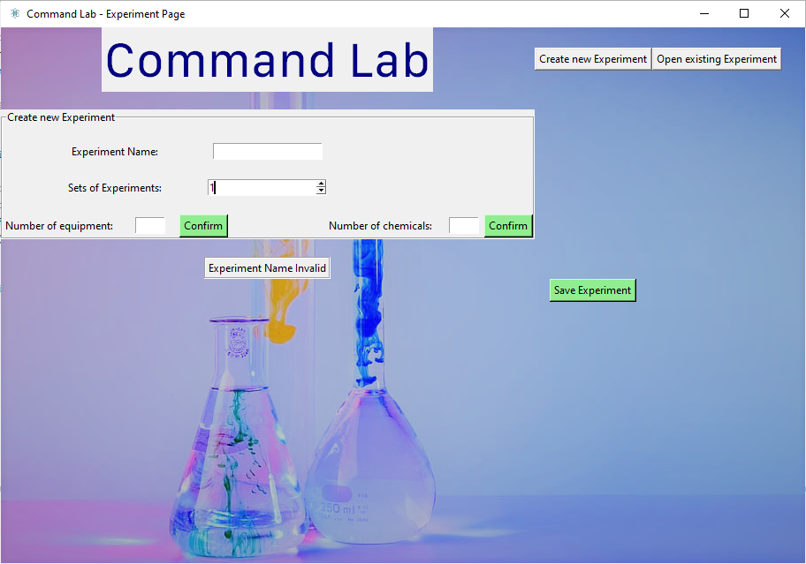Test 33:

Displays the error message that experiment name is invalid.

Test 34:

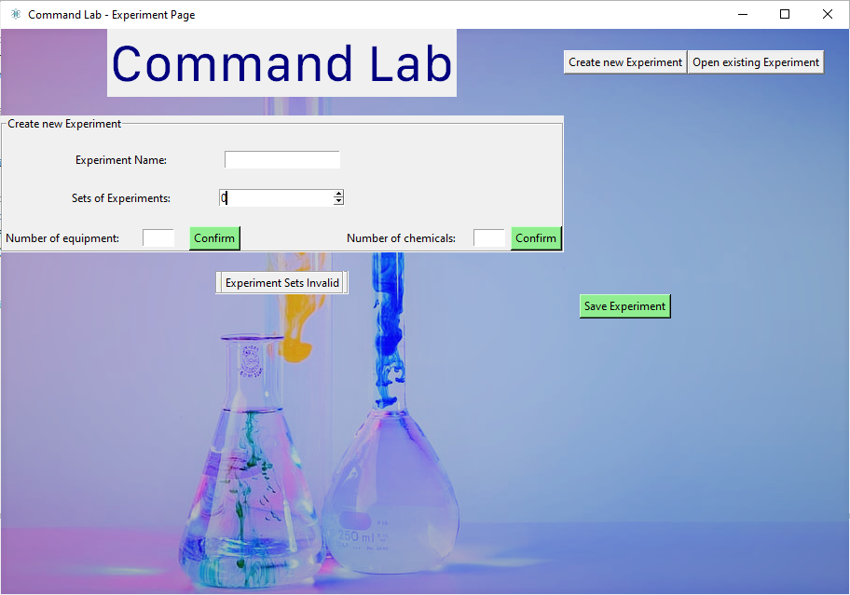 Displays the error message that experiment sets is invalid.

Test 35:

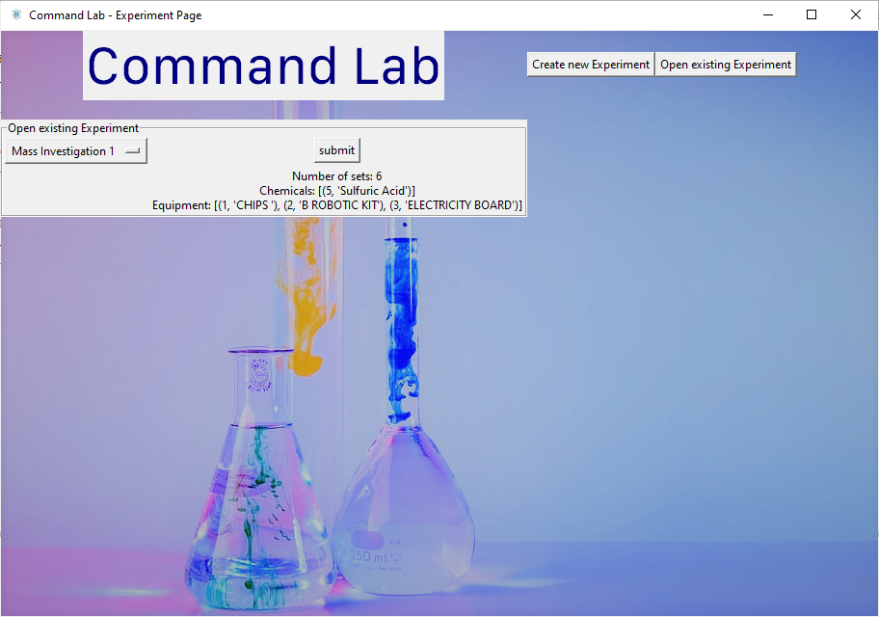

Displays details about the experiment.

Test 36:

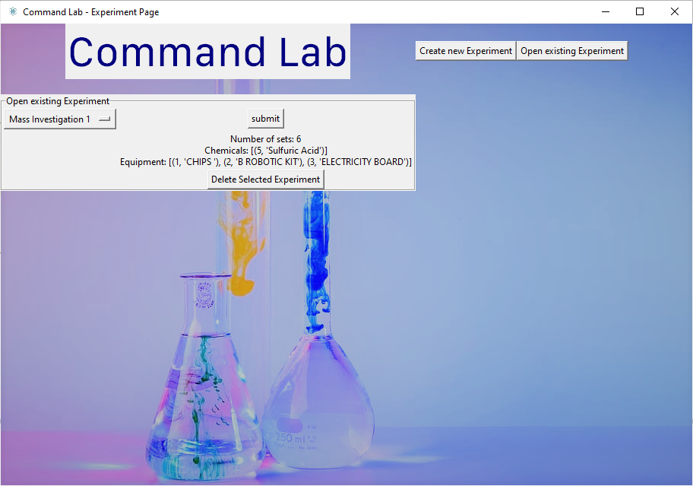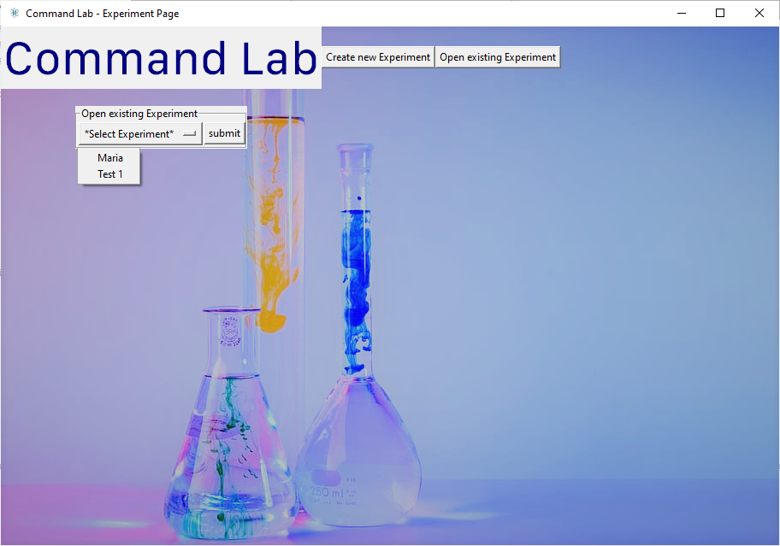

Successfully deleted the selected experiment.

Test 37:

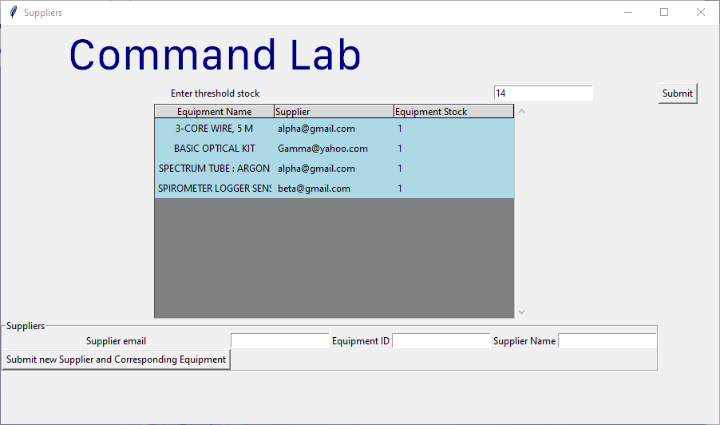

Successfully displayed equipment and their suppliers.

Test 38:

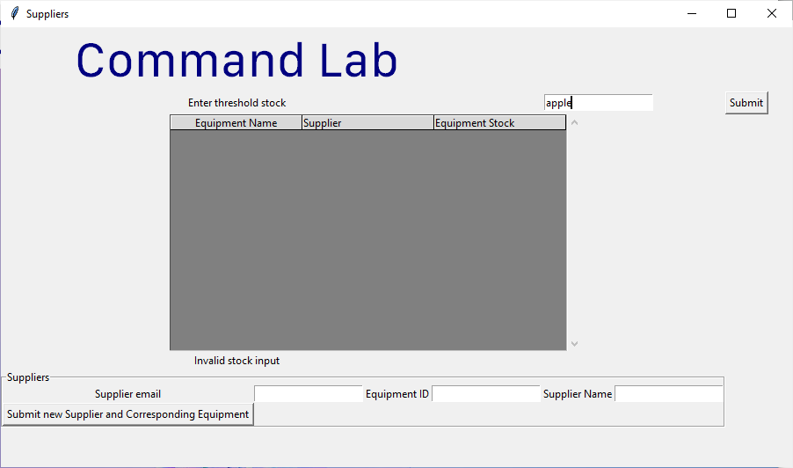Displays error message

Test 39:

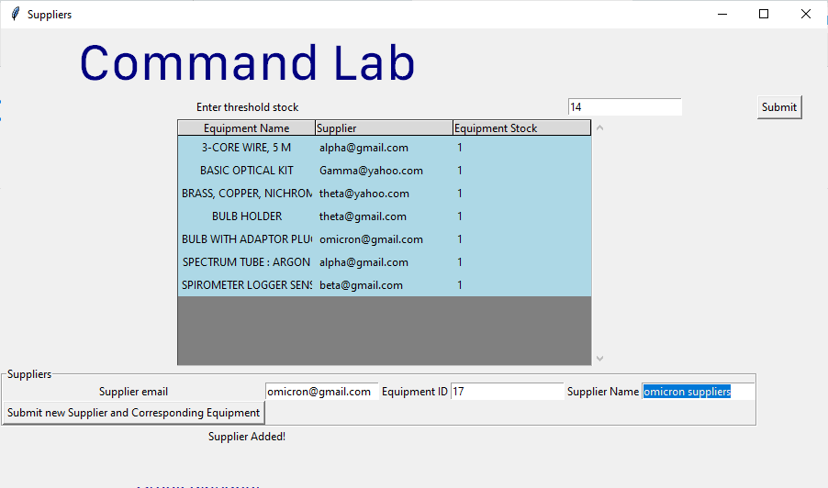

Correctly added

Test 40:

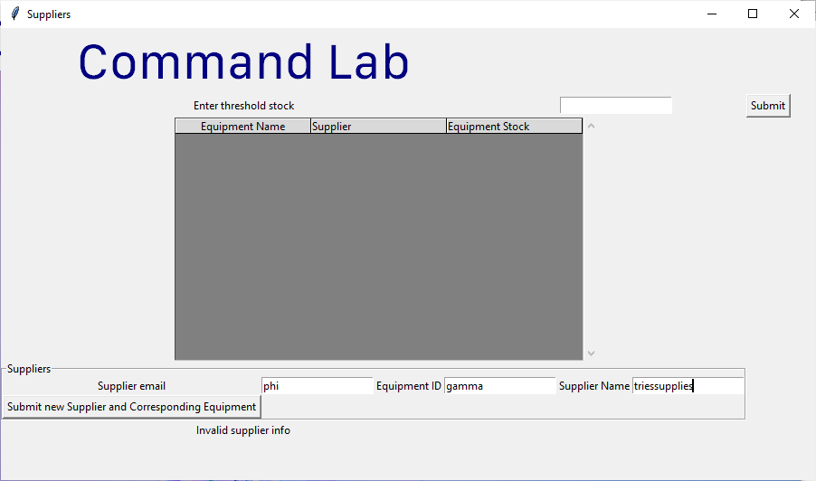

Test 41:

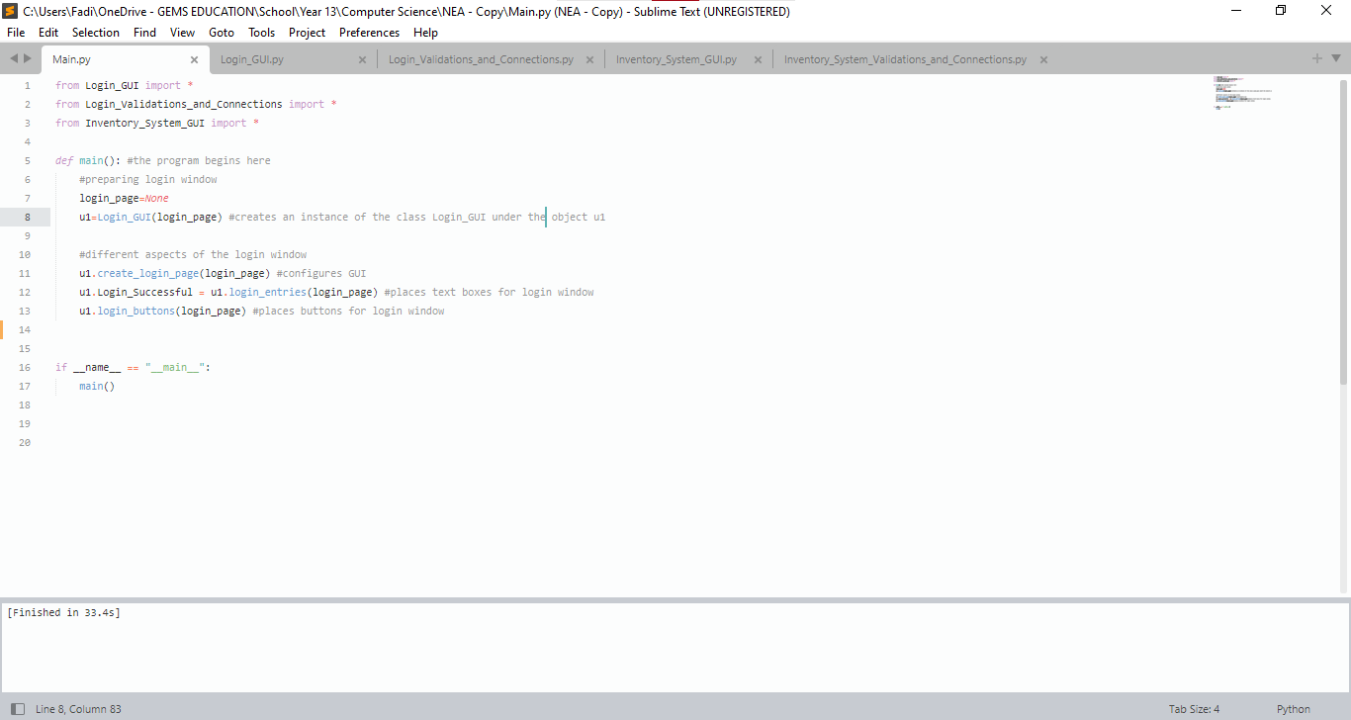This is the program file. When it is run, it automatically loads up the login page:

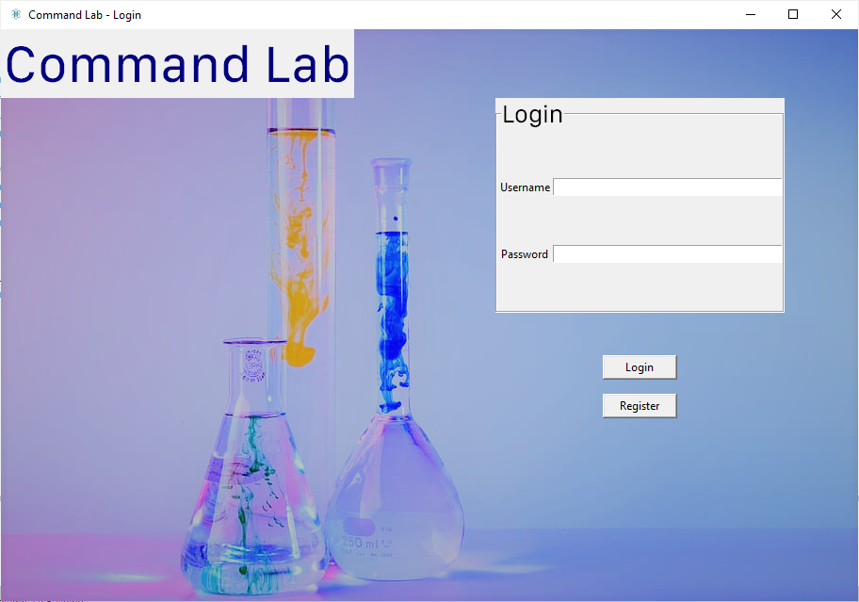

Test 42:

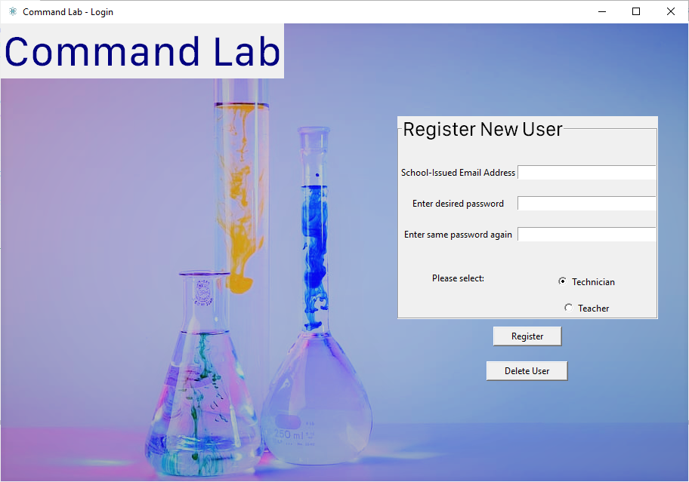

Successfully redirects to the registation page.

Test 43:

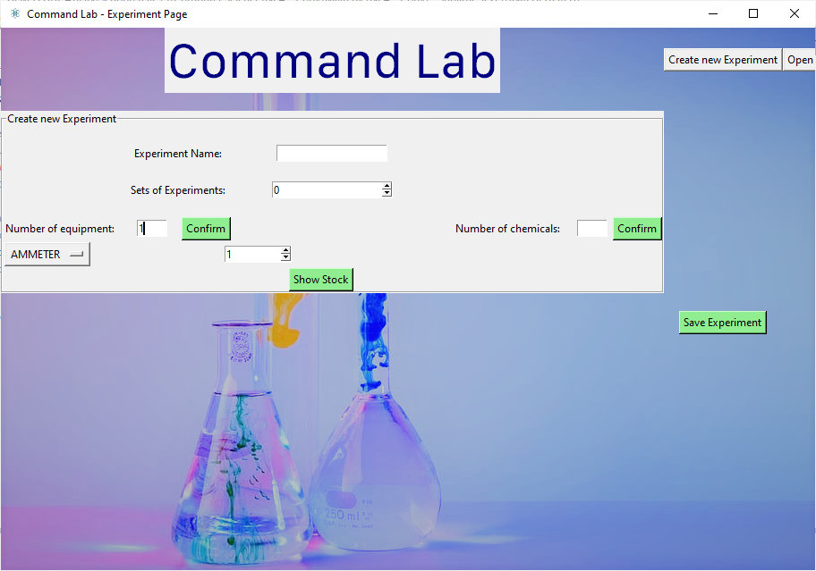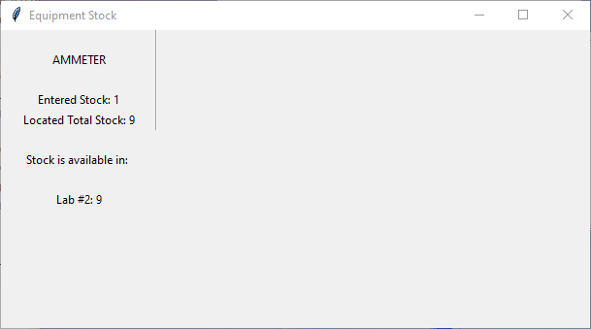

Successfully opens window with breakdown of stock locations and total stock available in inventory.

# 4. Technical Solution

## 4.1 Tables and Relationships

Creating Users Table

conn = sqlite3.connect("Command_Lab.db") *#creates or connects to the Command_Lab database*

c=conn.cursor() *#creates cursor to open connection to database*

c.execute("""CREATE TABLE if not exists Users (

username text primary key,

salt text,

hash_key text,

email text,

teacher_or_technician integer

)""") *#this is the command that will be executed*

conn.commit() *#commits changes so that the create table statement is executed within the database*

conn.close() *#closes connection to database*

Creating Equipment Table

conn = sqlite3.connect("Command_Lab.db") *#creates or connects to the database*

c=conn.cursor() *#creates cursor to open connection to database*

c.execute("""CREATE TABLE if not exists Equipment (

Equipment_Name STRING,

Consumable INTEGER,

Equipment_ID INTEGER PRIMARY KEY AUTOINCREMENT)""") *#this is the command that will be executed*

conn.commit() *#commits changes so that the create table statement is executed within the database*

conn.close() *#closes connection to database*

Creating Chemicals Table

conn = sqlite3.connect("Command_Lab.db") *#creates or connects to the database*

c=conn.cursor() *#creates cursor to open connection to database*

c.execute("""CREATE TABLE if not exists Chemicals (

Chemical_Name STRING,

Chemical_Stock DECIMAL,

Chemical_ID INTEGER PRIMARY KEY AUTOINCREMENT)""") *#this is the command that will be executed*

conn.commit() *#commits changes so that the create table statement is executed within the database*

conn.close() *#closes connection to database*

Creating Equipment_Location table

conn = sqlite3.connect("Command_Lab.db") *#creates or connects to the database*

c=conn.cursor() *#creates cursor to open connection to database*

c.execute("""CREATE TABLE if not exists Equipment_Location (

Location_ID INTEGER,

Equipment_ID INTEGER REFERENCES Equipment (Equipment_ID),

Equipment_Stock DECIMAL,

PRIMARY (Equipment_ID, Location_ID)""") *#this is the command that will be executed*

conn.commit() *#commits changes so that the create table statement is executed within the database*

conn.close() #closes connection to database

Creating Equipment_Science table

conn = sqlite3.connect("Command_Lab.db") *#creates or connects to the database*

c=conn.cursor() *#creates cursor to open connection to database*

c.execute("""CREATE TABLE if not exists Equipment_Science (

Science INTEGER,

Equipment_ID INTEGER REFERENCES Equipment (Equipment_ID)""") *#this is the command that will be executed*

conn.commit() *#commits changes so that the create table statement is executed within the database*

conn.close() #closes connection to database

Creating Equipment_Supplier

conn = sqlite3.connect("Command_Lab.db") *#creates or connects to the database*

c=conn.cursor() *#creates cursor to open connection to database*

c.execute("""CREATE TABLE Experiment_Supplier (

Equipment_ID INTEGER REFERENCES Equipment (Equipment_ID),

Supplier_Email STRING REFERENCES Supplier_Details (Supplier_Email)""") *#this is the command that will be executed*

conn.commit() *#commits changes so that the create table statement is executed within the database*

conn.close() #closes connection to database

Creating Experiment_Chemicals

conn = sqlite3.connect("Command_Lab.db") *#creates or connects to the database*

c=conn.cursor() *#creates cursor to open connection to database*

c.execute("""CREATE TABLE Experiment_Chemicals (

Experiment_ID INTEGER REFERENCES Experiment_Sets (Experiment_ID),

Chemical_ID INTEGER REFERENCES Chemicals (Chemical_ID),

Chemical_Amount DECIMAL,

PRIMARY KEY (

Experiment_ID,

Chemical_ID

)""") *#this is the command that will be executed*

conn.commit() *#commits changes so that the create table statement is executed within the database*

conn.close() *#closes connection to database*

Creating Experiment_Equipment

conn = sqlite3.connect("Command_Lab.db") *#creates or connects to the database*

c=conn.cursor() *#creates cursor to open connection to database*

c.execute("""CREATE TABLE Experiment_Equipment (

Experiment_ID INTEGER REFERENCES Experiment_Sets (Experiment_ID),

Equipment_ID REFERENCES Equipment (Equipment_ID),

Equipment_Amount DECIMAL,

PRIMARY KEY (

Experiment_ID,

Equipment_ID

)""") *#this is the command that will be executed*

conn.commit() *#commits changes so that the create table statement is executed within the database*

conn.close() *#closes connection to database*

Creating Experiment_Sets table

conn = sqlite3.connect("Command_Lab.db") *#creates or connects to the database*

c=conn.cursor() *#creates cursor to open connection to database*

c.execute("""CREATE TABLE Experiment_Sets (

Experiment_ID INTEGER PRIMARY KEY AUTOINCREMENT,

Experiment_Name STRING,

Experiment_Sets INTEGER""") *#this is the command that will be executed*

conn.commit() *#commits changes so that the create table statement is executed within the database*

conn.close() *#closes connection to database*

Creating Supplier_Details table

conn = sqlite3.connect("Command_Lab.db") *#creates or connects to the database*

c=conn.cursor() *#creates cursor to open connection to database*

c.execute("""CREATE TABLE Supplier_Details (

Supplier_Email STRING PRIMARY KEY,

Supplier_Name STRING""") *#this is the command that will be executed*

conn.commit() *#commits changes so that the create table statement is executed within the database*

conn.close() *#closes connection to database*

## 4.2 System Overview

### 4.2.1 System Overview Diagram

This is the system overview diagram

### 4.2.3 Class Diagram

As the classes have not been changed from the design section, the same class diagrams will be utilized below from the design section.

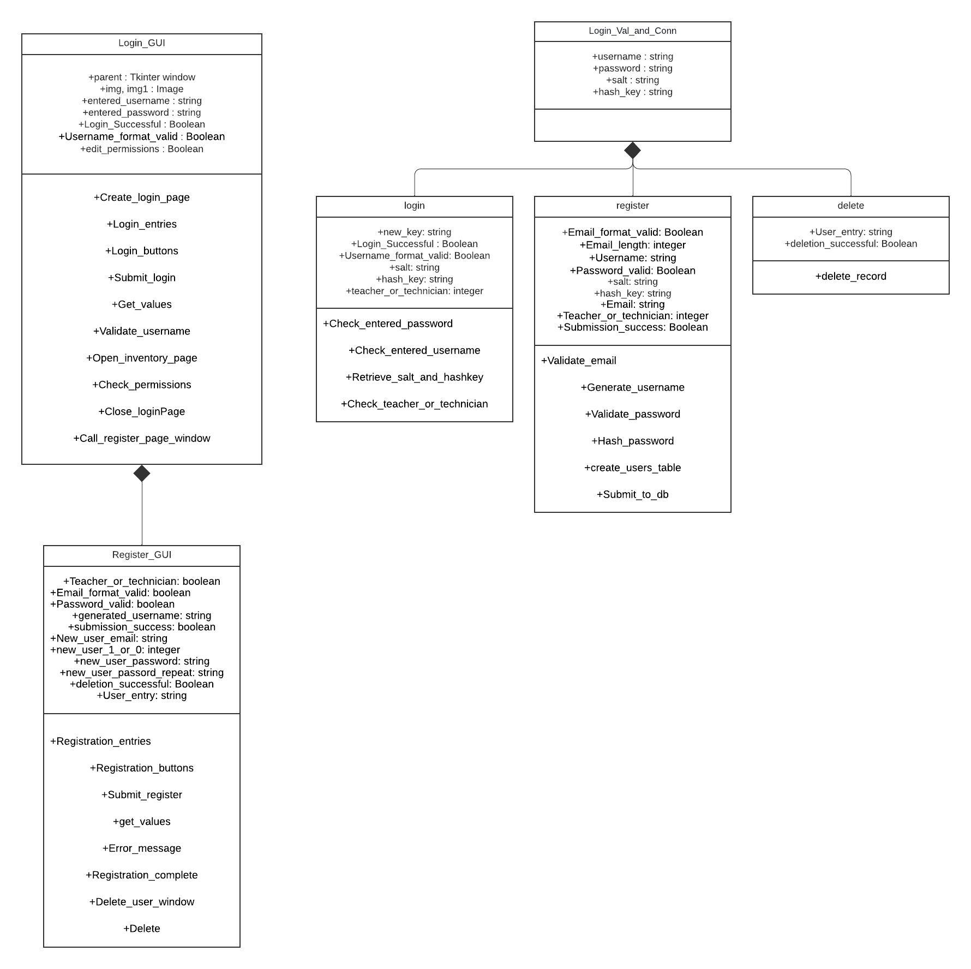

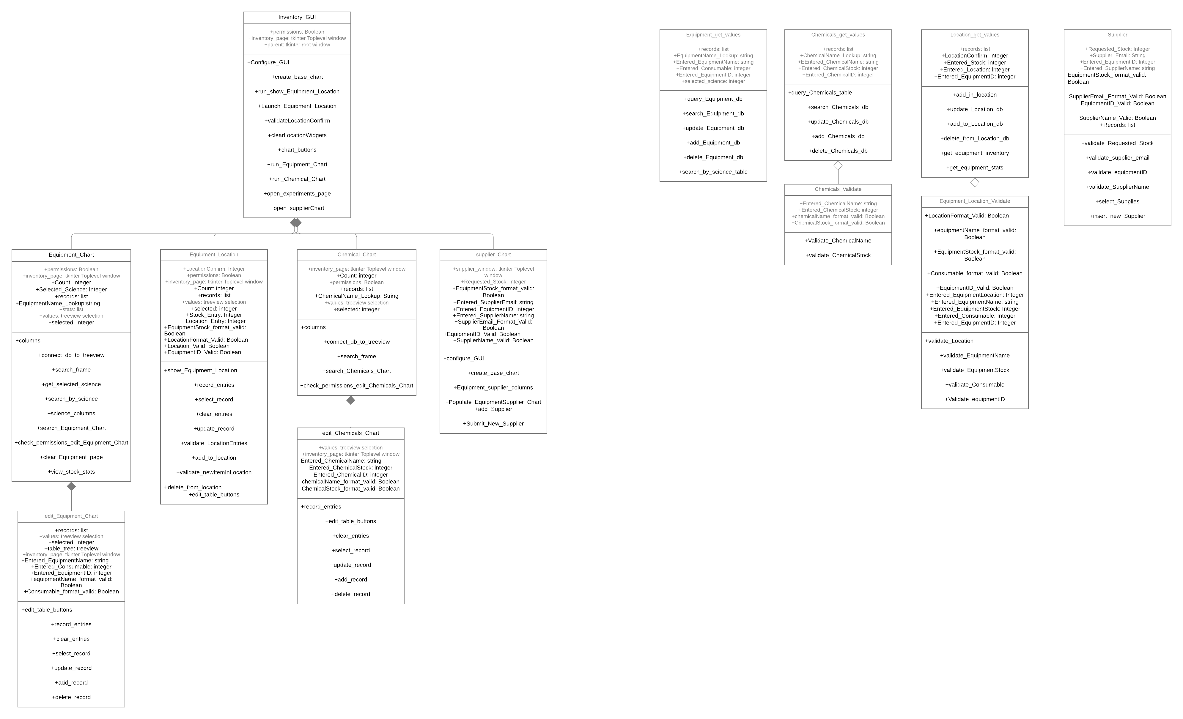

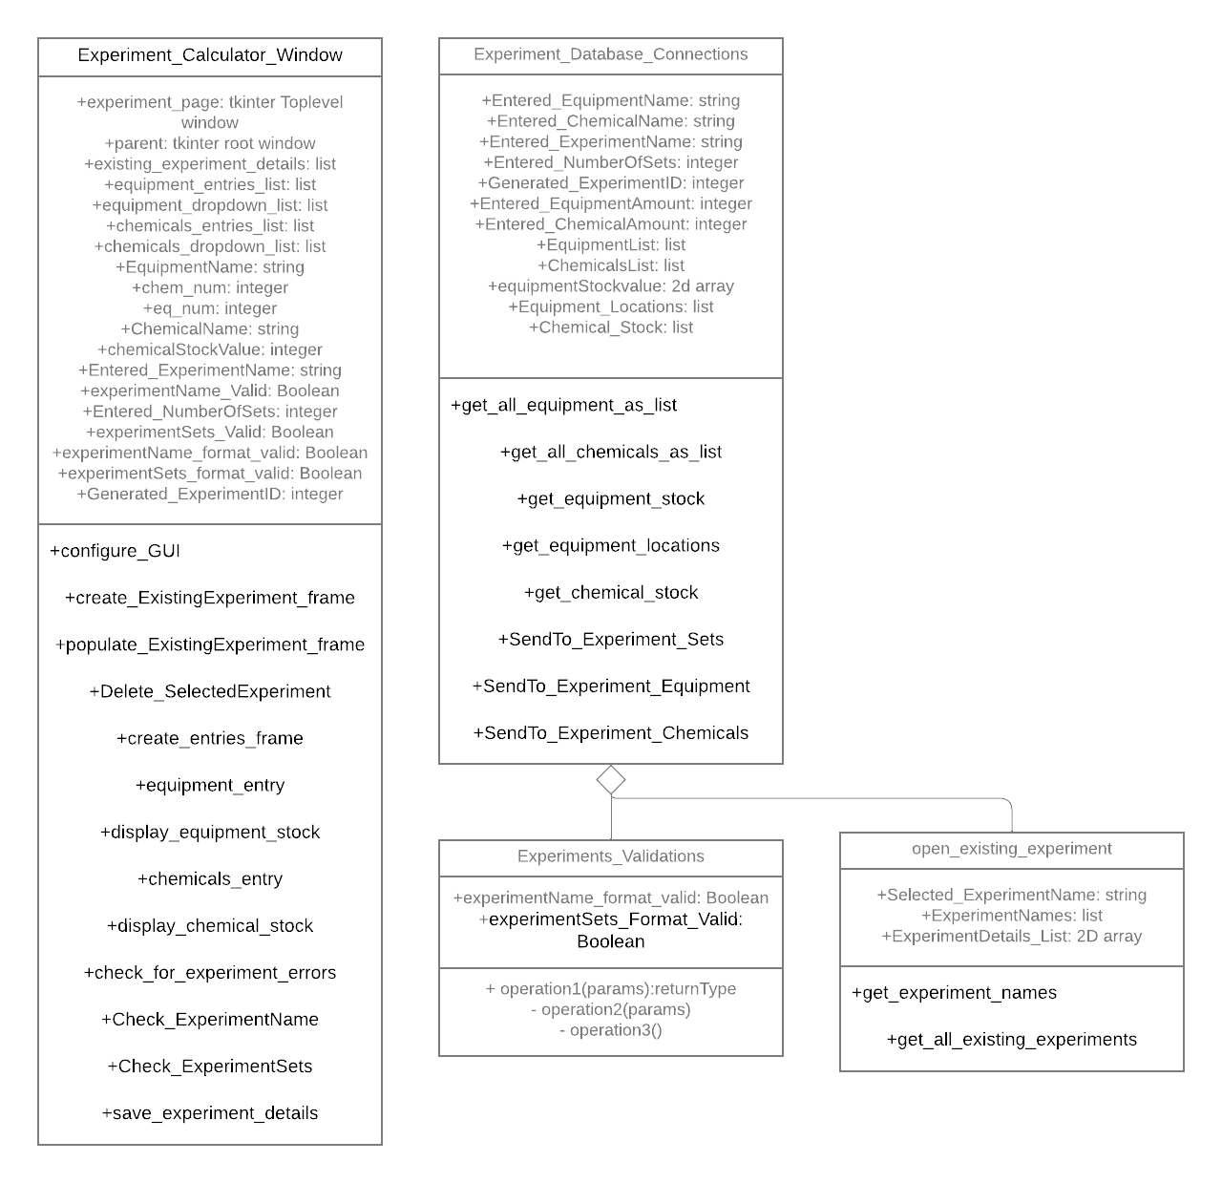

3





## 4.3 Code and UI

### 4.3.1 Main.py

**from** **Login_GUI** **import** *

**from** **Login_Validations_and_Connections** **import** *

**from** **Inventory_System_GUI** **import** *

**def** main(): *#the program begins here*

*#preparing login window*

login_page=None

u1=Login_GUI(login_page) *#creates an instance of the class Login_GUI under the object u1*

*#different aspects of the login window*

u1.create_login_page(login_page) *#configures GUI*

u1.Login_Successful = u1.login_entries(login_page) *#places text boxes for login window*

u1.login_buttons(login_page) *#places buttons for login window*

**if** __name__ == "__main__":

main()

### 4.3.2 Login_GUI.py

Code

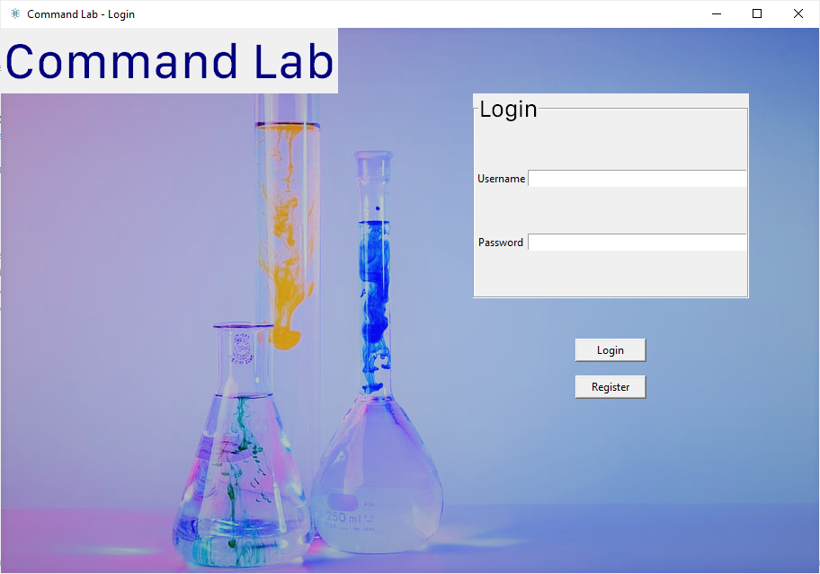

submit_login

call_register_page_window

login_entries

*#login_page and register_page section*

*#GUI section*

**from** **tkinter** **import** * *#imports tkinter library for GUI*

**from** **PIL** **import** ImageTk, Image

**from** **tkinter.font** **import** Font

*#imports Validations and Connections python functions*

**from** **Login_Validations_and_Connections** **import** *

**from** **Inventory_System_GUI** **import** *

**class** **Login_GUI**:

**def** __init__(self,parent):

login_page=Tk() *#creates the tkinter root window, from which all the other tkinter components are managed*

self.parent=login_page *#creates an instance of the class using the root tkinter window that can be accessed throughout the class*

**def** create_login_page(self, login_page):

*#initialises main module for login_page window*

self.parent.title("Command Lab - Login") *#sets title of the window*

self.parent.iconbitmap("logo.ico") *#sets icon of the window*

self.parent.geometry("910x607") *#sets size of login_page window as that of background image*

*#inserts image in background of main window*

**global** img

img=ImageTk.PhotoImage(file='img1.png') *#defined the background image*

back_label = Label(login_page, image=img) *#created a label for image*

back_label.place(x=0, y=0, relheight=1, relwidth=1) *#positioned image at the top left*

*#title text*

self.title_font = Font(family = "SF Compact Text", size=42)

self.title_text = Label(login_page, text="Command Lab", fg="navy blue", font=self.title_font)

self.title_text.grid(row=0, column=0, padx=(0,150))

**def** login_entries(self, login_page):

*#sets title for login frame*

self.login_text_font = Font(family = "SF Compact Display", size = 20)

self.login_frame = LabelFrame(login_page, text="Login", font=self.login_text_font)

self.login_frame.grid(row=1, column=1)

*#creates labels for username and password entry boxes*

self.u_name_label = Label(self.login_frame, text="Username")

self.u_name_label.grid(row=2, column=0, pady=(50,0))

self.p_name_label = Label(self.login_frame, text = "Password")

self.p_name_label.grid(row=3, column=0, pady=(50,50))

*#creates text boxes for username and password for login_page*

self.u_name = Entry(self.login_frame, width=40) *#username*

self.u_name.grid(row=2, column=2, pady=(50,0))

self.p_name = Entry(self.login_frame, width=40) *#password*

self.p_name.grid(row=3, column=2, pady=(50,50))

**def** login_buttons(self, login_page):

self.Login_Successful="" *#initializes the value of Login_Successful variable as blank. This will then be populated with whether the login was successful, so that the user can open the inventory page.*

*#creates submit button*

self.submit_button = Button(self.parent, text = "Login", command = **lambda**: self.Login_Successful == self.submit_login(), padx=20) *#this button calls the submit_login function*

self.submit_button.grid(row=3, column=1, pady=(45,15))

*#creates register button*

self.register_button = Button(self.parent, text = "Register", command= self.call_register_page_window, padx=14) *#this button calls the register_page_window*

self.register_button.grid(row=4, column=1)

**try**:

self.parent.mainloop() *#this encloses the root window's widgets*

**except**:

**pass**

**return** self.Login_Successful

**def** submit_login(self): *#this function is called from the above login button*

**try**: *#if there is an existing error response label, program destroys the label.*

self.Response_Label.destroy()

self.UsernameResponse_Label.destroy()

**except**:

**pass**

*#this is where the user's input are being checked*

self.entered_username, self.entered_password = self.get_values() *# getting the values in the password and username entries by calling the get_values function*

u2=self.validate_username() *#calls the validate username function to see if the user's input is valid and to check whether the username exists*

**try**: *#this part attempts to check the password. If any part of this process fails, including checking validity as well as existence of password, then the login is failed*

u2.salt, u2.hash_key = u2.retrieve_salt_and_hashkey(self.entered_username) *#calls and gets the values of the salt and hash key that matches the username entered by the user*

self.Login_Successful = u2.check_entered_password(self.entered_password, u2.salt, u2.hash_key) *#compares it with the existing salt and hash key associated with the username in the database*

**except**:

self.Login_Successful = False *#otherwise, the login fails*

**if** self.Login_Successful == False: *#outputs an appropriate error message*

self.Response_Label = Label(self.login_frame, text="Login Unsuccessful")

self.Response_Label.grid(row=4,column=0)

*#clears the entries for the username and password*

self.u_name.delete(0,END)

self.p_name.delete(0,END)

self.open_inventory_page(self.Login_Successful) *#calls the inventory page function to attempt to launch, based on whether the login was successful*

**return** self.Login_Successful

**def** get_values(self): *#this function is called to return the values in the username and password entries*

**try**:

self.entered_username = self.u_name.get()

self.entered_password = self.p_name.get()

**except**:

**pass**

**return** self.entered_username, self.entered_password *#returns the values of the username and password*

**def** validate_username(self): *#this function is to validate the username*

*#creates an instance of the login class in the LOgin_Validations_and_Connections file*

u2=login(self.entered_username, "", "", "", "", self.entered_password) *#passes in the values that were returned from the get_values function*

u2.Username_format_valid=u2.check_entered_username(self.entered_username) *#calls the check_entered_username function to check the input's validity*

**if** u2.Username_format_valid == False:

self.UsernameResponse_Label = Label(self.login_frame, text="Username invalid") *#displays an error message to the user*

self.UsernameResponse_Label.grid(row=5,column=0)

**return** u2

**def** open_inventory_page(self, Login_Successful):

**if** self.Login_Successful == True: *#checks whether Login_Successful variable is true*

self.teacher_or_technician = self.check_permissions() *#gets the value of the teacher_or_technician for the specific user logging in*

self.close_LoginPage()

u2=Inventory_GUI(self.parent, self.teacher_or_technician)

u2.configure_GUI()

u2.chart_buttons()

**def** check_permissions(self):

u2=login(self.entered_username, "", "", "", "", "") *#creates another instance of the login class, passing in the entered username*

*#calls the function check_teacher_or_technician to check whether the user logged in is a teacher or technician*

u2.teacher_or_technician = u2.check_teacher_or_technician (self.entered_username)

**if** u2.teacher_or_technician == 0: *#if they are a technician, they get access to editing controls of database*

self.edit_permissions=True

**else**:

self.edit_permissions=False *#else, teachers have viewing access to the database*

**return** self.edit_permissions

**def** close_LoginPage(self):

self.parent.withdraw()

**def** call_register_page_window(self):

*#clear the page to get ready for registration menu*

self.login_frame.destroy()

self.u_name_label.destroy()

self.p_name_label.destroy()

self.u_name.destroy()

self.p_name.destroy()

self.submit_button.destroy()

self.register_button.destroy()

new_u1 = Register_GUI(self.parent) *#creates an instance of the child class Register GUI*

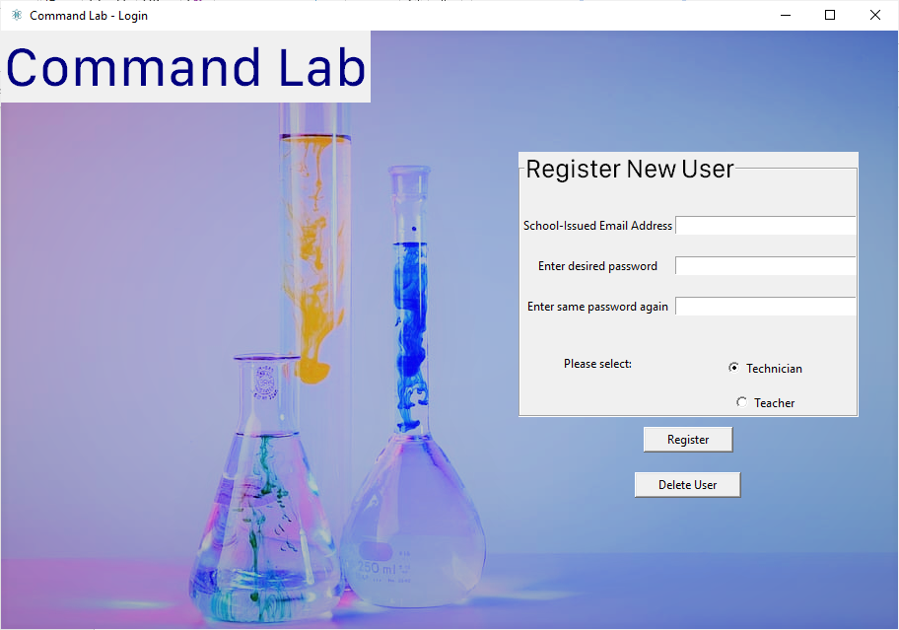

Delete_user_window

submit_register

registration_entries

**class** **Register_GUI**(Login_GUI):

**def** __init__(self, parent):

self.parent=parent

self.registration_entries(self.parent) *#calls the function that displays the entries in the registration window*

self.registration_buttons(self.parent) *#calls the function that displays the buttons in the registration window*

**def** registration_entries(self, parent):

*#creates a frame to visually separate different sections*

self.register_text_font = Font(family = "SF Compact Display", size = 20)

self.register_frame=LabelFrame(self.parent, text="Register New User", font=self.register_text_font)

self.register_frame.grid(row=1, column=2, pady=(50,0))

*#creates labels for entry optionsself.*

self.email_label = Label(self.register_frame, text="School-Issued Email Address")

self.email_label.grid(row=1, column=2, pady=(30,0))

self.password_label = Label(self.register_frame, text="Enter desired password")

self.password_label.grid(row=2, column=2, pady=(20,0))

self.password_repeat_label = Label(self.register_frame, text="Enter same password again")

self.password_repeat_label.grid(row=3, column=2, pady=(20,0))

self.teacher_or_technician = Label(self.register_frame, text="Please select:")

self.teacher_or_technician.grid(row=4, column=2, pady=(20,0))

*#creates text boxes for entries*

self.email=Entry(self.register_frame, width=30)

self.email.grid(row=1, column=3, pady=(30,0))

self.password=Entry(self.register_frame, width=30)

self.password.grid(row=2, column=3, pady=(20,0))

self.password_repeat=Entry(self.register_frame, width=30)

self.password_repeat.grid(row=3, column=3, pady=(20,0))

*#uses radio buttons for user to select whether teacher or technician*

self.r=IntVar()

self.r1=Radiobutton(self.register_frame, text="Technician", variable=self.r, value=0)

self.r1.grid(row=4, column=3, pady=(40,10))

self.r2=Radiobutton(self.register_frame, text="Teacher", variable=self.r, value=1)

self.r2.grid(row=5, column=3)

**def** registration_buttons(self, parent):

*#submit button*

self.register_button = Button(self.parent, text = "Register", command= **lambda**: self.submit_register(parent), padx=20) *#calls the function submit_register when the registration process is called*

self.register_button.grid(row=2, column=2, pady=10)

self.delete_button = Button(self.parent, text="Delete User", command=self.delete_user_window, padx=20) *#this button redirects you to the delete user window*

self.delete_button.grid(row=3, column=2, pady=10)

**def** submit_register(self, parent):

*#these are the functions that the button calls, one by one*

self.new_user_email, self.new_user_1_or_0, self.new_user_password, self.new_user_passord_repeat = self.get_values(parent) *#calls the function to get the entry values in the child class*

new_u1 = register("", self.new_user_email, self.new_user_1_or_0, self.new_user_password, self.new_user_passord_repeat, "", "") *#calls the function to create first instance of register in the Login_Validations_and_Connections file*

self.Email_Format_Valid = new_u1.validate_email(self.new_user_email) *#checks whether the formatting of the email entered by the user is valid*

self.Password_Valid = new_u1.validate_password(self.new_user_password, self.new_user_passord_repeat) *#checks whether the formatting of the password entered by the user is valid*

**if** self.Password_Valid **and** self.Email_Format_Valid == True: *#if all entries match formatting...*

self.salt, self.hash_key = new_u1.hash_password(self.new_user_password) *#calls hash function to hash the password and stores results in 'salt' and 'hash'*

self.generated_username=new_u1.generate_username(self.new_user_email) *#generates username from the user's email by truncating email domain*

new_u1.create_users_table() *#tries to create a table. If it fails, this means that a table already exists and the function simply passes along*

self.submission_success=new_u1.submit_to_db() *#submits entries to the database*

**else**:

new_u1.create_users_table() *#tries to create a table. If it fails, this means that a table already exists and the function simply passes along*

self.submission_success=""

self.error_message(self.Email_Format_Valid, self.Password_Valid, self.submission_success)

**if** self.submission_success==True:

self.registration_complete(self.parent, self.generated_username)

**else**:

**pass**

**return** new_u1

**def** get_values(self, parent):

*#gets values entered in text boxes*

self.new_user_email=self.email.get()

*#gets user input on whether new user is a technician or teacher*

self.new_user_1_or_0=self.r.get()

self.new_user_password=self.password.get()

self.new_user_passord_repeat=self.password_repeat.get()

**return** self.new_user_email, self.new_user_1_or_0, self.new_user_password, self.new_user_passord_repeat

**def** error_message(self, Email_Format_Valid, Password_Valid, submission_success): *#this function is called to display an appropriate error message based on the error*

**if** self.Email_Format_Valid == False: *#if the email entered has incorrect formatting, then this message is displayed*

self.Email_error_message=Label(self.register_frame, text="Email format invalid", fg="red")

self.Email_error_message.grid(row=7, column=3)

self.email.delete(0, END) *#clears the email entry*

**else**:

**try**:

self.Email_error_message.destroy() *#if an existing error message exists, then it should be destroyed if the formatting is valid*

**except**:

**pass**

**if** self.Password_Valid == False: *#if the password entered has incorrect formatting, then this message is displayed*

self.password_error_message=Label(self.register_frame, text="Password too short OR does not match", fg="red")

self.password_error_message.grid(row=8, column=3)

self.password.delete(0, END)

self.password_repeat.delete(0,END) *#clears the password entry*

**else**:

**try**:

self.Password_error_message.destroy() *#if an existing error message exists, then it should be destroyed if the formatting is valid*

**except**:

**pass**

**if** self.submission_success == False: *#if the user already exists in the database, this error message is displayed*

self.registration_error_message=Label(self.register_frame, text="User already exists", fg="red")

self.registration_error_message.grid(row=6, column=3)

**else**:

**try**:

self.registration_error_message.destroy() *#if an existing error message exists, then it should be destroyed if the formatting is valid*

**except**:

**pass**



registration_complete

*#Register_GUI is the window that allows to register a new user*

**class** **Register_GUI**(Login_GUI):

**def** __init__(self, parent):

self.parent=parent

self.registration_entries(self.parent) *#calls the function that displays the entries in the registration window*

self.registration_buttons(self.parent) *#calls the function that displays the buttons in the registration window*

**def** registration_entries(self, parent):

*#creates a frame to visually separate different sections*

self.register_text_font = Font(family = "SF Compact Display", size = 20)

self.register_frame=LabelFrame(self.parent, text="Register New User", font=self.register_text_font)

self.register_frame.grid(row=1, column=2, pady=(50,0))

*#creates labels for entry optionsself.*

self.email_label = Label(self.register_frame, text="School-Issued Email Address")

self.email_label.grid(row=1, column=2, pady=(30,0))

self.password_label = Label(self.register_frame, text="Enter desired password")

self.password_label.grid(row=2, column=2, pady=(20,0))

self.password_repeat_label = Label(self.register_frame, text="Enter same password again")

self.password_repeat_label.grid(row=3, column=2, pady=(20,0))

self.teacher_or_technician = Label(self.register_frame, text="Please select:")

self.teacher_or_technician.grid(row=4, column=2, pady=(20,0))

*#creates text boxes for entries*

self.email=Entry(self.register_frame, width=30)

self.email.grid(row=1, column=3, pady=(30,0))

self.password=Entry(self.register_frame, width=30)

self.password.grid(row=2, column=3, pady=(20,0))

self.password_repeat=Entry(self.register_frame, width=30)

self.password_repeat.grid(row=3, column=3, pady=(20,0))

*#uses radio buttons for user to select whether teacher or technician*

self.r=IntVar()

self.r1=Radiobutton(self.register_frame, text="Technician", variable=self.r, value=0)

self.r1.grid(row=4, column=3, pady=(40,10))

self.r2=Radiobutton(self.register_frame, text="Teacher", variable=self.r, value=1)

self.r2.grid(row=5, column=3)

**def** registration_buttons(self, parent):

*#submit button*

self.register_button = Button(self.parent, text = "Register", command= **lambda**: self.submit_register(parent), padx=20) *#calls the function submit_register when the registration process is called*

self.register_button.grid(row=2, column=2, pady=10)

self.delete_button = Button(self.parent, text="Delete User", command=self.delete_user_window, padx=20) *#this button redirects you to the delete user window*

self.delete_button.grid(row=3, column=2, pady=10)

**def** submit_register(self, parent):

*#these are the functions that the button calls, one by one*

self.new_user_email, self.new_user_1_or_0, self.new_user_password, self.new_user_passord_repeat = self.get_values(parent) *#calls the function to get the entry values in the child class*

new_u1 = register("", self.new_user_email, self.new_user_1_or_0, self.new_user_password, self.new_user_passord_repeat, "", "") *#calls the function to create first instance of register in the Login_Validations_and_Connections file*

self.Email_Format_Valid = new_u1.validate_email(self.new_user_email) *#checks whether the formatting of the email entered by the user is valid*

self.Password_Valid = new_u1.validate_password(self.new_user_password, self.new_user_passord_repeat) *#checks whether the formatting of the password entered by the user is valid*

**if** self.Password_Valid **and** self.Email_Format_Valid == True: *#if all entries match formatting...*

self.salt, self.hash_key = new_u1.hash_password(self.new_user_password) *#calls hash function to hash the password and stores results in 'salt' and 'hash'*

self.generated_username=new_u1.generate_username(self.new_user_email) *#generates username from the user's email by truncating email domain*

new_u1.create_users_table() *#tries to create a table. If it fails, this means that a table already exists and the function simply passes along*

self.submission_success=new_u1.submit_to_db() *#submits entries to the database*

**else**:

new_u1.create_users_table() *#tries to create a table. If it fails, this means that a table already exists and the function simply passes along*

self.submission_success=""

self.error_message(self.Email_Format_Valid, self.Password_Valid, self.submission_success)

**if** self.submission_success==True:

self.registration_complete(self.parent, self.generated_username)

**else**:

**pass**

**return** new_u1

**def** get_values(self, parent):

*#gets values entered in entry boxes*

self.new_user_email=self.email.get()

*#gets user input on whether new user is a technician or teacher*

self.new_user_1_or_0=self.r.get()

self.new_user_password=self.password.get()

self.new_user_passord_repeat=self.password_repeat.get()

**return** self.new_user_email, self.new_user_1_or_0, self.new_user_password, self.new_user_passord_repeat

**def** error_message(self, Email_Format_Valid, Password_Valid, submission_success): *#this function is called to display an appropriate error message based on the error*

**if** self.Email_Format_Valid == False: *#if the email entered has incorrect formatting, then this message is displayed*

self.Email_error_message=Label(self.register_frame, text="Email format invalid", fg="red")

self.Email_error_message.grid(row=7, column=3)

self.email.delete(0, END) *#clears the email entry*

**else**:

**try**:

self.Email_error_message.destroy() *#if an existing error message exists, then it should be destroyed if the formatting is valid*

**except**:

**pass**

**if** self.Password_Valid == False: *#if the password entered has incorrect formatting, then this message is displayed*

self.password_error_message=Label(self.register_frame, text="Password too short OR does not match**\n**Password must have one lower case, one upper case, **\n**one special character, and one number", fg="red")

self.password_error_message.grid(row=8, column=2, columnspan=2)

self.password.delete(0, END)

self.password_repeat.delete(0,END) *#clears the password entry*

**else**:

**try**:

self.Password_error_message.destroy() *#if an existing error message exists, then it should be destroyed if the formatting is valid*

**except**:

**pass**

**if** self.submission_success == False: *#if the user already exists in the database, this error message is displayed*

self.registration_error_message=Label(self.register_frame, text="User already exists", fg="red")

self.registration_error_message.grid(row=6, column=3)

**else**:

**try**:

self.registration_error_message.destroy() *#if an existing error message exists, then it should be destroyed if the formatting is valid*

**except**:

**pass**

**def** registration_complete(self, parent, generated_username):

*#clears out window*

self.email_label.destroy()

self.password_label.destroy()

self.password_repeat_label.destroy()

self.teacher_or_technician.destroy()

self.email.destroy()

self.password.destroy()

self.password_repeat.destroy()

self.r1.destroy()

self.r2.destroy()

self.register_button.destroy()

*#registration explanation text*

self.register_text_font = Font(family = "SF Compact Display", size = 10)

self.register_text = Label(self.register_frame, text = "Registration Complete", font=self.register_text_font)

self.register_text.grid(row=0, column=0)

self.text_message= "Username: " + self.generated_username + "**\n**Password: "+ self.new_user_password *#displays the generated username and password to the user for safekeeping*

self.explanation_text = Label(self.register_frame, text = self.text_message)

self.explanation_text.grid(row=1, column=3)

**def** delete_user_window(self): *#this is the window that deletes a user from the database*

**def** delete():

user=user_entry.get() *#gets the value in the username entry on the delete user window*

u1=Delete_User(user) *#creates an instance of the class Delete_User that deletes the user*

self.deletion_successful=u1.delete_record() *#deletes the record*

**if** self.deletion_successful==True:

deletion_complete = Label(delete_user_page, text = "Deletion Complete")

deletion_complete.grid(row=3, column=0, pady=(100,0))

**else**:

deletion_complete = Label(delete_user_page, text = "Deletion Failed")

deletion_complete.grid(row=3, column=0, pady=(100,0))

delete_user_page = Toplevel() *#creates a window that lies above the registration window*

delete_user_page.title("Command Lab - Delete User")

delete_user_page.iconbitmap("logo.ico")

delete_user_page.geometry("500x400") *#sets size of delete_user_page window as that of background image*

**global** img2

img2=ImageTk.PhotoImage(file='img1.png') *#defined the background image*

back2_label = Label(delete_user_page, image=img2) *#created a label for image*

back2_label.place(x=0, y=0, relheight=1, relwidth=1) *#positioned image at the top left*

*#title text of delete_user_page*

title_font = Font(family = "SF Compact Text", size=42)

title_text = Label(delete_user_page, text="Command Lab", fg="navy blue", font=title_font)

title_text.grid(row=0, column=0, padx=(0,50))

user_text = Label(delete_user_page, text = "Enter user you wish to delete:")

user_text.grid(row=1, column=0, pady=(100,0))

user_entry=Entry(delete_user_page, width=30) *#this is the entry in which the user enters which user they wish to delete.*

user_entry.grid(row=2, column=0, pady=(50,0))

delete_button = Button(delete_user_page, text="Delete User", command=delete, padx=20) *#this button calls the delete function above*

delete_button.grid(row=7, column=0, pady=10)

delete_user_page.mainloop()

Procedures and Variables

|  |  |  |
| --- | --- | --- |
| Login_GUI – This class holds the procedures for the GUI and calls to the Login_Validations_and_Connections file for data processing | | |
| Global Variables | Img, img1 *(these are for the background of the GUI for the login, register, and delete windows)* | |
| Procedures | Purpose | Variables |
| Create_login_page | Initializes the title and background for the login and register page | Self.parent  Img  Title_font |
| Login_entries | Displays the username and password entry boxes for the login window | Login_text_font  Login_frame  U_name_label  P_name_label  U_name  P_name |
| Login_buttons | Sets the value for the Login_Successful as blank.  Displays login and register buttons | Login_Successful  Submit_button  Register_button |
| Submit_login | When called from the Login button, the username and password are validated and then cross-checked with the database.  Outputs an error message if an error is encountered | Response_Label |
| Get_values | Returns the values in the username and password entries when called | Entered_username  Entered_password |
| Validate_username | Calls external check_entered_username function to validate the entered username.  Outputs an appropriate error message for the username | Username_format_valid  UsernameResponse_Label |
| Open_inventory_page | Creates an instance of the Inventory_GUI class and then calls the functions associated with initializing the Inventory window |  |
| Check_permissions | This function returns the teacher_or_technician variable associated with the user’s entered username and outputs their corresponding edit permissions | Edit_permissions |
| Close_loginPage | Withdraws the login page window when called |  |
| Call_register_page_window | Destroys all the elements associated with the login window and creates an instance of the Register_GUI child class |  |

|  |  |  |
| --- | --- | --- |
| Register_GUI – This class holds the procedures for the register window’s GUI and calls to the Login_Validations_and_Connections file for data processing | | |
| Procedures | Purpose | Variables |
| Registration_entries | Displays the username, password, repeat password entry boxes for registration | Register_frame  Email_label  Password_label  Password_repeat_label  Teacher_or_technician  Email  Password  Password_repeat  R1, r2 (radio buttons for teacher/technician) |
| Registration_buttons | Displays the register and delete user button | Register_button  Delete_button |
| Submit_register | When called from the register_button, it will call the associated functions to validate, verify and the user’s input to the database | Email_format_valid  Password_valid  generated_username  submission_success |
| get_values | Gets and returns values entered in register window entry boxes | New_user_email  new_user_1_or_0  new_user_password  new_user_passord_repeat |
| Error_message | Displays the appropriate error message based on where the error originates from in the registration process | Email_error_message  password_error_message  registration_error_message |
| Registration_complete | Clears the page and displays the generated username and password to the user for safekeeping | explanation_text |
| Delete_user_window | Creates toplevel window and the widgets for the window | User_text  User_entry  Delete_button |
| Delete | Calls the function that deletes the entered username’s record from the database and outputs a message once it is complete | Deletion_successful |

### 4.3.3 Login_Validations_and_Connections.py

**from** **tkinter** **import** * *#imports tkinter library for GUI*

**import** **sqlite3** *#imports database SQLite 3 library for SQL functions*

**import** **os** *#library for random number for salt*

**import** **hashlib** *#library for hashing*

**import** **re** *#this imports the regular expression module*

*#Data Processing*

*#using OOP, we will prepare the login_page window below*

**class** **Login_Val_and_Conn**: *#this is the main parent class, which defines the variables that are common to all the children classes*

**def** __init__(self, username, password, salt, hash_key): *#initialises parameters used in the login_page page*

self.username = username

self.password = password

self.salt = salt

self.hash_key = hash_key

**class** **login**(Login_Val_and_Conn):

**def** __init__(self, username, password, salt, hash_key, new_key, entered_password):

super().__init__(username, password, salt, hash_key)

self.new_key=new_key

self.entered_password=entered_password

**def** check_entered_password(self, entered_password, salt, hash_key):

self.new_key = hashlib.pbkdf2_hmac(

'sha256',

self.entered_password.encode('utf-8'), *# Convert the password to bytes*

self.salt, *#uses the same salt that was passed in*

100000) *#repeats the hashing 100,000 times*

**if** self.new_key == self.hash_key: *#if the existing hash key (that was passed in) matches the hash key that the user just entered, then the login was successful*

Login_Successful = True

**else**:

Login_Successful = False

**return** Login_Successful

**def** check_entered_username(self, username):

username_format = "^[a-zA-Z0-9\._-]{7,29}$" *#ensures that the username format starts with an alphabet. The username can include all other characters, which can be alphabets, numbers or an underscore. The length constraint is {7,29}.*

**if** re.fullmatch(username_format, self.username): *#checks if entered username matches the correct format*

Username_format_valid=True

**else**:

Username_format_valid=False *#any other format, including an empty value, would be revoked*

**return** Username_format_valid

**def** retrieve_salt_and_hashkey(self, username):

conn = sqlite3.connect("Command_Lab.db") *#creates or connects to the users database or connects to one*

c=conn.cursor() *#creates cursor*

*#query the database*

c.execute("SELECT salt FROM Users WHERE username=(?)", (self.username,)) *#selects the salt that matches the username that was entered*

self.salt= (c.fetchone()[0]) *#extracts from the tuple the first record, which can be used for processing later*

conn.commit() *#commits changes*

conn.close() *#closes connection to database*

conn = sqlite3.connect("Command_Lab.db") *#creates or connects to the users database or connects to one*

d=conn.cursor() *#creates cursor*

d.execute("SELECT hash_key FROM Users WHERE username=(?)", (self.username,)) *#selects the hash key that matches the username that was entered*

self.hash_key= (d.fetchone()[0])

conn.commit()

conn.close()

**return** self.salt, self.hash_key

**def** check_teacher_or_technician(self, username):

conn = sqlite3.connect("Command_Lab.db") *#creates or connects to the users database or connects to one*

c=conn.cursor() *#creates cursor*

*#query the database*

c.execute("SELECT teacher_or_technician FROM Users WHERE username=(?)", (self.username,))

self.teacher_or_technician=c.fetchone()[0] *#extracts from the tuple the first record, which can be used for processing later*

conn.commit() *#commits changes*

conn.close() *#closes connection to database*

**return** self.teacher_or_technician

**class** **register**(Login_Val_and_Conn):

**def** __init__(self, username, email, teacher_or_technician, password, password_repeat, salt, hash_key): *#initialises parameters used in the login_page page*

super().__init__(username, password, salt, hash_key)

self.email = email

self.teacher_or_technician = teacher_or_technician

self.password_repeat = password_repeat

**def** validate_email(self, email): *#this subroutine is called to validate the email format*

email_format = "^[a-zA-Z0-9]+[\._]?[a-z0-9A-Z]+_gfs@gemsedu.com$" *#ensures that the email format contains the gfs specification as well as the gemsedu (staff-only) domain*

**if** re.fullmatch(email_format, email): *#checks if entered email matches the correct format*

Email_Format_Valid=True

**else**:

Email_Format_Valid=False *#any other format, including an empty value, would be revoked*

**return** Email_Format_Valid

**def** generate_username(self, email): *#this function is called whenever a new username is being generated from the email that was entered*

email_length=len(self.email) *#gets the length of the entire email address*

self.username=self.email[0:email_length-12] *#truncates the end of the string that corresponds to the school email address*

**return** self.username

**def** validate_password(self, password, password_repeat): *#this overrides the validate_password function in the parent class*

password_format="^(?=.*[a-z])(?=.*[A-Z])(?=.*\d)(?=.*[@$!%*?&])[A-Za-z\d@$!%*?&]{8,}$"

**if** re.fullmatch(password_format, self.password) **and** self.password==self.password_repeat: *#checks if entered email matches the correct format*

Password_Valid=True

**else**:

Password_Valid=False *#any other format, including an empty value, would be revoked*

**return** Password_Valid

**def** hash_password(self, password): *#for hashing, we will be using a salt as well as a hash key for improved security*

self.salt= os.urandom(32) *#os.urandom will output 32 random bytes which will be used as the salt*

*#every user will have their own salt, so that the same salt is not used for all users' passwords*

self.hash_key= hashlib.pbkdf2_hmac( *#pbkdf2 is a function that derives the hash_key. HMAC will be used as the pseudorandom function.*

"sha256", *#this is the hash digest, which states that the hash value will be 256 bits long, irrespective of the size of plaintext*

self.password.encode("utf-8"), *#this will covert the password into bytes*

self.salt, *#provides the salt*

100000 *#100,000 iterations of SHA-256*

)

**return** self.salt, self.hash_key

**def** submit_to_db(self):

conn = sqlite3.connect("Command_Lab.db") *#creates or connects to the users database or connects to one*

c=conn.cursor() *#creates cursor*

**try**:

*#inserts into table*

c.execute("INSERT INTO Users VALUES (:username, :salt, :hash_key, :email, :teacher_or_technician)",

{ *#through the use of python dictionaries, we are mapping the placeholder variables above to the specific instance*

"username" : self.username,

"salt" : self.salt,

"hash_key" : self.hash_key,

"email" : self.email,

"teacher_or_technician" : self.teacher_or_technician

})

submission_success = True

**except**:

submission_success = False

conn.commit() *#commits changes*

conn.close() *#closes connection to database*

**return** submission_success

**class** **Delete_User**(Login_Val_and_Conn):

**def** __init__(self, username):

self.username=username

**def** delete_record(self):

conn = sqlite3.connect("Command_Lab.db") *#creates or connects to the users database or connects to one*

c=conn.cursor() *#creates cursor*

user_entry=self.username

check_to_see_if_username_exists = c.execute("SELECT username from Users WHERE username=(?)", (user_entry,)) *#checks to see if a user with that username exists*

**if** len(check_to_see_if_username_exists.fetchall())==0: *#if not, then the function returns false*

deletion_successful=False

**else**:

c.execute("DELETE FROM Users WHERE username = (?)", (user_entry,)) *#deletes the record in the database that matches the username that the user entered*

deletion_successful=True

conn.commit() *#commits changes*

conn.close() *#closes connection to database*

**return** deletion_successful

Procedures and Variables

|  |  |  |
| --- | --- | --- |
| login – This class holds the procedures for data processing related to the login window | | |
| Procedures | Purpose | Variables |
| Check_entered_password | **Creates a hash key and a salt based on the user’s input and compares it to the correct values that are passed in from the database.**  **Returns True if the entered hash key and the stored hash key match.** | new_key  Login_Successful |
| Check_entered_username | Checks whether the formatting of the username is valid **using regular expressions**.  Returns true if valid | Username_format  Username_format_valid |
| Retrieve_salt_and_hashkey | Returns the salt and the hash key associated with the existing username record in the database | Salt  Hash_key |
| Check_teacher_or_technician | Returns the value of teacher_or_technician from the database associated with the username passed in. This will dictate what permissions the user that is logged in will have. If the Teacher_or_technician variable is set to ‘teacher’, the logged-in user will have no access to edit inventory or supplier information. | Teacher_or_technician |

|  |  |  |
| --- | --- | --- |
| register – This class holds the procedures for data processing related to the registration window | | |
| Procedures | Purpose | Variables |
| Validate_email | Validates the email format entered when registering a new user **using regular expressions.**  Returns true if valid | Email_format  Email_format_valid |
| Generate_username | Generates a new username using the validated email | Email_length  Username |
| Validate_password | Validates the password format when registering a new user through regular expressions.  The password must contain at least one capital letter, one lower case letter, one special character, and one number.  Checks whether the repeated password matches the original password typed in.  The password must be between longer than 8 characters long.  Returns true if valid. | Password_valid |
| Hash_password | **Generates a hash key and a random salt using the validated password entered by the user.**  At the beginning of the file, the ‘os’ library is imported to generate a random number for the salt.  The salt is a randomly-generated 32-byte string that will be passed alongside the hash key. Every user will have their own salt (since the salt is completely random) so that the same salt is not used for all users' passwords.  The hash key is generated using the imported hashlib library and the ‘pbkdf2’ function from the library.  “sha256” is the hash digest, which states that the hash value will be 256 bits long, irrespective of the size of plain text.  The password is encoded to bytes using the ‘.encode’ function and “utf-8”.  Finally, the salt and the encoded password are passed into the ‘pbkdf2’ function and the process is iterated 100,000 times.  Finally the function returns the salt and hash key to be stored in the database. | Salt  Hash_key |
| create_users_table | Creates the users table if it does not exist |  |
| Submit_to_db | Passes in the validated username, email, hash key, salt, teacher_or_technician for storing in the Users table **through dictionaries**{,  Returns true if the process was successful *(the main error that may occur here is that a user with the same username was already entered into the database)* | Username  Salt  Hash_key  Email  Teacher_or_technician  Submission_success |

|  |  |  |
| --- | --- | --- |
| delete – This class holds the procedures for data processing related to the delete_user_window | | |
| Procedures | Purpose | Variables |
| delete_record | Deletes the record associated with the entered username from the Users table | User_entry  Deletion_Successful |

### 4.3.4 Inventory_System_GUI.py

Code

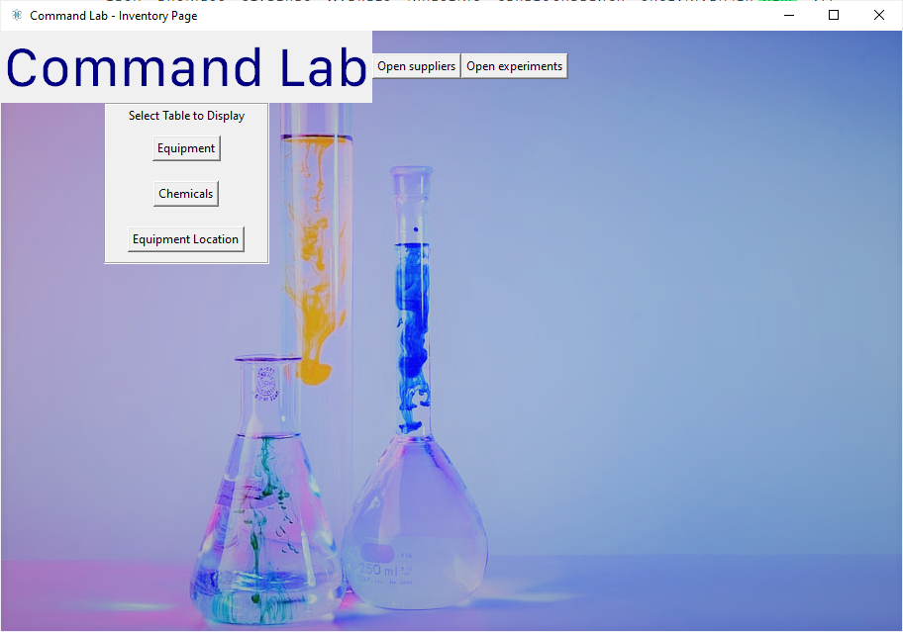

run_show_Equipment_Location

run_Chemical_Chart

run_Equipment_Chart

open_supplier_chart

open_experiments_page

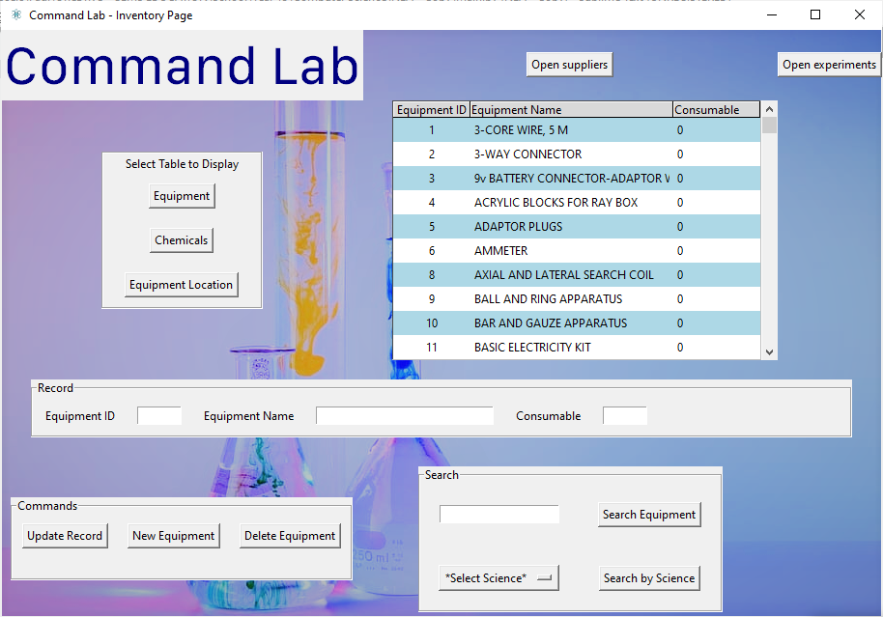

search_by_science

search_Equipment_Chart

delete_record

add_record

update_record

connect_db_to_treeview

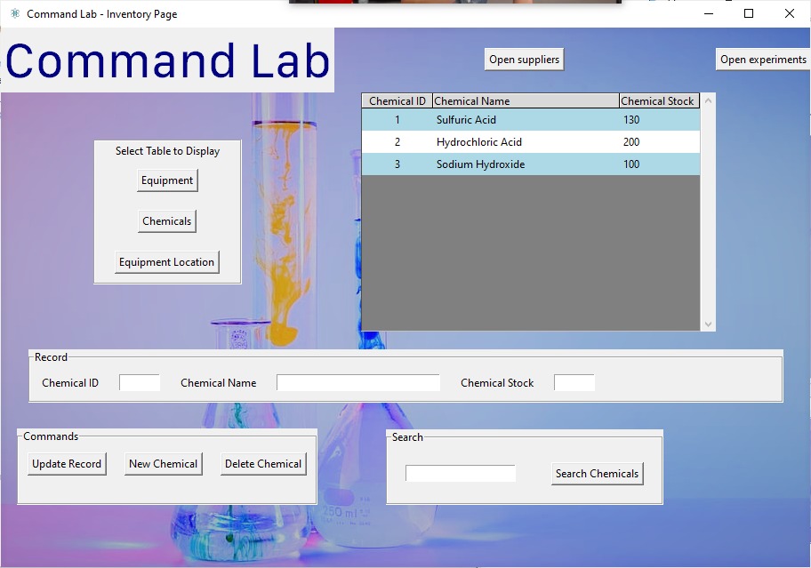

update_record

add_record

delete_record

search_Chemicals_Chart

connect_db_to_treeview

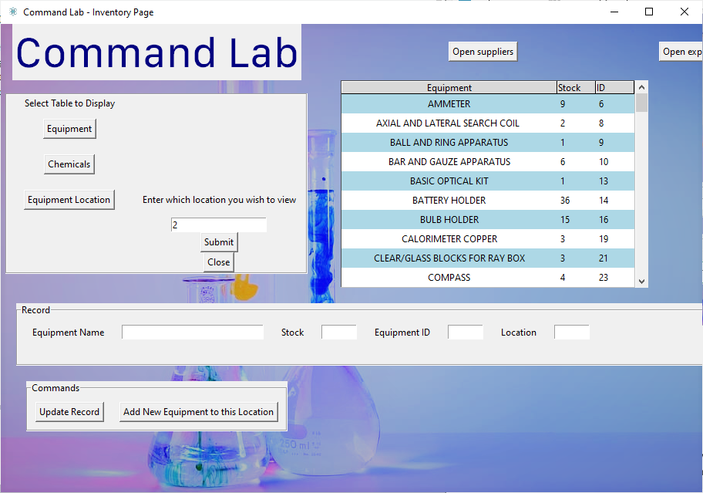

view_stock_stats

add_to_location

update_record

clearLocationWidgets

Launch_Equipment_Location

show_Equipment_Location

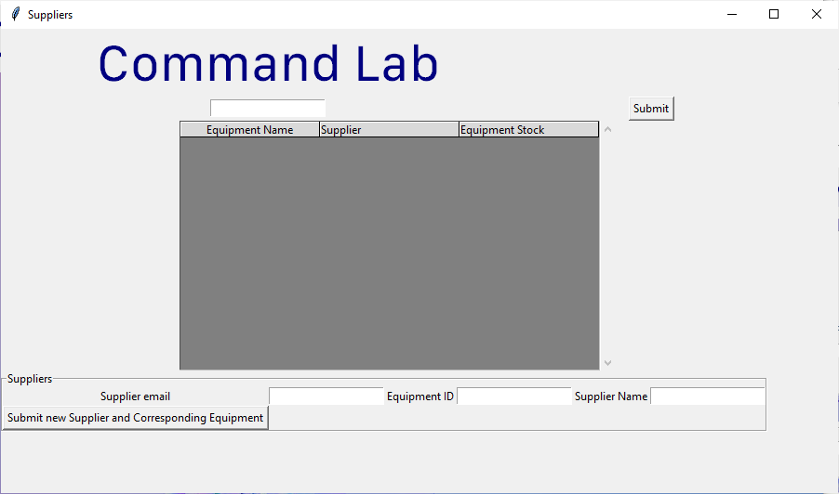

create_base_chart

Populate_EquipmentSupplier_Chart

Submit_New_Supplier

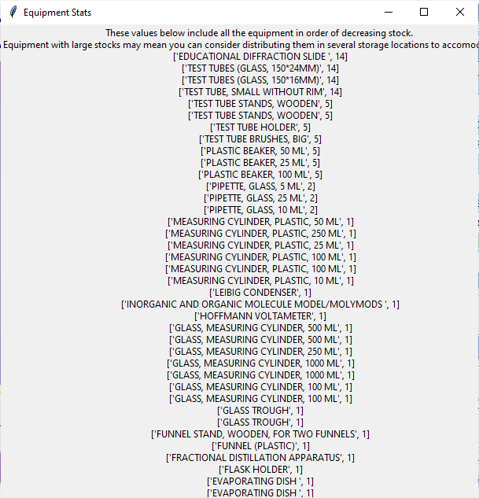

**from** **tkinter** **import** * *#imports tkinter library for GUI*

**import** **sqlite3** *#imports database SQLite 3 library for SQL functions*

**from** **PIL** **import** ImageTk, Image *#imports pillow to be able to handle png image files*

**from** **tkinter** **import** ttk *#this is used to use treeview, which can be used to visualize the database*

**from** **tkinter.font** **import** Font

**from** **Inventory_System_Validations_and_Connections** **import** *

**from** **Experiment_Calculator_GUI** **import** *

**class** **Inventory_GUI**:

**def** __init__(self, parent, permissions):

self.parent=parent

self.inventory_page=Toplevel(self.parent) *#creates a top level window over the withdrawn root login window*

self.permissions = permissions *#receives the permissions associated with the user that is logged in*

**def** configure_GUI(self):

self.inventory_page.title("Command Lab - Inventory Page") *#title of window*

self.inventory_page.iconbitmap("logo.ico") *#icon of window*

self.inventory_page.geometry("910x607") *#size of window*

*#inserts image in background of main inventory_page window*

**global** img

img=ImageTk.PhotoImage(file='img1.png') *#defined the background image*

back_label = Label(self.inventory_page, image=img) *#created a label for image*

back_label.place(x=0, y=0, relheight=1, relwidth=1) *#positioned image at the top left*

*#title text*

self.title_font = Font(family = "SF Compact Text", size=42)

self.title_text = Label(self.inventory_page, text="Command Lab", fg="navy blue", font=self.title_font)

self.title_text.grid(row=0, column=0)

self.openExperiments_Button=Button(self.inventory_page, text="Open experiments", command=self.open_experiments_page) *#when the button is pressed, it opens the experiment window*

self.openExperiments_Button.grid(row=0, column=2)

**if** self.permissions == True: *#only users with the technician permissions can view information about suppliers*

self.checkRestockForSuppliers_Button=Button(self.inventory_page, text="Open suppliers", command=self.open_supplierChart) *#when the button is pressed, it opens the supplier window*

self.checkRestockForSuppliers_Button.grid(row=0, column=1)

**else**:

**pass**

**def** create_base_chart(self): *#function that creates the treeview to display stock*

self.style=ttk.Style() *#initialises style*

self.style.theme_use('default') *#uses default ttk style*

self.style.configure("Treeview", background="light blue", foreground="black", rowheight=25, fieldbackground="grey")*# configures the colors*

self.style.map('Treeview', background=[('selected', "dark blue")]) *#uses a python tuple. when we select a record, this is the color that is used*

*#creating the frame*

self.table_frame = Frame(self.inventory_page) *#the table will be in its own frame, which makes adding a scrollbar easier to program*

self.table_frame.grid(row=2, column=1, padx=(30,0))

self.table_scroll = Scrollbar(self.table_frame)

self.table_scroll.pack(fill=Y ,side=RIGHT) *# this will allow us to scroll up and down the table*

self.table_tree = ttk.Treeview(self.table_frame, yscrollcommand=self.table_scroll.set, selectmode="extended")

self.table_tree.pack() *#creates the treeview*

*# Configure the Scrollbar*

self.table_scroll.config(command=self.table_tree.yview)

**return** self.table_tree

**def** run_show_Equipment_Location(self): *#this opens the menu for the user to input which location the user wishes to view the inventory for*

self.clear_Everything()

self.LocationLabel = Label(self.tables_buttons_frame, text="Enter which location you wish to view")

self.LocationLabel.grid(row=3, column=1, padx=10)

self.LocationEntry = Entry(self.tables_buttons_frame) *#this is the entry to enter the location ID*

self.LocationEntry.grid(row=4, column=1, padx=10)

self.LocationConfirmButton = Button(self.tables_buttons_frame, text="Submit", command=self.Launch_Equipment_Location) *#calls the equipment_location function to launch the table for the stock specific to locations*

self.LocationConfirmButton.grid(row=5, column=1)

self.LocationWidgetsclearButton=Button(self.tables_buttons_frame, text="Close", command=self.clearLocationWidgets) *#closes the menu for the equipment location*

self.LocationWidgetsclearButton.grid(row=6, column=1)

**def** Launch_Equipment_Location(self):

self.LocationConfirm = self.LocationEntry.get() *#gets the location ID entered by the user*

self.LocationFormat_Valid=self.validateLocationConfirm() *#validates the format of the location by calling validateLocationConfirm in the Inventory_Systems_Validations_and_Connections file*

**if** self.LocationFormat_Valid==True:

u1=Equipment_Location(self.inventory_page, self.LocationConfirm, self.permissions) *#if it is true, an instance of the class Equipment_location below*

u1.show_Equipment_Location(self.inventory_page, self.LocationConfirm) *#calls the function to create the table for the equipment location*

**else**:

self.LocationError_Label=Label(self.tables_buttons_frame, text="Invalid Location Format.**\n**Must be in labs 1-7") *#if the formatting is incorrect, an appropriate error message is displayed*

self.LocationError_Label.grid(row=7, column=0)

**def** validateLocationConfirm(self):

u3=Equipment_Location_Validate(self.LocationConfirm,"","","","") *#creates an instance of the class Equipment_Location_Validate to validate the format of the location entered by the user*

self.LocationFormat_Valid=u3.validate_Location(self.LocationConfirm)

**return** self.LocationFormat_Valid *#returns true if the format of the location is valid*

**def** clearLocationWidgets(self):

self.LocationLabel.destroy() *#clears all the widgets associated with the Equipment_Location table*

self.LocationEntry.destroy()

self.LocationConfirmButton.destroy()

self.LocationWidgetsclearButton.destroy()

**try**:

self.LocationError_Label.destroy() *#it will try and delete an error message if one exists*

**except**:

**pass**

**def** chart_buttons(self): *#this function displays the buttons to call the different tables*

self.tables_buttons_frame = LabelFrame(self.inventory_page) *#the table will be in its own frame, which makes adding a scrollbar easier to program*

self.tables_buttons_frame.grid(row=2, column=0)

self.buttons_explanation = Label(self.tables_buttons_frame, text="Select Table to Display")

self.buttons_explanation.grid(row=0, column=0, padx=20)

self.equipment_button = Button(self.tables_buttons_frame, text="Equipment", command = self.run_Equipment_Chart) *#when clicked, it calls the function to run the equipment chart*

self.equipment_button.grid(row=1, column=0, pady=10, padx=20)

self.chemical_button = Button(self.tables_buttons_frame, text="Chemicals", command = self.run_Chemical_Chart) *#when clicked, it calls the function to run the chemicals chart*

self.chemical_button.grid(row=2, column=0, pady=10, padx=20)

self.show_Location_button=Button(self.tables_buttons_frame, text="Equipment Location", command = self.run_show_Equipment_Location) *#when clicked, it calls the function to run the equipment location chart*

self.show_Location_button.grid(row=3, column=0, pady=10, padx=20)

**try**:

self.parent.mainloop()

**except**:

**pass**

**def** run_Equipment_Chart(self): *#when called, this function creates an instance of the Equipment_Chart child class below*

u1=Equipment_Chart(self.inventory_page, self.permissions, "", self.tables_buttons_frame)

u1.columns() *#columns for the equipment chart table*

**def** run_Chemical_Chart(self): *#when called, this function creates an instance of the Chemical_Chart child class below*

u1=Chemical_Chart(self.inventory_page, self.permissions)

**def** clear_Everything(self):

*#clears any existing Equipment-related widgets*

u1=Equipment_Chart("","","","")

u1.clear_Equipment_page()

**def** open_experiments_page(self): *#when called, this function will run the experiments window and withdraw the inventory window*

self.inventory_page.withdraw()

u1=Experiment_Calculator_Window(self.parent)

u1.configure_GUI()

**def** open_supplierChart(self): *#creates an instance of the supplier chart class*

u1=supplier_Chart()

**class** **Equipment_Chart**(Inventory_GUI):

**def** __init__(self, inventory_page, permissions, LocationConfirm, tables_buttons_frame):

self.inventory_page=inventory_page

self.permissions=permissions

self.LocationConfirm=LocationConfirm

self.tables_buttons_frame=tables_buttons_frame

self.table_tree=self.create_base_chart() *#calls function from inventory_page class.*

self.columns() *#sets the columns for the Equipment table. This will be repeated for all the other required tables.*

self.values=self.connect_db_to_treeview()

self.check_permissions_edit_Equipment_Chart() *#will run the associated functions that are reserved for users with technician permissions only if true*

self.search_frame() *#calls the function that creates the frame for the user to search in the equipment table*

self.stats_button=Button(self.search_frame, text="View equipment stock stats", command=self.view_stock_stats) *#this button, when pressed, will call the function that allows the user to view the equipment stock stats based on decreasing number of stock*

self.stats_button.grid(row=0, column=5)

**def** columns(self):

self.table_tree['columns'] = ("Equipment_ID", "Equipment_Name", "Consumable") *#sets the titles of the columns in the tree*

*#formats the columns*

self.table_tree.column("#0", width=0, stretch=NO)

self.table_tree.column("Equipment_ID", anchor=CENTER, width=80)

self.table_tree.column("Equipment_Name", anchor=W, width=210)

self.table_tree.column("Consumable", anchor=W, width=90)

*#creates headings for the equipment table*

self.table_tree.heading("#0", text="", anchor=W)

self.table_tree.heading("Equipment_ID", text="Equipment ID", anchor=CENTER)

self.table_tree.heading("Equipment_Name", text="Equipment Name", anchor=W)

self.table_tree.heading("Consumable", text="Consumable", anchor=W)

**def** connect_db_to_treeview(self):

u2=Equipment_get_values("", "", "", "","") *#creates an instance of the class get_values under the object self*

u2.records = u2.query_Equipment_db() *#gets everything from the equipment table*

**global** count *# Add our data to the screen*

count = 0

*#we will alternate the colors of the rows for improved visibility*

self.table_tree.tag_configure('oddrow', background="white")

self.table_tree.tag_configure('evenrow', background="lightblue")

**for** record **in** u2.records:

**if** count % 2 == 0:

self.table_tree.insert(parent='', index='end', iid=count, text='', values=(record[2], record[0], record[1]), tags=('evenrow',)) *#passes in the values that were brought over from the database to populate the treeview*

**else**:

self.table_tree.insert(parent='', index='end', iid=count, text='', values=(record[2], record[0], record[1]), tags=('oddrow',))

*# increment counter*

count += 1

self.selected = self.table_tree.focus()*# record Number*

self.values = self.table_tree.item(self.selected, 'values')*# record values*

**return** self.values

**def** search_frame(self):

*# Create label frame*

self.search_frame = LabelFrame(self.inventory_page, text="Search")

self.search_frame.grid(row=4,column=1, pady=10)

*# Add entry box*

self.search_entry = Entry(self.search_frame)

self.search_entry.grid(row=0, column=0, pady=20, padx=20)

*# Add button*

self.search_button = Button(self.search_frame, text="Search Equipment", command=self.search_Equipment_Chart)

self.search_button.grid(row=0, column=1, padx=20, pady=20)

self.searchByScience_Button=Button(self.search_frame, text="Search by Science", command=self.search_by_science)

self.searchByScience_Button.grid(row=1, column=1, padx=20, pady=20) *#this button allows you to filter the equipment table to equipment by science*

self.ScienceOptions= StringVar(self.search_frame) *#this is a dropdown menu to filter by science*

self.ScienceOptions.set("*Select Science*")

self.ScienceArray=["Physics", "Biology", "Chemistry"]

self.searchScience_Menu=OptionMenu(self.search_frame, self.ScienceOptions, *self.ScienceArray)

self.searchScience_Menu.grid(row=1, column=0)

**def** get_selected_science(self): *#returns the numerical value associated with the selection of the user from the dropdown menu*

self.Selected_Science=self.ScienceOptions.get()

**if** self.Selected_Science=="Physics":

self.Selected_Science=1

**elif** self.Selected_Science=="Chemistry":

self.Selected_Science=2

**else**: self.Selected_Science=3

**return** self.Selected_Science

**def** search_by_science(self):

self.Selected_Science=self.get_selected_science()

u3=Equipment_get_values("", "", "", "", self.Selected_Science) *#creates an instance of the class get_values under the object self*

u3.records = u3.search_by_science_table(self.Selected_Science) *#gets the equipment properties that match the selected science*

self.science_columns()

*# Clears the Treeview from any existing records*

**for** record **in** self.table_tree.get_children():

self.table_tree.delete(record)

**global** count

count = 0

*#we will alternate the colors of the rows for improved visibility*

self.table_tree.tag_configure('oddrow', background="white")

self.table_tree.tag_configure('evenrow', background="lightblue")

**for** record **in** u3.records:

**if** count % 2 == 0:

self.table_tree.insert(parent='', index='end', text='', values=(record[0], record[1], record[2]), tags=('evenrow',))

**else**:

self.table_tree.insert(parent='', index='end', text='', values=(record[0], record[1], record[2]), tags=('oddrow',))

*# increment counter*

count += 1

**def** science_columns(self):

self.table_tree['columns'] = ("Equipment_Name", "Science", "Consumable") *#sets the titles of the columns in the tree*

*#formats the columns*

self.table_tree.column("#0", width=0, stretch=NO)

self.table_tree.column("Equipment_Name", anchor=CENTER, width=230)

self.table_tree.column("Science", anchor=W, width=50)

self.table_tree.column("Consumable", anchor=W, width=90)

*#creates headings for the equipment table*

self.table_tree.heading("#0", text="", anchor=W)

self.table_tree.heading("Equipment_Name", text="Equipment Name", anchor=CENTER)

self.table_tree.heading("Science", text="Science", anchor=W)

self.table_tree.heading("Consumable", text="Consumable", anchor=W)

**def** search_Equipment_Chart(self):

self.EquipmentName_Lookup = self.search_entry.get() *#gets the value that was entered by the user to search for the equipment*

self.search_entry.delete(0, END) *#clears it*

*# Clear the Treeview*

**for** record **in** self.table_tree.get_children():

self.table_tree.delete(record)

u2=Equipment_get_values(self.EquipmentName_Lookup, "", "", "","") *#creates an instance of the class get_values under the object self*

u2.records = u2.search_Equipment_db() *#gets everything from the equipment table*

**global** count *# Add our data to the screen that matches the searched entry*

count = 0

**for** record **in** u2.records:

**if** count % 2 == 0:

self.table_tree.insert(parent='', index='end', iid=count, text='', values=(record[0], record[1], record[2]), tags=('evenrow',))

**else**:

self.table_tree.insert(parent='', index='end', iid=count, text='', values=(record[0], record[1], record[2]), tags=('oddrow',))

**def** check_permissions_edit_Equipment_Chart(self):

**if** self.permissions == True:

self = edit_Equipment_Chart(self.inventory_page, self.table_tree, self.values) *#creates an instance of the edit_Equipment_Chart only if the permissions of the user that is logged in allows it*

**else**:

**pass**

**def** clear_Equipment_page(self):

**try**:

*#deletes all the buttons*

self.updateButton.destroy()

self.newrecordButton.destroy()

self.deleterecordButton.destroy()

self.edit_button_frame.destroy()

*#deletes the record frame*

self.EquipmentID_Label.destroy()

self.EquipmentID_Entry.destroy()

self.EquipmentName_Label.destroy()

self.EquipmentName_Entry.destroy()

self.Consumable_Label.destroy()

self.Consumable_Entry.destroy()

self.data_frame.destroy()

**except**:

**pass**

**try**:

*#deletes the search frame*

self.search_entry.destroy()

self.search_button.destroy()

self.search_frame.destroy()

**except**:

**pass**

**def** view_stock_stats(self): *#this function outputs the equipment statistics in order of decreasing stock*

self.EquipmentStatsText=""

u3=Location_get_values("","","","","")

u3.stats=u3.get_equipment_stats()

self.top_window=Toplevel()

self.top_window.geometry("607x307")

self.top_window.title("Equipment Stats")

self.stats_frame=Frame(self.top_window)

self.stats_frame.grid(row=2, column=0)

self.table_scroll = Scrollbar(self.stats_frame, orient='horizontal')

self.table_scroll.pack(fill=X ,side=BOTTOM ) *# this will allow us to scroll up and down the table*

**for** i **in** range (len(u3.stats)-1,0,-1):

self.EquipmentStatsText=self.EquipmentStatsText+str(u3.stats[i])+"**\n**"

self.explanationtext=Label(self.stats_frame, text="These values below include all the equipment in order of decreasing stock. **\n**Equipment with large stocks may mean you can consider distributing them in several storage locations to accomodate them**\n**"+self.EquipmentStatsText)

self.explanationtext.pack()

**class** **supplier_Chart**(Inventory_GUI):

**def** __init__(self):

self.supplier_window=Toplevel()

self.supplier_window.geometry("900x500")

self.supplier_window.title("Suppliers") *#creates the suppliers window*

self.configure_GUI()

**def** configure_GUI(self):

*#title text*

self.title_font = Font(family = "SF Compact Text", size=42)

self.title_text = Label(self.supplier_window, text="Command Lab", fg="navy blue", font=self.title_font)

self.title_text.grid(row=0, column=0)

self.stockEntry_Label=Label(self.supplier_window, text="Enter threshold stock")

self.stockEntry_Label.grid(row=1, column=0)

self.stock_Entry=Entry(self.supplier_window) *#this is the entry to enter the stock that the user wishes to see for equipment below this stock threshold*

self.stock_Entry.grid(row=1, column=1)

self.submit_StockEntry_Button=Button(self.supplier_window, text="Submit", command=self.Populate_EquipmentSupplier_Chart) *#calls the Populate_EquipmentSupplier_Chart function when pressed*

self.submit_StockEntry_Button.grid(row=1, column=2)

self.create_base_chart() *#creates the treeview for the supplier chart*

self.Equipment_supplier_columns() *#sets the columns for the supplier table*

self.add_Supplier() *#calls the function to allow the user to add new suppliers to the table*

**def** create_base_chart(self):

self.style=ttk.Style() *#initialises style*

self.style.theme_use('default') *#uses default ttk style*

self.style.configure("Treeview", background="light blue", foreground="black", rowheight=25, fieldbackground="grey")*# configures the colors*

self.style.map('Treeview', background=[('selected', "dark blue")]) *#uses a python tuple. when we select a record, this is the color that is used*

*#creating the frame*

self.table_frame = Frame(self.supplier_window) *#the table will be in its own frame, which makes adding a scrollbar easier to program*

self.table_frame.grid(row=2, column=0, columnspan=2, padx=(30,0))

self.table_scroll = Scrollbar(self.table_frame)

self.table_scroll.pack(fill=Y ,side=RIGHT) *# this will allow us to scroll up and down the table*

self.supplier_table_tree = ttk.Treeview(self.table_frame, yscrollcommand=self.table_scroll.set, selectmode="extended")

self.supplier_table_tree.pack() *#creates the treeview*

*# Configure the Scrollbar*

self.table_scroll.config(command=self.supplier_table_tree.yview)

**return** self.supplier_table_tree

**def** Equipment_supplier_columns(self):

self.supplier_table_tree['columns'] = ("Equipment_Name", "Supplier_Email", "Equipment_Stock") *#sets the titles of the columns in the tree*

*#formatting the columns*

self.supplier_table_tree.column("#0", width=0, stretch=NO)

self.supplier_table_tree.column("Equipment_Name", anchor=CENTER, width=150)

self.supplier_table_tree.column("Supplier_Email", anchor=W, width=150)

self.supplier_table_tree.column("Equipment_Stock", anchor=W, width=150)

*#creates headings for the treeview*

self.supplier_table_tree.heading("#0", text="", anchor=W)

self.supplier_table_tree.heading("Equipment_Name", text="Equipment Name", anchor=CENTER)

self.supplier_table_tree.heading("Supplier_Email", text="Supplier", anchor=W)

self.supplier_table_tree.heading("Equipment_Stock", text="Equipment Stock", anchor=W)

**def** Populate_EquipmentSupplier_Chart(self):

self.Requested_Stock=self.stock_Entry.get() *#gets the value for the entered threshold stock*

u1=Supplier(self.Requested_Stock,"","","") *#creates an instance of the class Supplier in the Inventory_System_Validations_and_Connections file*

self.EquipmentStock_format_valid=u1.validate_Requested_Stock(self.Requested_Stock) *#calls the function that validates whether the stock format is valid*

**if** self.EquipmentStock_format_valid==True:

u1.records=u1.select_Supplies(self.Requested_Stock)

**global** count *#populates the treeview*

count = 0

**for** record **in** u1.records:

**if** count % 2 == 0:

self.supplier_table_tree.insert(parent='', index='end', iid=count, text='', values=(record[0], record[1], record[2]), tags=('evenrow',))

**else**:

self.supplier_table_tree.insert(parent='', index='end', iid=count, text='', values=(record[0], record[1], record[2]), tags=('oddrow',))

count+=1

**else**:

self.errorLabel=Label(self.supplier_window, text="Invalid stock input") *#if the formatting is incorrect, an appropriate error message is displayed*

self.errorLabel.grid(row=3, column=0)

**def** add_Supplier(self):

*#frame for adding a new supplier's details to the table*

self.SupplierFrame=LabelFrame(self.supplier_window, text="Suppliers")

self.SupplierFrame.grid(row=4, column=0, columnspan=2)

self.SupplierEmail_Label=Label(self.SupplierFrame, text="Supplier email")

self.SupplierEmail_Label.grid(row=0, column=0)

self.SupplierEmail_Entry=Entry(self.SupplierFrame)

self.SupplierEmail_Entry.grid(row=0, column=1)

self.EquipmentID_Label=Label(self.SupplierFrame, text="Equipment ID") *#equipment associated with the new supplier*

self.EquipmentID_Label.grid(row=0, column=2)

self.EquipmentID_Entry=Entry(self.SupplierFrame)

self.EquipmentID_Entry.grid(row=0, column=3)

self.SupplierName_Label=Label(self.SupplierFrame, text="Supplier Name")

self.SupplierName_Label.grid(row=0, column=4)

self.SupplierName_Entry=Entry(self.SupplierFrame)

self.SupplierName_Entry.grid(row=0, column=5)

self.Submit_NewSupplier_Button=Button(self.SupplierFrame, text="Submit new Supplier and Corresponding Equipment", command=self.Submit_New_Supplier)

self.Submit_NewSupplier_Button.grid(row=1, column=0)

**def** Submit_New_Supplier(self):

self.Entered_SupplierEmail=self.SupplierEmail_Entry.get()

self.Entered_EquipmentID=self.EquipmentID_Entry.get()

self.Entered_SupplierName=self.SupplierEmail_Entry.get()

u1=Supplier("",self.Entered_SupplierEmail, self.Entered_EquipmentID, self.Entered_SupplierName)

self.SupplierEmail_Format_Valid=u1.validate_supplier_email(self.Entered_SupplierEmail) *#validates the format of the supplier's email*

self.EquipmentID_Valid=u1.validate_equipmentID(self.Entered_EquipmentID) *#validates the format of the equipment ID*

self.SupplierName_Valid=u1.validate_SupplierName(self.Entered_SupplierName) *#validates the format of the supplier's name*

**if** self.SupplierEmail_Format_Valid==True **and** self.EquipmentID_Valid==True **and** self.SupplierName_Valid==True:

u1.insert_new_Supplier(self.Entered_SupplierEmail, self.Entered_EquipmentID,self.Entered_SupplierName) *#calls the function to insert the validated values to the database*

self.Supplier_errorLabel=Label(self.supplier_window, text="Supplier Added!")

self.Supplier_errorLabel.grid(row=6, column=0)

*# Clear The Treeview Table*

self.supplier_table_tree.delete(*self.supplier_table_tree.get_children())

*# Run to pull data from database on start*

self.Populate_EquipmentSupplier_Chart()

**else**:

self.Supplier_errorLabel=Label(self.supplier_window, text="Invalid supplier info") *#if the formatting is incorrect, an appropriate error message is displayed*

self.Supplier_errorLabel.grid(row=6, column=0)

**class** **edit_Equipment_Chart**(Equipment_Chart):

**def** __init__(self, inventory_page, table_tree, values):

self.values=values

self.table_tree=table_tree

self.inventory_page=inventory_page

self.record_entries()

self.edit_table_buttons()

**def** edit_table_buttons(self): *#displays the buttons that edit the equipment records*

self.edit_button_frame = LabelFrame(self.inventory_page, text="Commands")

self.edit_button_frame.grid(row=4, column=0)

self.updateButton = Button(self.edit_button_frame, text="Update Record", command=self.update_record) *#calls the function to update existing record*

self.updateButton.grid(row=0, column=0, padx=10, pady=10)

self.newrecordButton = Button(self.edit_button_frame, text="New Equipment", command=self.add_record) *#calls the function to add a new equipment*

self.newrecordButton.grid(row=0, column=1, padx=10, pady=10)

self.deleterecordButton = Button(self.edit_button_frame, text="Delete Equipment", command=self.delete_record) *#calls the function to delete the record*

self.deleterecordButton.grid(row=0, column=2, padx=10, pady=10)

self.errorLabel = Label(self.edit_button_frame)

self.errorLabel.grid(row=1, column=0)

**def** record_entries(self):

*#creates frame to hold entries for records*

self.data_frame = LabelFrame(self.inventory_page, text="Record")

self.data_frame.grid(row=3, column=0, columnspan=5, padx=20, pady=20, ipadx=100)

self.EquipmentID_Label = Label(self.data_frame, text="Equipment ID")

self.EquipmentID_Label.grid(row=0, column=0, padx=10, pady=10)

self.EquipmentID_Entry = Entry(self.data_frame, width=7) *#entry for the equipment ID*

self.EquipmentID_Entry.grid(row=0, column=1, padx=10, pady=10)

self.EquipmentName_Label = Label(self.data_frame, text="Equipment Name")

self.EquipmentName_Label.grid(row=0, column=2, padx=10, pady=10)

self.EquipmentName_Entry = Entry(self.data_frame, width=30) *#entry for the equipment name*

self.EquipmentName_Entry.grid(row=0, column=3, padx=10, pady=10)

self.Consumable_Label = Label(self.data_frame, text="Consumable")

self.Consumable_Label.grid(row=0, column=4, padx=10, pady=10)

self.Consumable_Entry = Entry(self.data_frame, width=7) *#entry for the consumable variable value*

self.Consumable_Entry.grid(row=0, column=5, padx=10, pady=10)

self.table_tree.bind("<ButtonRelease-1>", self.select_record) *#whenever the user clicks on a row in the treeview, it will call the function select_record*

**def** clear_entries(self):

*# Clear entry boxes*

self.EquipmentID_Entry.delete(0, END)

self.EquipmentName_Entry.delete(0, END)

self.Consumable_Entry.delete(0, END)

*# Select Record*

**def** select_record(self, event):

self.selected = self.table_tree.focus()*# record Number*

self.values = self.table_tree.item(self.selected, 'values')*# record values*

self.clear_entries()

*# outputs to entry boxes*

self.EquipmentID_Entry.insert(0, self.values[0])

self.EquipmentName_Entry.insert(0, self.values[1])

self.Consumable_Entry.insert(0, self.values[2])

**def** update_record(self):

self.selected = self.table_tree.focus() *#grabs the record number from the selected line on the treeview*

*#gets the values in the entries*

self.Entered_EquipmentName = self.EquipmentName_Entry.get()

self.Entered_Consumable = self.Consumable_Entry.get()

self.Entered_EquipmentID = self.EquipmentID_Entry.get()

u2=Equipment_Location_Validate("",self.Entered_EquipmentName,"",self.Entered_Consumable,"")

self.equipmentName_format_valid=u2.validate_EquipmentName(self.Entered_EquipmentName) *#validates the entered equipment name*

self.Consumable_format_valid=u2.validate_Consumable(self.Entered_Consumable) *#validates the entered consumable variable*

**if** self.equipmentName_format_valid==True **and** self.Consumable_format_valid==True:

u2=Equipment_get_values("", self.Entered_EquipmentName, self.Entered_Consumable, self.Entered_EquipmentID,"") *#creates an instance of the class get_values under the object self*

u2.update_Equipment_db() *#gets everything from the equipment table*

self.table_tree.item(self.selected, text="", values=(self.EquipmentID_Entry.get(), self.EquipmentName_Entry.get(), self.Consumable_Entry.get(),)) *# Update record*

**else**:

self.errorLabel.configure(text="Invalid input")

**def** add_record(self):

self.Entered_EquipmentName = self.EquipmentName_Entry.get()

self.Entered_Consumable = self.Consumable_Entry.get()

u2=Equipment_Location_Validate("",self.Entered_EquipmentName,"",self.Entered_Consumable,"")

self.equipmentName_format_valid=u2.validate_EquipmentName(self.Entered_EquipmentName) *#validates the entered equipment name*

self.Consumable_format_valid=u2.validate_Consumable(self.Entered_Consumable) *#validates the entered consumable variable*

**if** self.equipmentName_format_valid==True **and** self.Consumable_format_valid==True:

u2=Equipment_get_values("", self.Entered_EquipmentName, self.Entered_Consumable, "","")

u2.add_Equipment_db() *#if the entered values are valid, they are added to the database*

**else**:

self.errorLabel.configure(text="Invalid input")

*#clears entries*

self.clear_entries()

*# Clear The Treeview Table*

self.table_tree.delete(*self.table_tree.get_children())

*# Run to pull data from database on start*

self.connect_db_to_treeview()

**def** delete_record(self):

*#deletes the record from the selected record in the treeview*

self.x = self.table_tree.selection()[0]

self.table_tree.delete(self.x)

self.Entered_EquipmentID = self.EquipmentID_Entry.get()

u2=Equipment_get_values("", "", "", self.Entered_EquipmentID,"")

u2.delete_Equipment_db()

*# Clear The Entry Boxes*

self.clear_entries()

**class** **Equipment_Location**(Inventory_GUI):

**def** __init__(self, inventory_page, LocationConfirm, permissions):

self.LocationConfirm=LocationConfirm

self.inventory_page=inventory_page

self.permissions=permissions

self.table_tree=self.create_base_chart() *#calls function from parent class.*

**if** self.permissions == True:

self.record_entries()

self.edit_table_buttons()

**else**:

**pass**

**def** show_Equipment_Location(self, inventory_page, LocationConfirm):

*#new columns*

self.table_tree['columns'] = ("Equipment_Name", "Equipment_Stock", "Equipment_ID") *#sets the titles of the columns in the tree*

*# Format Our Columns*

self.table_tree.column("#0", width=0, stretch=NO)

self.table_tree.column("Equipment_Name", anchor=CENTER, width=280)

self.table_tree.column("Equipment_Stock", anchor=W, width=50)

self.table_tree.column("Equipment_ID", anchor=W, width=50)

*# Create Headings*

self.table_tree.heading("#0", text="", anchor=W)

self.table_tree.heading("Equipment_Name", text="Equipment**\n**name", anchor=CENTER)

self.table_tree.heading("Equipment_Stock", text="Stock", anchor=W)

self.table_tree.heading("Equipment_ID", text="ID", anchor=W)

u2=Location_get_values(self.LocationConfirm, "", "", "", "") *#creates an instance of the class get_values under the object self*

u2.records = u2.add_in_location() *#grabs values from location and equipment tables*

**global** count *# Add our data to the screen*

count = 0

*#we will alternate the colors of the rows for improved visibility*

self.table_tree.tag_configure('oddrow', background="white")

self.table_tree.tag_configure('evenrow', background="lightblue")

**for** record **in** u2.records:

**if** count % 2 == 0:

self.table_tree.insert(parent='', index='end', text='', values=(record[0], record[1], record[2]), tags=('evenrow',))

**else**:

self.table_tree.insert(parent='', index='end', text='', values=(record[0], record[1], record[2]), tags=('oddrow',))

*# increment counter*

count += 1

**def** record_entries(self):

*#creates frame to hold entries for records*

self.data_frame = LabelFrame(self.inventory_page, text="Record")

self.data_frame.grid(row=3, column=0, columnspan=5, padx=20, pady=20, ipadx=100)

self.EquipmentName_Label = Label(self.data_frame, text="Equipment Name")

self.EquipmentName_Label.grid(row=0, column=2, padx=10, pady=10)

self.EquipmentName_Entry = Entry(self.data_frame, width=30)

self.EquipmentName_Entry.grid(row=0, column=3, padx=10, pady=10)

self.Stock_Label = Label(self.data_frame, text="Stock")

self.Stock_Label.grid(row=0, column=4, padx=10, pady=10)

self.Stock_Entry = Entry(self.data_frame, width=7)

self.Stock_Entry.grid(row=0, column=5, padx=10, pady=10)

self.EquipmentID_Label = Label(self.data_frame, text="Equipment ID")

self.EquipmentID_Label.grid(row=0, column=6, padx=10, pady=10)

self.EquipmentID_Entry = Entry(self.data_frame, width=7)

self.EquipmentID_Entry.grid(row=0, column=7, padx=10, pady=10)

self.Location_Label= Label(self.data_frame, text="Location")

self.Location_Label.grid(row=0, column=8, padx=10, pady=10)

self.Location_Entry = Entry(self.data_frame, width=7)

self.Location_Entry.grid(row=0, column=9, padx=10, pady=10)

self.errorLabel = Label(self.data_frame)

self.errorLabel.grid(row=1, column=0)

self.table_tree.bind("<ButtonRelease-1>", self.select_record) *#whenever the user clicks on a row in the treeview, it will call the function select_record*

*# Select Record*

**def** select_record(self, event):

self.selected = self.table_tree.focus()*# record Number*

self.values = self.table_tree.item(self.selected, 'values')*# record values*

self.clear_entries()

*# outputs to entry boxes*

self.EquipmentName_Entry.insert(0, self.values[0])

self.Stock_Entry.insert(0, self.values[1])

self.EquipmentID_Entry.insert(0, self.values[2])

**def** clear_entries(self):

*# Clear entry boxes*

self.EquipmentName_Entry.delete(0, END)

self.EquipmentID_Entry.delete(0, END)

self.Stock_Entry.delete(0, END)

**def** update_record(self):

self.selected = self.table_tree.focus() *#grabs the record number from the selected line on the treeview*

self.table_tree.item(self.selected, text="", values=(self.EquipmentName_Entry.get(), self.Stock_Entry.get(),)) *# Update record*

*#before the record is updated, the entries must first be validated*

self.Entered_EquipmentName = self.EquipmentName_Entry.get()

self.Entered_Stock = self.Stock_Entry.get()

self.Entered_EquipmentID = self.EquipmentID_Entry.get()

self.error_status=self.validate_LocationEntries()

**if** self.error_status ==True:

u2=Location_get_values(self.LocationConfirm, "", self.Entered_Stock, self.Entered_EquipmentID, "") *#creates an instance of the class get_values under the object self*

u2.update_Location_db() *#updates the selected record with the entered validated values*

**else**:

self.errorLabel.configure(text="Invalid input")

**def** validate_LocationEntries(self):

u2=Equipment_Location_Validate("",self.Entered_EquipmentName, self.Entered_Stock,"","")

self.equipmentName_format_valid=u2.validate_EquipmentName(self.Entered_EquipmentName)

self.EquipmentStock_format_valid=u2.validate_EquipmentStock(self.Entered_Stock)

**if** self.equipmentName_format_valid==True **and** self.EquipmentStock_format_valid==True:

self.error_status=True

**else**:

self.error_status=False

**return** self.error_status

**def** add_to_location(self):

self.Entered_Stock = self.Stock_Entry.get()

self.Entered_EquipmentID = self.EquipmentID_Entry.get()

self.Entered_Location = self.Location_Entry.get()

self.error_status=self.validate_newItemInLocation()

**if** self.error_status ==True:

u2=Location_get_values("", "", self.Entered_Stock, self.Entered_EquipmentID, self.Entered_Location)

u2.add_to_Location_db()

*# Clear The Treeview Table*

self.table_tree.delete(*self.table_tree.get_children())

*# Run to pull data from database on start*

self.show_Equipment_Location(self.inventory_page, self.LocationConfirm)

**else**:

self.errorLabel.configure(text="Invalid input")

**def** validate_newItemInLocation(self):

u2=Equipment_Location_Validate(self.Entered_Location,"",self.Entered_Stock,"","")

*#validation of entries*

self.EquipmentStock_format_valid=u2.validate_EquipmentStock(self.Entered_Stock)

self.LocationFormat_Valid=u2.validate_Location(self.LocationConfirm)

**if** self.LocationFormat_Valid==True **and** self.EquipmentStock_format_valid==True:

self.error_status=True

**else**:

self.error_status=False

**return** self.error_status

**def** delete_from_location(self):

self.Entered_Stock = self.Stock_Entry.get()

self.Entered_EquipmentID = self.EquipmentID_Entry.get()

self.Entered_Location = self.Location_Entry.get()

u3=Equipment_Location_Validate(self.Entered_Location,"","","",self.Entered_EquipmentID)

self.Location_Valid=u3.validate_Location(self.Entered_Location)

self.EquipmentID_Valid=u3.validate_equipmentID(self.Entered_EquipmentID)

**if** self.Location_Valid==True **and** self.EquipmentID_Valid==True:

u2=Location_get_values("", "", "", self.Entered_EquipmentID, self.Entered_Location)

u2.delete_from_Location_db()

*# Clear The Treeview Table*

self.table_tree.delete(*self.table_tree.get_children())

*# Run to pull data from database on start*

self.show_Equipment_Location(self.inventory_page, self.LocationConfirm)

**else**:

self.errorLabel.configure(text="Invalid input")

**def** edit_table_buttons(self):

*#buttons associated with editing the equipment table*

self.edit_button_frame = LabelFrame(self.inventory_page, text="Commands")

self.edit_button_frame.grid(row=4, column=0)

self.updateButton = Button(self.edit_button_frame, text="Update Record", command=self.update_record)

self.updateButton.grid(row=0, column=0, padx=10, pady=10)

self.addButton = Button(self.edit_button_frame, text="Add New Equipment to this Location", command=self.add_to_location)

self.addButton.grid(row=0, column=1, padx=10, pady=10)

self.deleteButton=Button(self.edit_button_frame, text="Delete Equipment from this Location", command=self.delete_from_location)

self.deleteButton.grid(row=1, column=0, padx=10, pady=10)

**class** **Chemical_Chart**(Inventory_GUI):

**def** __init__(self, inventory_page, permissions):

self.inventory_page=inventory_page

self.permissions=permissions

self.table_tree=self.create_base_chart() *#calls function from parent class.*

self.columns()

self.connect_db_to_treeview()

self.columns() *#sets the columns for the Chemicals table. This will be repeated for all the other required tables.*

self.check_permissions_edit_Chemicals_Chart()

self.search_frame()

**def** columns(self): *#columns for chemical table*

self.table_tree['columns'] = ("Chemical_ID", "Chemical_Name", "Chemical_Stock") *#sets the titles of the columns in the tree*

*# Format Our Columns*

self.table_tree.column("#0", width=0, stretch=NO)

self.table_tree.column("Chemical_ID", anchor=CENTER, width=80)

self.table_tree.column("Chemical_Name", anchor=W, width=210)

self.table_tree.column("Chemical_Stock", anchor=W, width=90)

*# Create Headings*

self.table_tree.heading("#0", text="", anchor=W)

self.table_tree.heading("Chemical_ID", text="Chemical ID", anchor=CENTER)

self.table_tree.heading("Chemical_Name", text="Chemical Name", anchor=W)

self.table_tree.heading("Chemical_Stock", text="Chemical Stock", anchor=W)

**def** connect_db_to_treeview(self):

u2=Chemicals_get_values("","","","") *#creates an instance of the class get_values under the object self*

u2.records = u2.query_Chemicals_table() *#gets everything from the chemicals table*

**global** count *# Add our data to the screen*

count = 0

*#we will alternate the colors of the rows for improved visibility*

self.table_tree.tag_configure('oddrow', background="white")

self.table_tree.tag_configure('evenrow', background="lightblue")

*#populates the treeview*

**for** record **in** u2.records:

**if** count % 2 == 0:

self.table_tree.insert(parent='', index='end', iid=count, text='', values=(record[2], record[0], record[1]), tags=('evenrow',))

**else**:

self.table_tree.insert(parent='', index='end', iid=count, text='', values=(record[2], record[0], record[1]), tags=('oddrow',))

*# increment counter*

count += 1

self.selected = self.table_tree.focus()*# record Number*

self.values = self.table_tree.item(self.selected, 'values')*# record values*

**return** self.values

**def** search_frame(self):

*# Create label frame*

self.search_frame = LabelFrame(self.inventory_page, text="Search")

self.search_frame.grid(row=4,column=1, pady=10)

*# Search entry box*

self.search_entry = Entry(self.search_frame)

self.search_entry.grid(row=0, column=0, pady=20, padx=20)

*# Search button*

self.search_button = Button(self.search_frame, text="Search Chemicals", command=self.search_Chemicals_Chart)

self.search_button.grid(row=0, column=1, padx=20, pady=20)

**def** search_Chemicals_Chart(self):

self.ChemicalName_Lookup = self.search_entry.get()

self.search_entry.delete(0, END)

*# Clear the Treeview*

**for** record **in** self.table_tree.get_children():

self.table_tree.delete(record)

u2=Chemicals_get_values(self.ChemicalName_Lookup,"","","") *#creates an instance of the class Chemicals_get_values under the object self*

u2.records = u2.search_Chemicals_db(self.ChemicalName_Lookup) *#gets everything from the equipment table that matches the searched value*

**global** count *# Add our data to the screen*

count = 0

**for** record **in** u2.records:

**if** count % 2 == 0:

self.table_tree.insert(parent='', index='end', iid=count, text='', values=(record[0], record[1], record[2]), tags=('evenrow',))

**else**:

self.table_tree.insert(parent='', index='end', iid=count, text='', values=(record[0], record[1], record[2]), tags=('oddrow',))

**def** check_permissions_edit_Chemicals_Chart(self):

**if** self.permissions == True: *#if the logged in user has technician permissions, then an instance of the edit_Chemicals_Chart is made.*

self = edit_Chemicals_Chart(self.inventory_page, self.table_tree, self.values)

**else**:

**pass**

**class** **edit_Chemicals_Chart**(Chemical_Chart):

**def** __init__(self, inventory_page, table_tree, values):

self.values=values

self.table_tree=table_tree

self.inventory_page=inventory_page

self.record_entries()

self.edit_table_buttons()

**def** record_entries(self):

*#creates frame to hold entries for records*

self.data_frame = LabelFrame(self.inventory_page, text="Record")

self.data_frame.grid(row=3, column=0, columnspan=5, padx=20, pady=20, ipadx=100)

self.ChemicalID_Label = Label(self.data_frame, text="Chemical ID")

self.ChemicalID_Label.grid(row=0, column=0, padx=10, pady=10)

self.ChemicalID_Entry = Entry(self.data_frame, width=7)

self.ChemicalID_Entry.grid(row=0, column=1, padx=10, pady=10)

self.ChemicalName_Label = Label(self.data_frame, text="Chemical Name")

self.ChemicalName_Label.grid(row=0, column=2, padx=10, pady=10)

self.ChemicalName_Entry = Entry(self.data_frame, width=30)

self.ChemicalName_Entry.grid(row=0, column=3, padx=10, pady=10)

self.ChemicalStock_Label = Label(self.data_frame, text="Chemical Stock")

self.ChemicalStock_Label.grid(row=0, column=4, padx=10, pady=10)

self.ChemicalStock_Entry = Entry(self.data_frame, width=7)

self.ChemicalStock_Entry.grid(row=0, column=5, padx=10, pady=10)

self.table_tree.bind("<ButtonRelease-1>", self.select_record) *#whenever the user clicks on a row in the treeview, it will call the function*

**def** edit_table_buttons(self):

*#buttons to edit the chemicals table*

self.edit_button_frame = LabelFrame(self.inventory_page, text="Commands")

self.edit_button_frame.grid(row=4, column=0)

self.updateButton = Button(self.edit_button_frame, text="Update Record", command=self.update_record)

self.updateButton.grid(row=0, column=0, padx=10, pady=10)

self.newrecordButton = Button(self.edit_button_frame, text="New Chemical", command=self.add_record)

self.newrecordButton.grid(row=0, column=1, padx=10, pady=10)

self.deleterecordButton = Button(self.edit_button_frame, text="Delete Chemical", command=self.delete_record)

self.deleterecordButton.grid(row=0, column=2, padx=10, pady=10)

self.errorLabel = Label(self.edit_button_frame)

self.errorLabel.grid(row=2, column=0)

**def** clear_entries(self):

*# Clear entry boxes*

self.ChemicalID_Entry.delete(0, END)

self.ChemicalName_Entry.delete(0, END)

self.ChemicalStock_Entry.delete(0, END)

*# Select Record*

**def** select_record(self, event):

self.selected = self.table_tree.focus()*# record Number*

self.values = self.table_tree.item(self.selected, 'values')*# record values*

self.clear_entries()

*# outputs to entry boxes*

self.ChemicalID_Entry.insert(0, self.values[0])

self.ChemicalName_Entry.insert(0, self.values[1])

self.ChemicalStock_Entry.insert(0, self.values[2])

**def** update_record(self):

self.selected = self.table_tree.focus() *#grabs the record number from the selected line on the treeview*

self.Entered_ChemicalName = self.ChemicalName_Entry.get()

self.Entered_ChemicalStock = self.ChemicalStock_Entry.get()

self.Entered_ChemicalID = self.ChemicalID_Entry.get()

*#validate the entries*

u2=Chemicals_Validate(self.Entered_ChemicalName, self.Entered_ChemicalStock)

self.chemicalName_format_valid=u2.Validate_ChemicalName(self.Entered_ChemicalName)

self.ChemicalStock_format_valid=u2.validate_ChemicalStock(self.Entered_ChemicalStock)

**if** self.chemicalName_format_valid==True **and** self.ChemicalStock_format_valid==True:

u2=Chemicals_get_values("", self.Entered_ChemicalName, self.Entered_ChemicalStock, self.Entered_ChemicalID)

u2.update_Chemicals_db() *#updates the chemicals table*

self.table_tree.item(self.selected, text="", values=(self.ChemicalID_Entry.get(), self.ChemicalName_Entry.get(), self.ChemicalStock_Entry.get(),)) *# Update record*

**else**:

self.errorLabel.configure(text="Invalid input")

**def** add_record(self):

self.Entered_ChemicalName = self.ChemicalName_Entry.get()

self.Entered_ChemicalStock = self.ChemicalStock_Entry.get()

*#validate the entries*

u2=Chemicals_Validate(self.Entered_ChemicalName, self.Entered_ChemicalStock)

self.chemicalName_format_valid=u2.Validate_ChemicalName(self.Entered_ChemicalName)

self.ChemicalStock_format_valid=u2.validate_ChemicalStock(self.Entered_ChemicalStock)

**if** self.chemicalName_format_valid==True **and** self.ChemicalStock_format_valid==True:

u2=Chemicals_get_values("", self.Entered_ChemicalName, self.Entered_ChemicalStock, "")

u2.add_Chemicals_db()

**else**:

self.errorLabel.configure(text="Invalid input")

*#clears entries*

self.clear_entries()

*# Clear The Treeview Table*

self.table_tree.delete(*self.table_tree.get_children())

*# Run to pull data from database on start*

self.connect_db_to_treeview()

**def** delete_record(self):

self.x = self.table_tree.selection()[0]

self.table_tree.delete(self.x)

*#deletes the selected value*

self.Entered_ChemicalID = self.ChemicalID_Entry.get()

u2=Chemicals_get_values("", "", "", self.Entered_ChemicalID)

u2.delete_Chemicals_db()

*# Clear The Entry Boxes*

self.clear_entries()

Procedures and Variables

|  |  |  |
| --- | --- | --- |
| Inventory_GUI – This class holds the procedures for the GUI and calls to the Inventory_System_Validations_and_Connections file for data processing | | |
| Global Variables | Img *(for the background of the GUI for the inventory window)*  Count *(tracker for the rows of the treeview)* | |
| Procedures | Purpose | Variables |
| Configure_GUI | Sets background, title, and size of window.  Displays experiment and suppliers buttons | openExperiments_Button  checkRestockForSuppliers_Button |
| create_base_chart | Creates treeview to display stock | Table_frame  Table_tree |
| run_show_Equipment_Location | Opens the menu for the user to input which location the user wishes to view the inventory for | LocationEntry  LocationConfirmButton  LocationWidgetsclearButton |
| Launch_Equipment_Location | calls the function to create the table for the equipment location if location ID is validated correctly | LocationConfirm  LocationError_Label |
| validateLocationConfirm | returns true if the format of the entered location is valid | LocationFormat_Valid |
| clearLocationWidgets | clears all the widgets associated with the Equipment_Location table |  |
| chart_buttons | displays the buttons to call the different inventory tables | tables_buttons_frame  equipment_button  chemical_button  show_Location_button |
| run_Equipment_Chart | creates an instance of the Equipment_Chart child class below to prep to display equipment table |  |
| run_Chemical_Chart | creates an instance of the Chemical_Chart child class below to prep to display chemical table |  |
| open_experiments_page | Closes inventory page and will run the experiments window |  |
| open_supplierChart | creates an instance of the Supplier_Chart child class below to prep to display supplier window |  |

|  |  |  |
| --- | --- | --- |
| Equipment_Chart – This class holds the procedures to display and manipulate the equipment inventory table | | |
| Global Variables | Count *(tracker for the rows of the treeview)* | |
| Procedures | Purpose | Variables |
| columns | Initialises columns for equipment table |  |
| connect_db_to_treeview | Populates the equipment table by calling the query_Equipment_db function that returns all the records from the equipment database.  Values stores the value indicated by the selected record in the treeview. | Records  Values |
| search_frame | Makes frame to hold widgets to search and filter the equipment table | search_entry  search_button  searchByScience_Button  searchScience_Menu |
| get_selected_science | returns the numerical value associated with the selection of the user from the dropdown menu | Selected_Science |
| search_by_science | Gets the equipment that match the science (which is stored in the ‘records’ variable) in the selected science filter. | records |
| science_columns | Makes columns for the equipment table that is filtered by science |  |
| search_Equipment_Chart | Repopulates the equipment chart with matches to the searched query by the user (which is stored in the ‘records’ variable) | EquipmentName_Lookup  records |
| check_permissions_edit_Equipment_Chart | Creates an instance of the edit_Equipment_Chart class only if the user is a technician |  |
| clear_Equipment_page | Deletes everything associated with the equipment table page |  |
| view_stock_stats | Outputs the equipment statistics (and stores in ‘stats’ variable) in order of decreasing stock (*to smartly distribute stock)* | stats |

|  |  |  |
| --- | --- | --- |
| edit_Equipment_Chart– This class holds the procedures to add to, delete from, and update the equipment inventory table. This class is only accessed when the permissions are set to true (meaning that the user that is logged in is a technician) | | |
| Global Variables | Count *(tracker for the rows of the treeview)* | |
| Procedures | Purpose | Variables |
| edit_table_buttons | displays the buttons that edit the equipment records |  |
| record_entries | creates frame to hold entry boxes for equipment ID, name, and consumable variable value | EquipmentID_Entry  EquipmentName_Entry  Consumable_Entry |
| clear_entries | Clears entry boxes |  |
| select_record | Takes the values in the row that is selected by the user in the treeview and outputs them to the entry boxes below for manipulation | selected  values |
| update_record | Validates the entered equipment name and consumable property.  Takes the values in the entries and updates the treeview with the new values.  Calls the function to update the database with the new values | equipmentName_format_valid  Consumable_format_valid  Entered_EquipmentName  Entered_Consumable  Entered_EquipmentID |
| add_record | Calls functions externally to validate the entered equipment ID, name, and consumable variable value.  If valid, it calls the function that adds the new record to the database. | equipmentName_format_valid  Consumable_format_valid  Entered_EquipmentName  Entered_Consumable  Entered_EquipmentID |
| delete_record | deletes the record from the selected record in the treeview.  Calls the function to delete the record from the database. | Entered_EquipmentID |

|  |  |  |
| --- | --- | --- |
| Equipment_Location– This class holds the procedures for the GUI to search for and view the equipment that exist in a specific location | | |
| Global Variables | Count *(tracker for the rows of the treeview)* | |
| Procedures | Purpose | Variables |
| show_Equipment_Location | Configures columns and creates treeview for the equipment location table.  Populates treeview with records. | records |
| record_entries | Only runs if technician permissions are true.  creates frame to hold entry boxes for equipment ID, name, location, and stock value | EquipmentID_Entry  EquipmentName_Entry  Stock_Entry  Location_Entry |
| select_record | Takes the values in the row that is selected by the user in the treeview and outputs them to the entry boxes below for manipulation | selected  values |
| clear_entries | Clears entry boxes |  |
| update_record | Takes the values in the entries and updates the treeview with the new values for the location stock.  Calls the function to update the database with the new values. |  |
| validate_LocationEntries | Validates the values entered in the location entry boxes when updating a record  Returns true if both are valid. | equipmentName_format_valid  EquipmentStock_format_valid |
| add_to_location | Calls function to validate the values in the entry boxes  If valid, it calls the function that adds the new record to the database. |  |
| validate_newItemInLocation | Validates the values entered in the location entry boxes when adding a new record.  Returns true if valid. | EquipmentStock_format_valid  LocationFormat_Valid |
| delete_from_location | Validates the Equipment ID and location entered in the location entry boxes.  Passes it to the delete_from_Location_db function to be deleted.  Displays appropriate error message. | Location_Valid  EquipmentID_Valid |
| edit_table_buttons | Only runs if technician permissions are true.  Displays buttons associated with editing the equipment location table. |  |

|  |  |  |
| --- | --- | --- |
| Chemical_Chart– This class holds the procedures to display and search the chemistry table | | |
| Global Variables | Count *(tracker for the rows of the treeview)* | |
| Procedures | Purpose | Variables |
| columns | Initialises columns for chemicals table |  |
| connect_db_to_treeview | Populates the chemicals table |  |
| search_frame | Makes frame to hold widgets to search the chemicals table | search_entry  search_button |
| search_Chemicals_Chart | Repopulates the chemicals chart with matches to the searched query by the user | ChemicalName_Lookup |
| check_permissions_edit_Chemicals_Chart | Creates an instance of the edit_Chemicals_Chart class only if the user is a technician |  |

|  |  |  |
| --- | --- | --- |
| edit_Chemicals_Chart– This class holds the procedures to add to, delete from, and update the chemicals table. This class is only accessed when the permissions are set to true (meaning that the user that is logged in is a technician) | | |
| Global Variables | Count *(tracker for the rows of the treeview)* | |
| Procedures | Purpose | Variables |
| record_entries | creates frame to hold entry boxes for chemical ID, name, and stock values | ChemicalID_Entry  ChemicalName_Entry  ChemicalStock_Entry |
| edit_table_buttons | displays the buttons that edit the chemical records |  |
| clear_entries | Clears entry boxes |  |
| select_record | Takes the values in the row that is selected by the user in the treeview and outputs them to the chemical entry boxes below for manipulation | selected  values |
| update_record | Takes the values in the entries, validates them, and updates the treeview with the new values.  Calls the function to update the database with the new values | Entered_ChemicalName  Entered_ChemicalStock  Entered_ChemicalID  chemicalName_format_valid  ChemicalStock_format_valid |
| add_record | Calls functions externally to validate the entered chemical ID, name, and stock values.  If valid, it calls the function that adds the new record to the database. | Entered_ChemicalName  Entered_ChemicalStock  chemicalName_format_valid  ChemicalStock_format_valid |
| delete_record | deletes the record from the selected record in the chemicals treeview.  Calls the function to delete the record from the database. | Entered_ChemicalID |

|  |  |  |
| --- | --- | --- |
| Supplier_Chart – This class holds the procedures for the GUI to view the suppliers and the stock that needs restocking | | |
| Global Variables | Count *(tracker for the rows of the treeview)* | |
| Procedures | Purpose | Variables |
| configure_GUI | Sets background, title, and size of supplier chart window.  Entries and buttons to select stock threshold | stock_Entry  submit_StockEntry_Button |
| create_base_chart | Creates treeview to display suppliers | Table_frame  Table_tree |
| Equipment_supplier_columns | Sets columns for supplier table |  |
| Populate_EquipmentSupplier_Chart | Populates the supplier table with suppliers that match the equipment that need restocking.  Displays appropriate error message if stock entered is invalid. | Requested_Stock  EquipmentStock_format_valid  errorLabel |
| add_Supplier | adding a new supplier's details to the table as well as the equipment that they supply | SupplierEmail_Entry  EquipmentID_Entry  SupplierName_Entry  Submit_NewSupplier_Button |
| Submit_New_Supplier | validates the format of the equipment ID , supplier's email, and name.  If valid, the new supplier details are valid, the function is called to insert the record to the database.  Displays appropriate error message if supplier details entered are invalid. | SupplierEmail_Format_Valid  EquipmentID_Valid  SupplierName_Valid  Supplier_errorLabel  Entered_SupplierEmail  Entered_EquipmentID  Entered_SupplierName |

### 4.3.5 Inventory_System_Validations_and_Connections.py

Code

**import** **sqlite3** *#imports database SQLite 3 library for SQL functions*

**import** **numpy** **as** **np**

**import** **re** *#this imports the regular expression module*

**class** **Equipment_get_values**():

**def** __init__(self, EquipmentName_Lookup, Entered_EquipmentName, Entered_Consumable, Entered_EquipmentID, selected_science):

self.EquipmentName_Lookup=EquipmentName_Lookup

self.Entered_EquipmentName=Entered_EquipmentName

self.Entered_Consumable=Entered_Consumable

self.Entered_EquipmentID=Entered_EquipmentID

self.selected_science=selected_science

**def** query_Equipment_db(self):

conn = sqlite3.connect("Command_Lab.db") *#creates or connects to the database*

c=conn.cursor() *#creates cursor*

c.execute("SELECT * FROM Equipment") *#selects all the records in the equipment table to populate the treeview*

records = c.fetchall()

conn.commit() *#commits changes*

conn.close() *#closes connection to database*

**return** records

**def** search_Equipment_db(self):

conn = sqlite3.connect("Command_Lab.db") *#creates or connects to the database*

c=conn.cursor() *#creates cursor*

c.execute("SELECT Equipment_ID, * FROM Equipment WHERE Equipment_Name like ?", (self.EquipmentName_Lookup,)) *#this returns all the matches to the equipment search query of the user*

records = c.fetchall()

conn.commit() *#commits changes*

conn.close() *#closes connection to database*

**return** records

**def** update_Equipment_db(self):

*# Update the database*

conn = sqlite3.connect("Command_Lab.db") *#creates or connects to the database*

c=conn.cursor() *#creates cursor*

c.execute('UPDATE Equipment SET Equipment_Name=?, Consumable=? WHERE Equipment_ID=?', (self.Entered_EquipmentName, self.Entered_Consumable, self.Entered_EquipmentID)) *#passes in the new values for the updated equipment name and consumable property, based on the passed-in equipment ID*

conn.commit() *#commits changes*

conn.close() *#closes connection to database*

**def** add_Equipment_db(self):

conn = sqlite3.connect("Command_Lab.db") *#creates or connects to the database*

c=conn.cursor() *#creates cursor*

**print**(self.Entered_EquipmentName)

*# Add New Record*

c.execute("INSERT INTO Equipment VALUES (:Equipment_Name, :Consumable, NULL)", *#inserts a new record into the equipment table using the validated values*

{

"Equipment_Name" : self.Entered_EquipmentName,

"Consumable" : self.Entered_Consumable

})

conn.commit() *#commits changes*

conn.close() *#closes connection to database*

**def** delete_Equipment_db(self):

conn = sqlite3.connect("Command_Lab.db") *#creates or connects to the database*

c=conn.cursor() *#creates cursor*

c.execute("DELETE from Equipment WHERE oid=" + self.Entered_EquipmentID)*# Delete From Database with the provided equipment ID*

conn.commit() *#commits changes*

conn.close() *#closes connection to database*

**def** search_by_science_table(self, selected_science):

conn = sqlite3.connect("Command_Lab.db") *#creates or connects to the database*

c=conn.cursor() *#creates cursor*

c.execute("""

SELECT Equipment.Equipment_Name, Equipment_Science.Science, Equipment.Consumable FROM Equipment

INNER JOIN Equipment_Science ON Equipment.Equipment_ID = Equipment_Science.Equipment_ID

WHERE Science=(?)

""", (self.selected_science,)) *#this is to filter all the equipment names that match the selected science based on the foreign key Equipment_ID*

records=c.fetchall()

conn.commit() *#commits changes*

conn.close() *#closes connection to database*

**return** records

**class** **Chemicals_get_values**:

**def** __init__(self, ChemicalName_Lookup, Entered_ChemicalName, Entered_ChemicalStock, Entered_ChemicalID):

self.ChemicalName_Lookup=ChemicalName_Lookup

self.Entered_ChemicalName=Entered_ChemicalName

self.Entered_ChemicalStock=Entered_ChemicalStock

self.Entered_ChemicalID=Entered_ChemicalID

**def** query_Chemicals_table(self):

conn = sqlite3.connect("Command_Lab.db") *#creates or connects to the database*

c=conn.cursor() *#creates cursor*

c.execute("SELECT * FROM Chemicals") *#gets everything from the chemicals table to populate the treeview*

records = c.fetchall()

conn.commit() *#commits changes*

conn.close() *#closes connection to database*

**return** records

**def** search_Chemicals_db(self, ChemicalName_Lookup):

conn = sqlite3.connect("Command_Lab.db")*#creates or connects to the database*

c=conn.cursor() *#creates cursor*

c.execute("SELECT Chemical_ID, * FROM Chemicals WHERE Chemical_Name like ?", (self.ChemicalName_Lookup,)) *#this returns all the matches to the chemical search query of the user*

records = c.fetchall()

conn.commit() *#commits changes*

conn.close() *#closes connection to database*

**return** records

**def** update_Chemicals_db(self):

*# Update the database*

conn = sqlite3.connect("Command_Lab.db") *##creates or connects to the database*

c=conn.cursor() *#creates cursor*

c.execute('UPDATE Chemicals SET Chemical_Name=?, Chemical_Stock=? WHERE Chemical_ID=?', (self.Entered_ChemicalName, self.Entered_ChemicalStock, self.Entered_ChemicalID)) *#passes in the new values for the updated chemical name and stock property, based on the passed-in chemical ID*

conn.commit() *#commits changes*

conn.close() *#closes connection to database*

**def** add_Chemicals_db(self):

conn = sqlite3.connect("Command_Lab.db") *##creates or connects to the database*

c=conn.cursor() *#creates cursor*

*# Add New Record*

c.execute("INSERT INTO Chemicals VALUES (:Chemical_Name, :Chemical_Stock, NULL)", *#inserts a new record into the chemicals table using the validated values*

{

"Chemical_Name" : self.Entered_ChemicalName,

"Chemical_Stock" : self.Entered_ChemicalStock

})

conn.commit() *#commits changes*

conn.close() *#closes connection to database*

**def** delete_Chemicals_db(self):

conn = sqlite3.connect("Command_Lab.db") *##creates or connects to the database*

c=conn.cursor() *#creates cursor*

c.execute("DELETE from Chemicals WHERE oid=" + self.Entered_ChemicalID)*# Delete From Database with the provided chemical ID*

conn.commit() *#commits changes*

conn.close() *#closes connection to database*

**class** **Chemicals_Validate**(Chemicals_get_values):

**def** __init__(self, Entered_ChemicalName, Entered_ChemicalStock):

self.Entered_ChemicalName=Entered_ChemicalName

self.Entered_ChemicalStock=Entered_ChemicalStock

**def** Validate_ChemicalName(self, Entered_ChemicalName):

ChemicalName_Format = "^[A-Za-z0-9\)\(\- ]{1,50}$" *#checks that chemical name includes alphabet, numbers, and brackets or a space and is between 1 and 50 characters.*

**if** re.fullmatch(ChemicalName_Format, self.Entered_ChemicalName): *#checks if entered chemical name matches the correct format*

chemicalName_format_valid=True

**else**:

chemicalName_format_valid=False *#any other format, including an empty value, would be revoked*

**return** chemicalName_format_valid

**def** validate_ChemicalStock(self, Entered_ChemicalStock):

**try**:

**if** int(self.Entered_ChemicalStock) >=1 **and** int(self.Entered_ChemicalStock) <=2000: *#checks if passed in chemical stock value is between 1 and 2000*

ChemicalStock_format_valid=True

**except**:

ChemicalStock_format_valid=False *#any other format, including an empty value, would be revoked*

**return** ChemicalStock_format_valid

**class** **Location_get_values**():

**def** __init__(self, LocationConfirm, Entered_EquipmentName, Entered_Stock, Entered_EquipmentID, Entered_Location):

self.LocationConfirm=LocationConfirm

self.Entered_EquipmentName=Entered_EquipmentName

self.Entered_Stock=Entered_Stock

self.Entered_EquipmentID=Entered_EquipmentID

self.Entered_Location=Entered_Location

**def** add_in_location(self):

conn = sqlite3.connect("Command_Lab.db") *#creates or connects to the database*

c=conn.cursor() *#creates cursor*

c.execute("""

SELECT Equipment.Equipment_Name, Equipment_Location.Equipment_Stock, Equipment.Equipment_ID FROM Equipment

INNER JOIN Equipment_Location ON Equipment_Location.Equipment_ID = Equipment.Equipment_ID

WHERE Location_ID=(?)

""", (self.LocationConfirm)) *#gets all the values that exist in the passed-in LocationID as well as the corresponding stock in that location*

records=c.fetchall()

conn.commit() *#commits changes*

conn.close() *#closes connection to database*

**return** records

**def** update_Location_db(self):

conn = sqlite3.connect("Command_Lab.db") *#creates or connects to the database*

c=conn.cursor() *#creates cursor*

c.execute('UPDATE Equipment_Location SET Equipment_Stock=? WHERE Location_ID=? AND Equipment_ID=?', (self.Entered_Stock, self.Entered_Location, self.Entered_EquipmentID)) *#passes in the new equipment stock value based on the passed-in equipment ID, Location_ID*

conn.commit() *#commits changes*

conn.close() *#closes connection to database*

**def** delete_from_Location_db(self):

conn = sqlite3.connect("Command_Lab.db") *#creates or connects to the database*

c=conn.cursor() *#creates cursor*

c.execute('DELETE from Equipment_Location WHERE Location_ID=? AND Equipment_ID=?', (self.Entered_Location, self.Entered_EquipmentID)) *#passes in the new equipment stock value based on the passed-in equipment ID, Location_ID*

conn.commit() *#commits changes*

conn.close() *#closes connection to database*

**def** add_to_Location_db(self):

conn = sqlite3.connect("Command_Lab.db") *##creates or connects to the database*

c=conn.cursor() *#creates cursor*

*# Add New Record*

c.execute("INSERT INTO Equipment_Location VALUES (:Location_ID, :Equipment_ID, :Equipment_Stock)", *#inserts a new record into the equipment location table using the validated values*

{

"Location_ID" : self.Entered_Location,

"Equipment_ID" : self.Entered_EquipmentID,

"Equipment_Stock" : self.Entered_Stock

})

conn.commit() *#commits changes*

conn.close() *#closes connection to database*

**def** get_equipment_inventory(self):

conn = sqlite3.connect("Command_Lab.db") *##creates or connects to the database*

c=conn.cursor() *#creates cursor*

c.execute("""

SELECT Equipment.Equipment_Name, Equipment_Location.Equipment_Stock FROM Equipment

INNER JOIN Equipment_Location ON Equipment_Location.Equipment_ID = Equipment.Equipment_ID""") *#gets all the inventory in all locations for the purpose of equipment statistics*

records=c.fetchall()

conn.commit() *#commits changes*

conn.close() *#closes connection to database*

**return** records

**def** get_equipment_stats(self):

**def** merge_sort(data):

**if** len(data) > 1:

half = len(data) // 2 *#splits the list in two until the list is completely split into single units*

left = data[:half]

right = data[half:]

**if** isinstance(data, np.ndarray):

left = left.copy() *#because data is a numpy array, we will use copies of the data*

right = right.copy()

merge_sort(left) *#passes the left side of the split table back into the merge_sort function to be split again*

merge_sort(right) *#same here, but for the right side of the list this time*

a = 0 *# 'a' and 'b' tracks the two halves*

b = 0

c = 0 *# 'c' tracks through the main list*

**while** a < len(left) **and** b < len(right):

**if** left[a][1] <= right[b][1]: *#if the value on the left is smaller than the value on the right, the left one moves up one.*

data[c][1] = left[a][1]

a=a+ 1 *#increments 'a'*

**else**:

data[c][1] = right[b][1]

b=b+1

c=c+1 *#moves on in the main list*

**while** a < len(left): *#continues on for the rest of the list on the left side*

data[c][1] = left[a][1]

a=a+ 1

c=c+1

**while** b < len(right): *#continues on for the rest of the list on the right side*

data[c][1]=right[b][1]

b=b+1

c=c+1

u2=Location_get_values("", "", "", "", "") *#creates an instance of the class get_values under the object self*

u2.records = u2.get_equipment_inventory() *#grabs values from location and equipment tables*

**for** idx, (x,y) **in** enumerate(u2.records):

u2.records[idx]=(x, int(y)) *#changes the stock value to an integer*

array=[list(item) **for** item **in** u2.records] *#turns the list of tuples into a 2d list*

merge_sort(array) *#passes it into merge sort recursive algorithm until it is fully sorted by inventory*

**return** array

**class** **Equipment_Location_Validate**(Location_get_values):

**def** __init__(self, Entered_EquipmentLocation, Entered_EquipmentName, Entered_EquipmentStock,Entered_Consumable, Entered_EquipmentID):

self.Entered_EquipmentLocation=Entered_EquipmentLocation

self.Entered_EquipmentName=Entered_EquipmentName

self.Entered_EquipmentStock=Entered_EquipmentStock

self.Entered_Consumable=Entered_Consumable

self.Entered_EquipmentID=Entered_EquipmentID

**def** validate_Location(self, Entered_EquipmentLocation):

Location_Format = "^[1-7]$" *#checks that location is included in the seven science labs*

**if** re.fullmatch(Location_Format, self.Entered_EquipmentLocation): *#checks if entered location matches the correct format*

LocationFormat_Valid=True

**else**:

LocationFormat_Valid=False *#any other format, including an empty value, would be revoked*

**return** LocationFormat_Valid

**def** validate_EquipmentName(self, Entered_EquipmentName):

equipmentName_Format = "^[A-Za-z0-9\._\-\)\( )]{1,50}$" *#checks that equipment name includes alphabet, numbers, and brackets or a space and is between 1 and 50 characters.*

**if** re.fullmatch(equipmentName_Format, self.Entered_EquipmentName): *#checks if entered equipment name matches the correct format*

equipmentName_format_valid=True

**else**:

equipmentName_format_valid=False *#any other format, including an empty value, would be revoked*

**return** equipmentName_format_valid

**def** validate_EquipmentStock(self,Entered_EquipmentStock):

**if** int(Entered_EquipmentStock) >=1 **and** int(Entered_EquipmentStock) <=1000: *#checks that the entered stock is between 1 and 100*

EquipmentStock_format_valid=True

**else**:

EquipmentStock_format_valid=False *#any other format, including an empty value, would be revoked*

**return** EquipmentStock_format_valid

**def** validate_Consumable(self,Entered_Consumable):

Consumable_Format="^[1|0]$"

**if** re.fullmatch(Consumable_Format, self.Entered_Consumable): *#checks if entered Consumable value matches the correct format*

Consumable_format_valid=True

**else**:

Consumable_format_valid=False *#any other format, including an empty value, would be revoked*

**return** Consumable_format_valid

**def** validate_equipmentID(self, Entered_EquipmentID):

conn = sqlite3.connect("Command_Lab.db") *##creates or connects to the database*

c=conn.cursor() *#creates cursor*

records=c.execute("SELECT * FROM Equipment WHERE Equipment_ID=(?)", (self.Entered_EquipmentID,)) *#selects any record that matches the provided equipment ID. If this fails, that means that the equipment does not exist*

**if** len(records.fetchall())>0:

EquipmentID_Valid=True

**else**:

EquipmentID_Valid=False

conn.commit() *#commits changes*

conn.close() *#closes connection to database*

**return** EquipmentID_Valid

**class** **Supplier**():

**def** __init__(self,Requested_Stock,Supplier_Email, Entered_EquipmentID, Entered_SupplierName):

self.Requested_Stock=Requested_Stock

self.Supplier_Email=Supplier_Email

self.Entered_EquipmentID=Entered_EquipmentID

self.Entered_SupplierName=Entered_SupplierName

**def** validate_Requested_Stock(self, Requested_Stock):

**try**:

**if** int(self.Requested_Stock) >=1 **and** int(self.Requested_Stock) <=100: *#checks that the entered stock is between 1 and 100*

EquipmentStock_format_valid=True

**except**:

EquipmentStock_format_valid=False *#any other format, including an empty value, would be revoked*

**return** EquipmentStock_format_valid

**def** validate_supplier_email(self, Supplier_Email):

SupplierEmail_Format="([A-Za-z0-9]+[.-_])*[A-Za-z0-9]+@[A-Za-z0-9-]+(\.[A-Z|a-z]{2,})+"

*#checks that the supplier email has a certain set of alphanumeric characters, followed by (possibly) a full stop, then another series of alphanumeric characters (for the email domain), followed by the ending of the email address. It must have an '@'*

**if** re.fullmatch(SupplierEmail_Format, self.Supplier_Email): *#checks if entered value matches the correct format*

SupplierEmail_Format_Valid=True

**else**:

SupplierEmail_Format_Valid=False *#any other format, including an empty value, would be revoked*

**return** SupplierEmail_Format_Valid

**def** validate_equipmentID(self, Entered_EquipmentID):

conn = sqlite3.connect("Command_Lab.db") *##creates or connects to the database*

c=conn.cursor() *#creates cursor*

records=c.execute("SELECT * FROM Equipment WHERE Equipment_ID=(?)", (self.Entered_EquipmentID,)) *#selects any record that matches the provided equipment ID. If this fails, that means that the equipment does not exist*

**if** len(records.fetchall())>0:

EquipmentID_Valid=True

**else**:

EquipmentID_Valid=False

conn.commit() *#commits changes*

conn.close() *#closes connection to database*

**return** EquipmentID_Valid

**def** validate_SupplierName(self, Entered_SupplierName):

**if** len(self.Entered_SupplierName)>0 **and** len(self.Entered_SupplierName)<=40: *#checks that the length of the supplier name is greater than 0 but less than or equal to 40 characters*

SupplierName_Valid=True

**else**:

SupplierName_Valid=False

**return** SupplierName_Valid

**def** select_Supplies(self, Requested_Stock):

conn = sqlite3.connect("Command_Lab.db") *##creates or connects to the database*

c=conn.cursor() *#creates cursor*

c.execute("""

SELECT Equipment.Equipment_Name, Equipment_Supplier.Supplier_Email, Equipment_Location.Equipment_Stock FROM Equipment

INNER JOIN Equipment_Supplier, Equipment_Location ON Equipment.Equipment_ID = Equipment_Supplier.Equipment_ID = Equipment_Location.Equipment_Stock

WHERE Equipment_Location.Equipment_Stock<=(?)

""", (int(self.Requested_Stock),)) *#returns all the equiment that have a stock at or below the threshold number*

records=c.fetchall()

conn.commit() *#commits changes*

conn.close() *#closes connection to database*

**return** records

**def** insert_new_Supplier(self,Supplier_Email, Entered_EquipmentID, Entered_SupplierName):

conn = sqlite3.connect("Command_Lab.db") *##creates or connects to the database*

c=conn.cursor() *#creates cursor*

*# Add New Record*

c.execute("INSERT INTO Supplier_Details VALUES (:Supplier_Email, :Supplier_Name)", *#inserts the new record of a supplier with the validated supplier values*

{

"Supplier_Email" : self.Supplier_Email,

"Supplier_Name" : self.Entered_SupplierName

})

*# Add New Record*

c.execute("INSERT INTO Equipment_Supplier VALUES (:Equipment_ID, :Supplier_Email)", *#adds the new equipment linked to the supplier*

{

"Equipment_ID" : self.Entered_EquipmentID,

"Supplier_Email" : self.Supplier_Email

})

conn.commit() *#commits changes*

conn.close() *#closes connection to database*

Procedures and Variables

|  |  |  |
| --- | --- | --- |
| Equipment_get_values– This class holds the procedures for SQL queries for the equipment table exclusively | | |
| Procedures | Purpose | Variables |
| query_Equipment_db | selects all the records in the equipment table to populate the treeview | records |
| search_Equipment_db | this returns all the matches to the equipment search query of the user | records |
| update_Equipment_db | passes in the new values for the updated equipment name and consumable property, based on the passed-in equipment ID |  |
| add_Equipment_db | inserts a new record into the equipment table using the validated **values using a dictionary to map the passed-in values to the corresponding columns.** |  |
| delete_Equipment_db | Deletes from Database the record that matches the provided equipment ID |  |
| search_by_science_table | this is to filter all the equipment names that match the selected science based on the foreign key Equipment_ID | records |

|  |  |  |
| --- | --- | --- |
| Chemicals_get_values– This class holds the procedures for SQL queries for the chemical table exclusively | | |
| Procedures | Purpose | Variables |
| query_Chemicals_table | gets everything from the chemicals table to populate the treeview | records |
| search_Chemicals_db | returns all the matches to the chemical search query of the user | records |
| update_Chemicals_db | passes in the new values for the updated chemical name and stock property, based on the passed-in chemical ID |  |
| add_Chemicals_db | inserts a new record into the chemicals table using the validated values **using a dictionary.** |  |
| delete_Chemicals_db | Delete From Database with the provided chemical ID |  |

|  |  |  |
| --- | --- | --- |
| Chemicals_Validate– This class holds the procedures for data processing for the chemical table exclusively | | |
| Procedures | Purpose | Variables |
| Validate_ChemicalName | checks if entered chemical name matches the correct format **using regular expressions**.  any other format, including an empty value, would be revoked. | chemicalName_format_valid |
| validate_ChemicalStock | checks if passed in chemical stock value is between 1 and 2000 | ChemicalStock_format_valid |

|  |  |  |
| --- | --- | --- |
| Location_get_values– This class holds the procedures for SQL queries for the Equipment Location table exclusively | | |
| Procedures | Purpose | Variables |
| add_in_location | gets all the values that exist in the passed-in LocationID as well as the corresponding stock in that location **using parametrised cross-table SQL statements**. | records  LocationConfirm |
| update_Location_db | passes in the new equipment stock value based on the passed-in equipment ID, Location_ID | Entered_Stock  Entered_Location  Entered_EquipmentID |
| add_to_Location_db | inserts a new record into the equipment location table using the validated value **through the use of dictionaries**. | Entered_Location  Entered_EquipmentID  Entered_Stock |
| delete_from_Location_db | Uses the passed-in Location ID and Equipment ID to delete the inventory existing in that location for the specified equipment. | Entered_Location  Entered_EquipmentID |
| get_equipment_inventory | gets all the inventory in all locations for the purpose of equipment statistics | Records |
| get_equipment_stats | Gets all the equipment in all the locations.  Converts the tuple into a 2D list.  **Recursively merge sorts on the values and returns it to the equipment statistics window.** | Records  array |

|  |  |  |
| --- | --- | --- |
| Equipment_Location_Validate– This class holds the procedures for data processing for the equipment location table exclusively | | |
| Procedures | Purpose | Variables |
| validate_Location | checks if entered location matches the correct format | LocationFormat_Valid |
| validate_EquipmentName | checks if entered equipment name matches the correct format **using regular expressions**. | equipmentName_format_valid |
| validate_EquipmentStock | checks that the entered stock is between 1 and 100 | EquipmentStock_format_valid |
| validate_Consumable | checks if entered Consumable value matches the correct format | Consumable_format_valid |
| Validate_equipmentID | Checks whether the entered equipment ID exists in the databse | EquipmentID_Valid |

|  |  |  |
| --- | --- | --- |
| Supplier– This class holds the procedures for data processing and SQL queries for the Supplier table | | |
| Procedures | Purpose | Variables |
| validate_Requested_Stock | checks that the entered stock is between 1 and 100 | EquipmentStock_format_valid |
| validate_supplier_email | checks that the supplier email has a certain set of alphanumeric characters, followed by (possibly) a full stop, then another series of alphanumeric characters (for the email domain), followed by the ending of the email address. It must have an '@' | SupplierEmail_Format_Valid |
| validate_equipmentID | selects any record that matches the provided equipment ID. If this fails, that means that the equipment does not exist | Records  EquipmentID_Valid |
| validate_SupplierName | checks that the length of the supplier name is greater than 0 but less than or equal to 40 characters | SupplierName_Valid |
| select_Supplies | returns all the equiment that have a stock at or below the threshold number | Records |
| insert_new_Supplier | inserts the new record of a supplier with the validated supplier values.  adds the new equipment linked to the supplier |  |

### 4.3.6 Experiment_Calculator_GUI.py

Code

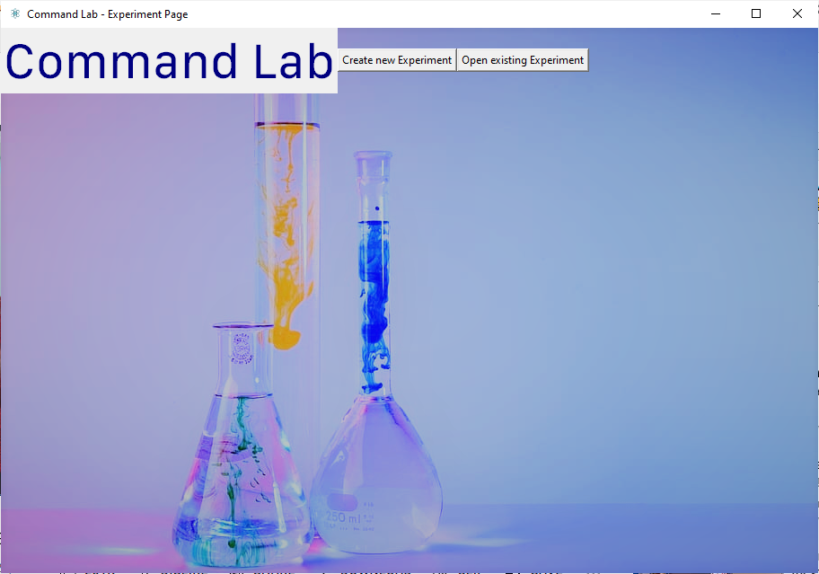

create_entries_frame

create_ExistingExperiment_frame

When ‘Create New Experiment’ Button is clicked: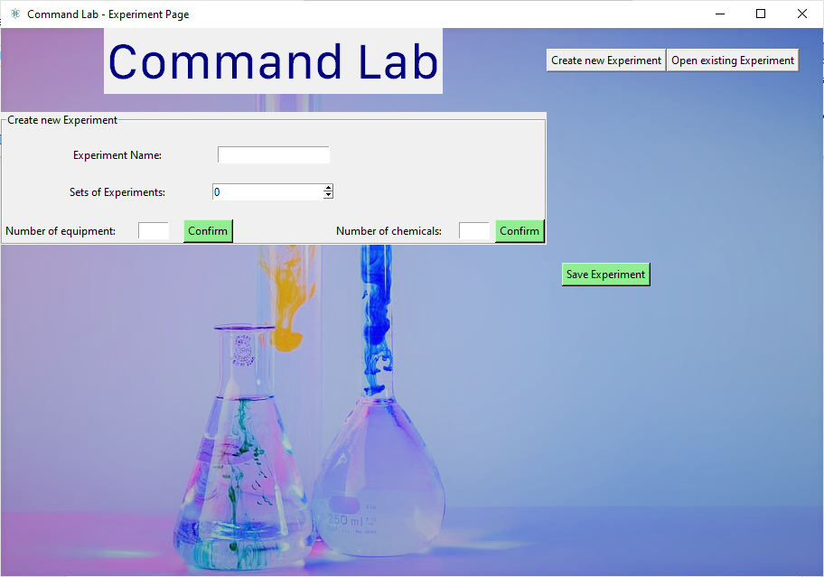

check_for_experiment_errors

chemicals_entry

equipment_entry

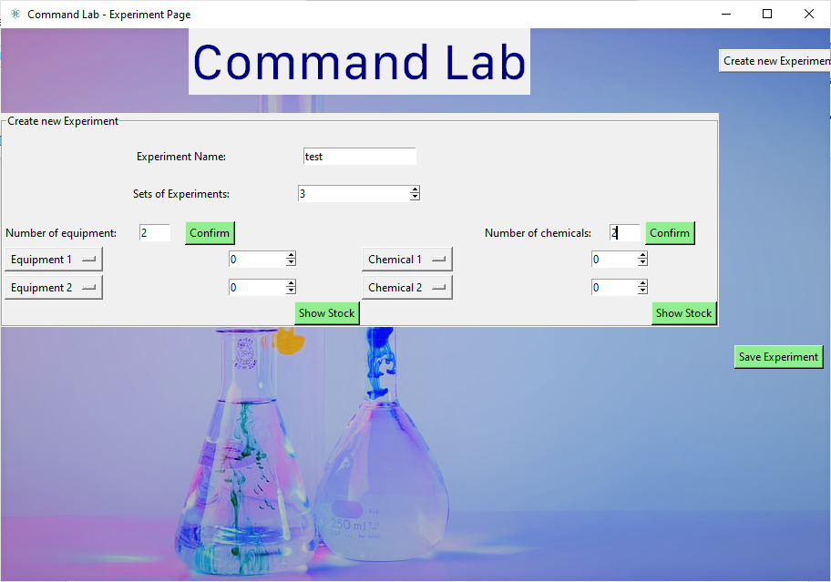

display_chemical_stock

display_equipment_stock

This is the window to display the stock for the selected equipment, for example: 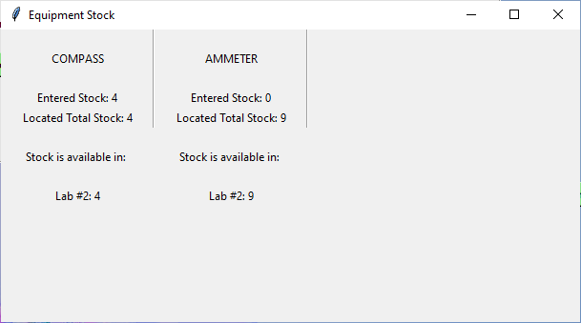

When ‘Open existing Experiment’ button is pressed: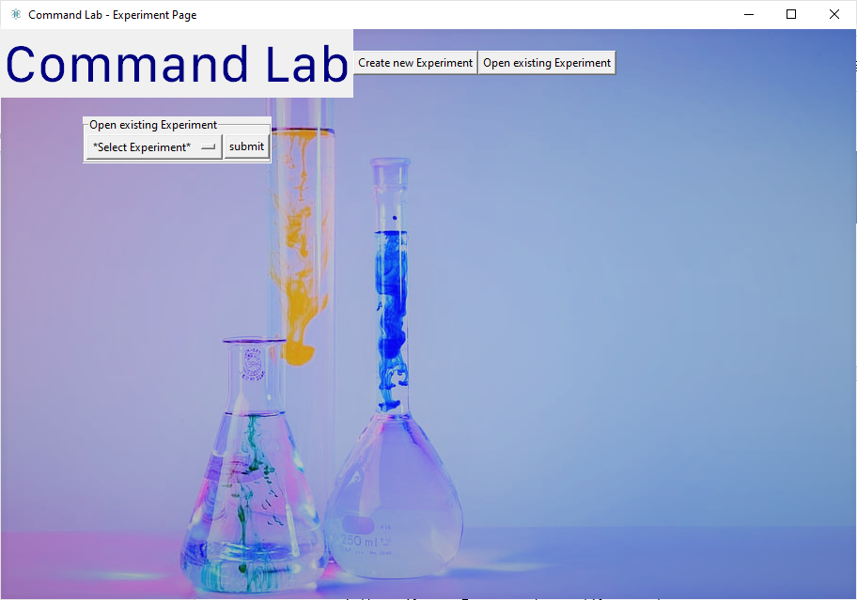

populate_ExistingExperiment_frame

When an experiment is selected, the appropriate information is displayed: 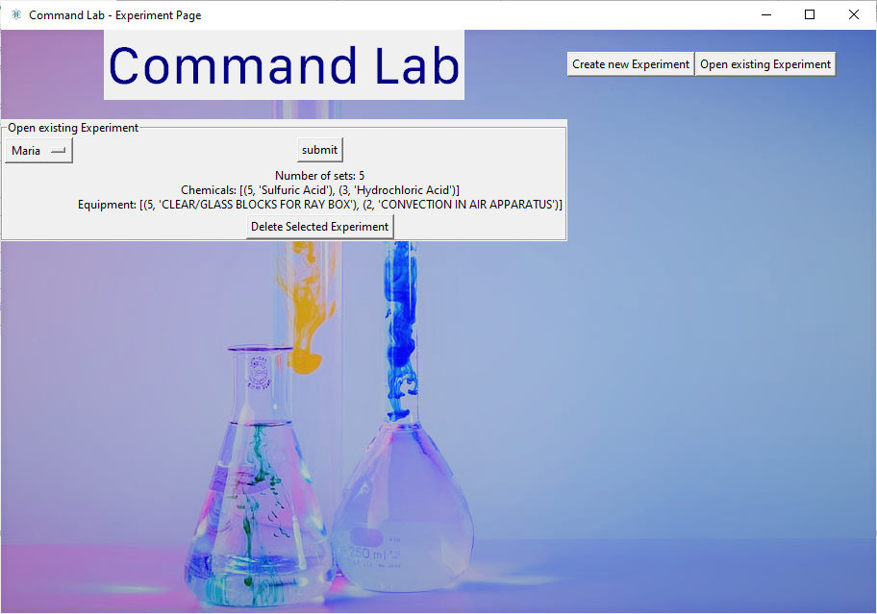

**from** **tkinter** **import** * *#imports tkinter library for GUI*

**from** **PIL** **import** ImageTk, Image *#imports pillow to be able to handle png image files*

**from** **tkinter** **import** ttk *#this is used to use treeview, which can be used to visualize the database*

**from** **tkinter.font** **import** Font

**from** **Experiment_Validations_and_Connections** **import** *

**class** **Experiment_Calculator_Window**:

**def** __init__(self, parent):

self.parent=parent *#creates the tkinter root window, from which all the other tkinter components are managed*

self.experiment_page=Toplevel(self.parent) *#creates an instance of the class using the root tkinter window that can be accessed throughout the class*

**def** configure_GUI(self):

self.experiment_page.title("Command Lab - Experiment Page") *#sets title of the window*

self.experiment_page.iconbitmap("logo.ico") *#sets icon of the window*

self.experiment_page.geometry("910x607") *#sets size of login_page window as that of background image*

*#inserts image in background of main experiment_page window*

**global** img

img=ImageTk.PhotoImage(file='img1.png') *#defined the background image*

back_label = Label(self.experiment_page, image=img) *#created a label for image*

back_label.place(x=0, y=0, relheight=1, relwidth=1) *#positioned image at the top left*

*#title text*

self.title_font = Font(family = "SF Compact Text", size=42)

self.title_text = Label(self.experiment_page, text="Command Lab", fg="navy blue", font=self.title_font)

self.title_text.grid(row=0, column=0)

self.createNewExperiment_Button=Button(self.experiment_page, text="Create new Experiment", command=self.create_entries_frame) *#when pressed, it calls the function to create the widgets to create a new experiment*

self.createNewExperiment_Button.grid(row=0, column=1)

self.openExistingExperiment_Button=Button(self.experiment_page, text="Open existing Experiment", command=self.create_ExistingExperiment_frame) *#when pressed, the button calls the function that opens the frame to view the details about an existing experiment*

self.openExistingExperiment_Button.grid(row=0, column=2)

**try**:

self.parent.mainloop()

**except**:

**pass**

**def** create_ExistingExperiment_frame(self):

self.existing_experiment_frame = LabelFrame(self.experiment_page, text="Open existing Experiment")

self.existing_experiment_frame.grid(row=1, column=0, pady=20)

u5=open_existing_experiment("")

u5.experimentlist=u5.get_experiment_names() *#gets all the experiment names to go into the dropdwon menu*

self.ExperimentOptions= StringVar(self.experiment_page)

self.ExperimentOptions.set("*Select Experiment*")

self.experiment_menu=OptionMenu(self.existing_experiment_frame, self.ExperimentOptions, *u5.experimentlist) *#dropdown menu with the contents of the experiment list as the options*

self.experiment_menu.grid(row=0, column=0)

self.submit_Experiment_Button=Button(self.existing_experiment_frame, text="submit", command=self.populate_ExistingExperiment_frame) *#calls the function to get all the details about the selected experiment from the dropdown menu*

self.submit_Experiment_Button.grid(row=0, column=1)

**def** populate_ExistingExperiment_frame(self):

u2=open_existing_experiment(self.ExperimentOptions.get())

self.existing_experiment_details=u2.get_all_existing_experiments(self.ExperimentOptions.get()) *#populates the window with the information about the selected experiment*

self.existing_experiment_output=("Number of sets: "+ str(self.existing_experiment_details[0][1])+"**\n**Chemicals: "+str(self.existing_experiment_details[1])+"**\n**Equipment: "+str(self.existing_experiment_details[2])) *#displays all the equipment and chemicals and their amounts associated with that specific experiment*

self.experiment_Label=Label(self.existing_experiment_frame, text=self.existing_experiment_output) *#displays that information to the screen*

self.experiment_Label.grid(row=2, column=1)

self.Delete_SelectedExperiment_Button=Button(self.existing_experiment_frame, text="Delete Selected Experiment", command=self.Delete_SelectedExperiment)

self.Delete_SelectedExperiment_Button.grid(row=3, column=1)

**def** Delete_SelectedExperiment(self):

u2=Experiment_Database_Connections("","",self.ExperimentOptions.get(),"","","","")

u2.delete_Selected_Experiment(self.ExperimentOptions.get())

**def** create_entries_frame(self):

self.new_experiment_frame = LabelFrame(self.experiment_page, text="Create new Experiment") *#frame for the entry boxes*

self.new_experiment_frame.grid(row=1, column=0, pady=20)

self.experimentTitle_Label = Label(self.new_experiment_frame, text="Experiment Name:")

self.experimentTitle_Label.grid(row=0, column=0, pady=(20,0))

self.experimentTitle_Entry= Entry(self.new_experiment_frame) *#user enters the experiment name*

self.experimentTitle_Entry.grid(row=0, column=0, columnspan=2, pady=(20,0))

self.experimentSets_Label=Label(self.new_experiment_frame, text="Sets of Experiments:")

self.experimentSets_Label.grid(row=1, column=0, pady=20)

self.experimentSets_Entry=Spinbox(self.new_experiment_frame, from_=0, to=100) *#user enters the number of sets of that experiment (how many groups of students are going to be doing the experiment)*

self.experimentSets_Entry.grid(row=2, column=0, columnspan=2)

self.experimentEquipment_Label=Label(self.new_experiment_frame, text="Equipment:")

self.experimentSets_Label.grid(row=2, column=0, pady=20)

self.equipmentRow=4 *#first equipment drop down menu is going to be placed in row 3*

self.equipment_entries_list=[] *#this list is where the equipment amounts will be stored*

self.equipment_dropdown_list=[] *#this list is where the equipment names will be stored*

self.numberOfEquipment_Label=Label(self.new_experiment_frame, text="Number of equipment:")

self.numberOfEquipment_Label.grid(row=3, column=0, stick='w')

self.numberOfEquipment_Entry=Entry(self.new_experiment_frame, width=5) *#number of equipment that are specific to that experiment*

self.numberOfEquipment_Entry.grid(row=3, column=0, padx=(150,0), stick='w')

self.confirm_NumberofEquipment_Entry = Button(self.new_experiment_frame, bg="light green", text="Confirm", command=self.equipment_entry) *#this will call the function to create an appropriate number of entries of equipment*

self.confirm_NumberofEquipment_Entry.grid(row=3, column=0, padx=(200,0), stick='w')

self.chemicalRow=4

self.chemicals_entries_list=[] *#this list is where the chemical amounts will be stored*

self.chemicals_dropdown_list=[] *#this list is where the chemical names will be stored*

self.numberOfChemicals_Label=Label(self.new_experiment_frame, text="Number of chemicals:")

self.numberOfChemicals_Label.grid(row=3, column=1)

self.numberOfChemicals_Entry=Entry(self.new_experiment_frame, width=5) *#number of chemicals that are specific to that experiment*

self.numberOfChemicals_Entry.grid(row=3, column=1, padx=(190,0))

self.confirm_NumberofChemicals_Entry = Button(self.new_experiment_frame, bg="light green", text="Confirm", command=self.chemicals_entry) *#this will call the function to create an appropriate number of entries of chemicals*

self.confirm_NumberofChemicals_Entry.grid(row=3, column=1, padx=(290,0))

self.submitExperimenttoDb_Button = Button(self.experiment_page, bg="light green", text="Save Experiment", command=self.check_for_experiment_errors) *#calls the function to submit these new details to the database to be stored*

self.submitExperimenttoDb_Button.grid(row=3, column=1)

**def** equipment_entry(self):

u2=Experiment_Database_Connections("","","","","","","")

u2.equipmentlist=u2.get_all_equipment_as_list() *#this is the list which will store all the equipment names in the entire database, from which the user can choose which one they wish to select for their experiment*

self.equipment_num=int(self.numberOfEquipment_Entry.get()) *#this stores the number of equipments that is extracted from the entry*

**for** i **in** range (0, self.equipment_num): *#creates as many equipment entry boxes for the number that was selected earlier*

self.EquipmentOptions = StringVar(self.experiment_page)

self.EquipmentOptions.set("Equipment "+ str(i+1)) *#makes the default selected value of the dropdown menu linked to the row*

self.equipment_dropdown=OptionMenu(self.new_experiment_frame, self.EquipmentOptions, *u2.equipmentlist) *# Create and append to list*

self.equipment_dropdown.grid(row=i+4, column=0, sticky='w') *# Place the just created widget*

self.equipment_dropdown_list.append(self.EquipmentOptions)

**for** i **in** range(0, self.equipment_num):

self.equipment_entries_list.append(Spinbox(self.new_experiment_frame, width=10, from_=0, to=1000)) *# Create and append to list*

self.equipment_entries_list[-1].grid(row=i+4, column=0, padx=(180,0)) *# Place the just created widget*

self.check_equipment_stock_Button = Button(self.new_experiment_frame, bg="light green", text="Show Stock", command=self.display_equipment_stock) *#this will call the function to display the stock and location of the selected equipment*

self.check_equipment_stock_Button.grid(row=11, column=0, padx=(320,0))

**def** display_equipment_stock(self):

*#makes the window to display the available locations and stocks for the corresponding equipment*

self.top_window=Toplevel()

self.top_window.geometry("607x307")

self.top_window.title("Equipment Stock")

**for** val **in** range(0, (len(self.equipment_dropdown_list))): *#for every value in the equipment name list...*

*#displays all the equipment*

self.EquipmentName=self.equipment_dropdown_list.pop()

self.EquipmentName=self.EquipmentName.get()

self.EquipmentName_Label=Label(self.top_window, text=self.EquipmentName)

self.EquipmentName_Label.grid(row=0, column=val, padx=20, pady=20)

*#places a column separator for visual separation between equipment*

self.ColumnSeparator=ttk.Separator(self.top_window, orient=VERTICAL).grid(column=val, row=0, rowspan=3, sticky='nse')

*#gets values of stock that are entered by the user earlier*

self.EnteredEquipmentStock_Label=Label(self.top_window, text="Entered Stock: "+(self.equipment_entries_list[val].get()))

self.EnteredEquipmentStock_Label.grid(row=1, column=val, padx=20)

*# try:*

u2=Experiment_Database_Connections(self.EquipmentName, "","","","","","")

u2.equipmentStockvalue=u2.get_equipment_stock(self.EquipmentName)

**if** u2.equipmentStockvalue==0: *#if there is no recorded stock in the database, then an appropriate message is displayed*

self.EquipmentStockLookup_Label=Label(self.top_window, text="Located Stock: None", bg='red')

self.EquipmentStockLookup_Label.grid(row=2, column=val, padx=20)

**else**:

self.EquipmentStockLookup_Label=Label(self.top_window, text="Located Total Stock: "+str(u2.equipmentStockvalue)) *#displays the stock in the location*

self.EquipmentStockLookup_Label.grid(row=2, column=val, padx=20)

self.LocationofStock_Label=Label(self.top_window, text="Stock is available in: ") *#displays the location of the stock*

self.LocationofStock_Label.grid(row=3, column=val, pady=20)

u2.Equipment_Locations=u2.get_equipment_locations(self.EquipmentName)

**for** i **in** range (0, len(u2.Equipment_Locations)):

self.EquipmentStock_Label=Label(self.top_window, text="Lab #" + str(u2.Equipment_Locations[i][0]) + ": " + str(u2.Equipment_Locations[i][1])) *#Manipulates array and tuple in vector array to display corresponding values correctly*

self.EquipmentStock_Label.grid(row=i+5, column=val)

**def** chemicals_entry(self):

u2=Experiment_Database_Connections("","","","","","","")

u2.chemicalList=u2.get_all_chemicals_as_list() *#this is the list which will store all the chemical names in the entire database, from which the user can choose which one they wish to select for their experiment*

self.chem_num=int(self.numberOfChemicals_Entry.get()) *#this stores the number of chemicals that is extracted from the entry that the user selected*

**for** i **in** range (0, self.chem_num): *#creates as many chemical entry boxes for the number that was selected earlier*

self.ChemicalOptions = StringVar(self.experiment_page)

self.ChemicalOptions.set("Chemical "+ str(i+1)) *#makes the default selected value of the dropdown menu linked to the row*

self.chemicals_dropdown=OptionMenu(self.new_experiment_frame, self.ChemicalOptions, *u2.chemicalList) *# Create and append to list*

self.chemicals_dropdown.grid(row=i+4, column=1, sticky='w') *# Place the just created widget*

self.chemicals_dropdown_list.append(self.ChemicalOptions)

**for** i **in** range(0, self.chem_num):

self.chemicals_entries_list.append(Spinbox(self.new_experiment_frame, width=8, from_=0, to=2000)) *# Create and append to list*

self.chemicals_entries_list[-1].grid(row=i+4, column=1, padx=(180,0)) *# Place the just created widget*

self.check_chemical_stock_Button = Button(self.new_experiment_frame, bg="light green", text="Show Stock", command=self.display_chemical_stock)*#this will call the function to display the stock availability of the selected chemical*

self.check_chemical_stock_Button.grid(row=11, column=1, padx=(320,0))

**def** display_chemical_stock(self):

*#makes the window to display the available stocks for the corresponding chemical*

self.top_window=Toplevel()

self.top_window.geometry("607x307")

self.top_window.title("Chemical Stock")

**for** val **in** range(0, (len(self.chemicals_dropdown_list))): *#for every value in the chemical name list...*

*#displays all the equipment*

self.ChemicalName=self.chemicals_dropdown_list[val].get()

self.ChemicalName_Label=Label(self.top_window, text=self.ChemicalName)

self.ChemicalName_Label.grid(row=0, column=val, padx=20, pady=20)

*#places a column separator for visual separation between equipment*

self.ColumnSeparator=ttk.Separator(self.top_window, orient=VERTICAL).grid(column=val, row=0, rowspan=3, sticky='nse')

*#gets values of stock that are entered by the user earlier*

self.EnteredChemicalStock_Label=Label(self.top_window, text="Entered Chemical Stock: "+(self.chemicals_entries_list[val].get()))

self.EnteredChemicalStock_Label.grid(row=1, column=val, padx=20)

**try**:

u2=Experiment_Database_Connections("",self.ChemicalName,"","","","","")

u2.chemicalStockValue=u2.get_chemical_stock(self.ChemicalName)

**if** u2.chemicalStockValue==0: *#if there is no recorded stock in the database, then an appropriate message is displayed*

self.ChemicalStockLookup_Label=Label(self.top_window, text="Located Stock: None", bg='red')

self.ChemicalStockLookup_Label.grid(row=2, column=val, padx=20)

**else**:

self.ChemicalsStockLookup_Label=Label(self.top_window, text="Located Total Stock: "+str(u2.chemicalStockValue[0][0])) *#displays the stock that was found for the chemical*

self.ChemicalsStockLookup_Label.grid(row=2, column=val, padx=20)

**except**:

self.ChemicalsStockLookup_Label=Label(self.top_window, text="Located Stock: None")

self.ChemicalsStockLookup_Label.grid(row=2, column=val, padx=20)

self.ChemicalName_Label.config(bg='red')

**def** check_for_experiment_errors(self):

*#creates frame to add error messages*

self.ExperimentError_Frame=LabelFrame(self.experiment_page)

self.ExperimentError_Frame.grid(row=2, column=0)

self.ExperimentError_Label=Label(self.ExperimentError_Frame)

self.ExperimentError_Label.grid(row=0, column=0)

*#sends the below values to the database*

*#gets and checks the entered experiment title*

self.Entered_ExperimentName=self.experimentTitle_Entry.get()

self.experimentName_Valid=self.Check_ExperimentName()

*#gets and checks the entered experiment sets*

self.Entered_NumberOfSets=self.experimentSets_Entry.get()

self.experimentSets_Valid=self.Check_ExperimentSets()

**if** self.experimentName_Valid == True **and** self.experimentSets_Valid==True:

self.save_experiment_details()

**def** Check_ExperimentName(self):

*#performs validation on the experiment name*

u2=Experiments_Validations(self.Entered_ExperimentName,"")

u2.experimentName_format_valid=u2.validate_ExperimentName(self.Entered_ExperimentName)

**if** u2.experimentName_format_valid==False: *#if it is invalid...*

self.ExperimentError_Label.configure(text="Experiment Name Invalid")

**else**:

**pass**

**return** u2.experimentName_format_valid

**def** Check_ExperimentSets(self): *#performs validation on the number of equipment sets*

u2=Experiments_Validations("",self.Entered_NumberOfSets)

u2.experimentSets_format_valid=u2.validate_ExperimentSets(self.Entered_NumberOfSets)

**if** u2.experimentSets_format_valid==False: *#if it is invalid...*

self.ExperimentError_Label.configure(text="Experiment Sets Invalid")

**else**:

**pass**

**return** u2.experimentSets_format_valid

**def** save_experiment_details(self):

u2=Experiment_Database_Connections("","", self.Entered_ExperimentName, self.Entered_NumberOfSets,"","","") *#creates an instance of the class Experiment_Database_Connections*

self.Generated_ExperimentID= u2.SendTo_Experiment_Sets(self.Entered_ExperimentName, self.Entered_NumberOfSets) *#sends off the experiment name and number of sets to be added to the database*

**for** i **in** range(0, (len(self.equipment_dropdown_list))):

u3=Experiment_Database_Connections(self.equipment_dropdown_list[i].get(),"","","",self.Generated_ExperimentID,self.equipment_entries_list[i].get(),"")

u3.SendTo_Experiment_Equipment(self.equipment_dropdown_list[i].get(), self.Generated_ExperimentID, self.equipment_entries_list[i].get()) *#sends off the equipment ID's and their amounts that were selected for the experiment*

**for** i **in** range(0, (len(self.chemicals_dropdown_list))):

u4=Experiment_Database_Connections("",self.chemicals_dropdown_list[i].get(),"","",self.Generated_ExperimentID,"",self.chemicals_entries_list[i].get())

u4.SendTo_Experiment_Chemicals(self.chemicals_dropdown_list[i].get(),self.Generated_ExperimentID,self.chemicals_entries_list[i].get()) *#sends off the chemical ID's and the amounts that were selected for the experiment to be sent off for storage*

Procedures and Variables

|  |  |  |
| --- | --- | --- |
| Experiment_Calculator_Window– This class holds the procedures for the GUI to create and view experiments | | |
| Procedures | Purpose | Variables |
| configure_GUI | Sets background, title, and size of window.  Displays buttons for creating and viewing buttons | createNewExperiment_Button  openExistingExperiment_Button |
| create_ExistingExperiment_frame | Displaying the widgets to allow user to select which experiment they would like to view information about | ExperimentOptions  submit_Experiment_Button |
| populate_ExistingExperiment_frame | Calls for and displays all the information about the experiment selected by the user | existing_experiment_details |
| Delete_SelectedExperiment | Sends off the experiment to be deleted to the validations and connections file | self.ExperimentOptions.get() |
| create_entries_frame | Displays the entries for the user to input the experiment name, sets, chemicals, and equipment amounts and names | experimentTitle_Entry  experimentSets_Entry  equipment_entries_list  equipment_dropdown_list  chemicals_entries_list  chemicals_dropdown_list |
| equipment_entry | Calls for the list of equipment names to be displayed as a dropdown menu for the user.  Creates the same number of dropdown menus as specified by the user.  Creates entries to input the number of equipment required.  Displays button to confirm stock location of selected equipment |  |
| display_equipment_stock | Creates a toplevel window to display the location and stock for the selected equipment(s).  **Through the use of stacks, the equipment names are appended and popped from the stack to be displayed to the user.** |  |
| chemicals_entry | Calls for the list of chemical names to be displayed as a dropdown menu for the user.  Creates the same number of dropdown menus as specified by the user.  Creates entries to input the amount of chemical required.  Displays button to confirm stock of selected chemical. |  |
| display_chemical_stock | Creates a toplevel window to display the stock for the selected chemical(s). |  |
| check_for_experiment_errors | Calls functions to validate the entries throughout the ‘create experiment page’ | ExperimentError_Label |
| Check_ExperimentName | Validates the format of the experiment name.  Displays appropriate error message if required. | experimentName_Valid |
| Check_ExperimentSets | Validates the format of the experiment sets.  Displays appropriate error message if required. | experimentSets_Valid |
| save_experiment_details | Calls functions to send off validated data for the new experiment and its attributes |  |

### 4.3.7 Experiment_Validations_and_Connections.py

Code

**import** **sqlite3** *#imports database SQLite 3 library for SQL functions*

**import** **re** *#this imports the regular expression module*

**class** **Experiment_Database_Connections**:

**def** __init__(self, Entered_EquipmentName, Entered_ChemicalName, Entered_ExperimentName, Entered_NumberOfSets, Generated_ExperimentID, Entered_EquipmentAmount, Entered_ChemicalAmount):

self.Entered_EquipmentName=Entered_EquipmentName

self.Entered_ChemicalName=Entered_ChemicalName

self.Entered_ExperimentName=Entered_ExperimentName

self.Entered_NumberOfSets=Entered_NumberOfSets

self.Generated_ExperimentID=Generated_ExperimentID

self.Entered_EquipmentAmount=Entered_EquipmentAmount

self.Entered_ChemicalAmount=Entered_ChemicalAmount

**def** get_all_equipment_as_list(self):

conn = sqlite3.connect("Command_Lab.db")

conn.row_factory = **lambda** cursor, row: row[0] *#configures it so that it is stored as a regular list in the form [x,y,z] instead of [(x,),(y,),(z,)], which is easier to read by tkinter optionmenu*

c = conn.cursor()

EquipmentList = c.execute("SELECT Equipment_Name FROM Equipment").fetchall() *#gets all the names in the equipment table for the dropdown menu*

conn.commit() *#commits changes*

conn.close() *#closes connection to database*

**return** EquipmentList

**def** get_all_chemicals_as_list(self):

conn = sqlite3.connect("Command_Lab.db")

conn.row_factory = **lambda** cursor, row: row[0] *#configures it so that it is stored as a regular list in the form [x,y,z] instead of [(x,),(y,),(z,)], which is easier to read by tkinter optionmenu*

c = conn.cursor()

ChemicalsList = c.execute("SELECT Chemical_Name FROM Chemicals").fetchall() *#gets all the names in the chemicals table for the dropdown menu*

conn.commit() *#commits changes*

conn.close() *#closes connection to database*

**return** ChemicalsList

**def** get_equipment_stock(self, Entered_EquipmentName):

conn = sqlite3.connect("Command_Lab.db")

c=conn.cursor()

c.execute("""

SELECT Equipment_Location.Equipment_Stock FROM Equipment

INNER JOIN Equipment_Location ON Equipment_Location.Equipment_ID = Equipment.Equipment_ID

WHERE Equipment.Equipment_Name=(?)

""", (self.Entered_EquipmentName,)) *#gets the information about the stock and location of the selected equipment.*

queriedStockvalue=(c.fetchall())

equipmentStockvalue=0

**for** i **in** range(0, len(queriedStockvalue)):

equipmentStockvalue+=int(queriedStockvalue[i][0]) *#adds them to a 2D array for easier manipulation*

conn.commit() *#commits changes*

conn.close() *#closes connection to database*

**return** equipmentStockvalue

**def** get_equipment_locations(self,Entered_EquipmentName):

conn = sqlite3.connect("Command_Lab.db")

c=conn.cursor()

Equipment_Locations=c.execute("SELECT Equipment_Location.Location_ID, Equipment_Location.Equipment_Stock FROM Equipment INNER JOIN Equipment_Location ON Equipment_Location.Equipment_ID = Equipment.Equipment_ID WHERE Equipment_Name=(?) ORDER BY Equipment_Location.Location_ID ASC", (self.Entered_EquipmentName,)).fetchall() *#selects the stock available in a specific location for the specified equipment*

conn.commit() *#commits changes*

conn.close() *#closes connection to database*

**return** Equipment_Locations

**def** get_chemical_stock(self, Entered_ChemicalName):

conn = sqlite3.connect("Command_Lab.db")

c=conn.cursor()

Chemical_Stock=c.execute("SELECT Chemical_Stock FROM Chemicals WHERE Chemical_Name=(?)", (self.Entered_ChemicalName,)).fetchall() *#gets the stock for the specified chemical*

conn.commit() *#commits changes*

conn.close() *#closes connection to database*

**return** Chemical_Stock

**def** SendTo_Experiment_Sets(self, Entered_ExperimentName, Entered_NumberOfSets):

conn = sqlite3.connect("Command_Lab.db")

c=conn.cursor()

c.execute("INSERT INTO Experiment_Sets VALUES (NULL, :Experiment_Name, :Experiment_Sets)", {"Experiment_Name": self.Entered_ExperimentName, "Experiment_Sets": self.Entered_NumberOfSets}) *#inserts the new attributes related to the experiment name and experiment sets for the new experiment to get a new experiment ID*

Generated_ExperimentID=c.execute("SELECT Experiment_ID FROM Experiment_Sets WHERE Experiment_Name=(?)", (self.Entered_ExperimentName,)).fetchone()[0] *#returns the new experiment ID*

conn.commit() *#commits changes*

conn.close() *#closes connection to database*

**return** Generated_ExperimentID

**def** SendTo_Experiment_Equipment(self, Entered_EquipmentName, Generated_ExperimentID, Entered_EquipmentAmount):

conn = sqlite3.connect("Command_Lab.db")

c=conn.cursor()

self.Equipment_ID = c.execute("SELECT Equipment_ID FROM Equipment WHERE Equipment_Name = (?)", (self.Entered_EquipmentName,)).fetchone()[0]

c.execute("INSERT INTO Experiment_Equipment VALUES (:Experiment_ID, :Equipment_ID, :Equipment_Amount)", {"Experiment_ID": self.Generated_ExperimentID, "Equipment_ID": self.Equipment_ID, "Equipment_Amount": self.Entered_EquipmentAmount}) *#adds the new equipment and their amounts to the table*

conn.commit() *#commits changes*

conn.close() *#closes connection to database*

**def** SendTo_Experiment_Chemicals(self, Entered_ChemicalName, Generated_ExperimentID, Entered_ChemicalAmount):

conn = sqlite3.connect("Command_Lab.db")

c=conn.cursor()

self.Chemical_ID = c.execute("SELECT Chemical_ID FROM Chemicals WHERE Chemical_Name = (?)", (self.Entered_ChemicalName,)).fetchone()[0]

c.execute("INSERT INTO Experiment_Chemicals VALUES (:Experiment_ID, :Chemical_ID, :Chemical_Amount)", {"Experiment_ID": self.Generated_ExperimentID, "Chemical_ID": self.Chemical_ID, "Chemical_Amount": self.Entered_ChemicalAmount}) *#adds the new chemicals and their amounts to the table*

conn.commit() *#commits changes*

conn.close() *#closes connection to database*

**def** delete_Selected_Experiment(self, Entered_ExperimentName):

conn = sqlite3.connect("Command_Lab.db")

c=conn.cursor()

c.execute('DELETE from Experiment_Sets WHERE Experiment_Name=?',(self.Entered_ExperimentName,))

conn.commit() *#commits changes*

conn.close() *#closes connection to database*

**class** **Experiments_Validations**(Experiment_Database_Connections): *#validation functions*

**def** __init__(self, Experiment_Name, Experiment_Sets):

self.Experiment_Name=Experiment_Name

self.Experiment_Sets=Experiment_Sets

**def** validate_ExperimentName(self, Experiment_Name):

experimentName_Format = "^[A-Za-z0-9 ]{1,50}$" *#checks that experiment title is only alphabet or a space and is between 1 and 50 characters.*

**if** re.fullmatch(experimentName_Format, self.Experiment_Name): *#checks if entered experiment name matches the correct format*

experimentName_format_valid=True

**else**:

experimentName_format_valid=False *#any other format, including an empty value, would be revoked*

**return** experimentName_format_valid

**def** validate_ExperimentSets(self, Experiment_Sets):

experimentSets_Format = "^([1-9]|10|)$" *#checks that the sets are between 0-10*

**if** re.fullmatch(experimentSets_Format, self.Experiment_Sets): *#checks if matches the correct format*

experimentSets_Format_Valid=True

**else**:

experimentSets_Format_Valid=False *#any other format, including an empty value, would be revoked*

**return** experimentSets_Format_Valid

**class** **open_existing_experiment**(Experiment_Database_Connections):

**def** __init__(self, Selected_ExperimentName):

self.Selected_ExperimentName=Selected_ExperimentName

**def** get_experiment_names(self):

conn = sqlite3.connect("Command_Lab.db")

conn.row_factory = **lambda** cursor, row: row[0] *#configures it so that it is stored as a regular list in the form [x,y,z] instead of [(x,),(y,),(z,)], which is easier to read by tkinter optionmenu*

c=conn.cursor()

ExperimentNames = c.execute("SELECT Experiment_Name FROM Experiment_Sets").fetchall() *#gets all the existing experiments to be displayed for the user*

conn.commit() *#commits changes*

conn.close() *#closes connection to database*

**return** ExperimentNames

**def** get_all_existing_experiments(self, Selected_ExperimentName):

conn=sqlite3.connect("Command_Lab.db")

c=conn.cursor()

ExperimentDetails_List = c.execute("SELECT Experiment_ID, Experiment_Sets FROM Experiment_Sets WHERE Experiment_Sets.Experiment_Name=(?)", (self.Selected_ExperimentName,)).fetchall()

self.Experiment_ID=ExperimentDetails_List[0][0]

ExperimentDetails_List.append(c.execute("SELECT Experiment_Chemicals.Chemical_Amount, Chemicals.Chemical_Name FROM Experiment_Chemicals INNER JOIN Chemicals ON Experiment_Chemicals.Chemical_ID = Chemicals.Chemical_ID WHERE Experiment_Chemicals.Experiment_ID=(?)", (self.Experiment_ID,)).fetchall())

ExperimentDetails_List.append(c.execute("SELECT Experiment_Equipment.Equipment_Amount, Equipment.Equipment_Name FROM Experiment_Equipment INNER JOIN Equipment ON Experiment_Equipment.Equipment_ID = Equipment.Equipment_ID WHERE Experiment_Equipment.Experiment_ID=(?)", (self.Experiment_ID,)).fetchall())

conn.commit()

conn.close() *#gets all the information about equipment and chemicals and their corresponding amounts for the passed in experiment Name from the dropdown menu.*

**return** ExperimentDetails_List

Procedures and Variables

|  |  |  |
| --- | --- | --- |
| Experiment_Database_Connections– This class holds the procedures for SQL queries in creating experiments | | |
| Procedures | Purpose | Variables |
| get_all_equipment_as_list | gets all the names in the equipment table for the dropdown menu | EquipmentList |
| get_all_chemicals_as_list | gets all the names in the chemicals table for the dropdown menu | ChemicalsList |
| get_equipment_stock | gets the information about the stock and location of the selected equipment and converts it to a 2D array for manipulation using **parametrised cross-table SQL statement embedded in the programming language**. | queriedStockvalue  equipmentStockvalue |
| get_equipment_locations | selects the stock available in a specific location for the specified equipment | Equipment_Locations |
| get_chemical_stock | gets the stock for the specified chemical | Chemical_Stock |
| SendTo_Experiment_Sets | inserts the new attributes related to the experiment name and experiment sets for the new experiment to get a new experiment ID for the Experiment_Sets table |  |
| SendTo_Experiment_Equipment | adds the new equipment and their amounts to the Experiment_Equipment table |  |
| SendTo_Experiment_Chemicals | adds the new chemicals and their amounts to the table |  |

|  |  |  |
| --- | --- | --- |
| Experiments_Validations– This class holds the procedures for validating user inputs | | |
| Procedures | Purpose | Variables |
| validate_ExperimentName | checks that experiment title is only alphabet or a space and is between 1 and 50 characters. | experimentName_format_valid |
| validate_ExperimentSets | checks that the sets are between 0-10 | experimentSets_Format_Valid |

|  |  |  |
| --- | --- | --- |
| open_existing_experiment– T This class holds the procedures for SQL queries in viewing existing experiments | | |
| Procedures | Purpose | Variables |
| get_experiment_names | gets all the existing experiments to be displayed for the user | ExperimentNames |
| get_all_existing_experiments | gets all the information about equipment and chemicals and their corresponding amounts for the passed in Experiment Name from the dropdown menu.  Stores it as a list | ExperimentDetails_List |

### 4.3.8 Reference File for creating tables and database

This file’s purpose is to store all the functions relating to creating the tables and columns and relationships between the tables. Since this only needs to be run once, I have separated them into functions which can be called whenever needed.

**import** **sqlite3** *#imports database SQLite 3 library for SQL functions*

**def** create_equipment_db():

conn = sqlite3.connect("Command_Lab.db") *#creates or connects to the users database*

c=conn.cursor() *#creates cursor*

c.execute("""CREATE TABLE if not exists Equipment (

Equipment_Name STRING,

Consumable INTEGER,

Equipment_ID INTEGER PRIMARY KEY AUTOINCREMENT)""")

conn.commit() *#commits changes*

conn.close() *#closes connection to database*

**def** create_chemicals_db():

conn = sqlite3.connect("Command_Lab.db") *#creates or connects to the Chemicals database*

c=conn.cursor() *#creates cursor*

c.execute("""CREATE TABLE if not exists Chemicals (

Chemical_Name STRING,

Chemical_Stock DECIMAL,

Chemical_ID INTEGER PRIMARY KEY AUTOINCREMENT)""")

conn.commit() *#commits changes*

conn.close() *#closes connection to database*

**def** create_equipment_science_db():

conn = sqlite3.connect("Command_Lab.db") *#creates or connects to the Equipment_Science database*

c=conn.cursor() *#creates cursor*

c.execute("""CREATE TABLE if not exists Equipment_Science (

Equipment_ID INTEGER REFERENCES Equipment (Equipment_ID),

Science integer

);""")

conn.commit() *#commits changes*

conn.close() *#closes connection to database*

**def** create_Equipment_Location_table():

conn = sqlite3.connect("Command_Lab.db") *#creates or connects to the Equipment_Location database*

c=conn.cursor() *#creates cursor*

c.execute("""CREATE TABLE if not exists Equipment_Location (

Location_ID INTEGER,

Equipment_ID INTEGER REFERENCES Equipment (Equipment_ID),

Equipment_Stock DECIMAL,

PRIMARY (Equipment_ID, Location_ID)

);""")

conn.commit() *#commits changes*

conn.close() *#closes connection to database*

**def** create_Experiment_Sets_table():

conn = sqlite3.connect("Command_Lab.db") *#creates or connects to the Equipment_Sets database or connects to one*

c=conn.cursor() *#creates cursor*

c.execute("""CREATE TABLE if not exists Equipment_Sets (

Experiment_Name STRING,

Experiment_Sets INTEGER,

Experiment_ID INTEGER PRIMARY KEY AUTOINCREMENT)""")

conn.commit() *#commits changes*

conn.close() *#closes connection to database*

**def** create_Experiment_Equipment_table():

conn = sqlite3.connect("Command_Lab.db") *#creates or connects to the Experiment_Equipment database*

c=conn.cursor() *#creates cursor*

c.execute("""CREATE TABLE if not exists Experiment_Equipment (

Experiment_ID INTEGER REFERENCES Experiment_Sets (Experiment_ID),

Equipment_ID REFERENCES Equipment (Equipment_ID),

Equipment_Amount DECIMAL,

PRIMARY KEY (

Experiment_ID,

Equipment_ID

)""")

conn.commit() *#commits changes*

conn.close() *#closes connection to database*

**def** create_Experiment_Equipment_table():

conn = sqlite3.connect("Command_Lab.db") *#creates or connects to the Experiment_Chemicals database*

c=conn.cursor() *#creates cursor*

c.execute("""CREATE TABLE if not exists Experiment_Chemicals (

Experiment_ID INTEGER REFERENCES Experiment_Sets (Experiment_ID),

Chemical_ID REFERENCES Chemicals (Chemical_ID),

Chemical_Amount DECIMAL,

PRIMARY KEY (

Experiment_ID,

Chemical_ID

)""")

conn.commit() *#commits changes*

conn.close() *#closes connection to database*

**def** create_Equipment_Supplier_table():

conn = sqlite3.connect("Command_Lab.db") *#creates or connects to the Equipment_Supplier database*

c=conn.cursor() *#creates cursor*

c.execute("""CREATE TABLE if not exists Equipment_Supplier (

Supplier_Email STRING REFERENCES Supplier_Details (Supplier_Email),

Equipment_ID REFERENCES Equipment (Equipment_ID)

)""")

conn.commit() *#commits changes*

conn.close() *#closes connection to database*

**def** create_users_table():

conn = sqlite3.connect("Command_Lab.db") *#creates or connects to the users database or connects to one*

c=conn.cursor() *#creates cursor*

c.execute("""CREATE TABLE if not exists Users (

username text primary key,

salt text,

hash_key text,

email text,

teacher_or_technician integer

)""") *#creates the table for the user's info, including the username as well as the hash key, the salt, the email, and the teacher_or_technician variable*

conn.commit() *#commits changes*

conn.close() *#closes connection to database*

**def** create_Supplier_Details_Table():

conn = sqlite3.connect("Command_Lab.db") *#creates or connects to the Supplier_Details database or connects to one*

c=conn.cursor() *#creates cursor*

c.execute("""CREATE TABLE if not exists Supplier_Details (

Supplier_email text primary key,

Supplier_Name text,

)""")

conn.commit() *#commits changes*

conn.close() *#closes connection to database*

create_equipment_db()

create_chemicals_db()

create_equipment_science_db()

create_Equipment_Location_table()

create_Experiment_Sets_table()

create_Experiment_Equipment_table()

create_Experiment_Equipment_table()

create_Equipment_Supplier_table()

create_users_table()

create_Supplier_Details_Table()

# 5. Evaluation

## 5.1 Comparing Performance against Objectives

|  |  |  |  |
| --- | --- | --- | --- |
| No | Objective | Performance Criteria | Evaluation |
| 2 | A secure login system | A separate view for login, registration, and deletion of accounts. | Test 38 shows that upon running the program, the login page is automatically loaded up.  The execution of the login page is shown in Tests 1-5.  The register window can be accessed by clicking the register button, as shown by Test 39.  The execution of the register page is shown in Tests 6-9.  The delete user window can be accessed by the ‘delete User’ button, as shown by Test 10.  The execution of the delete user window is shown in Tests 10 and 11.  This objective has been met. |
| 2 | A secure login system | Robust use of validation for formatting of passwords and email addresses. | Through the use of regular expressions, the validation of the password is shown in the Validate_Password function in the Login_Validations_and_Connections.py file.  The execution of this is shown through Tests 6, 8, and 9.  The program will insist that the password is longer than 8 characters and must match the repeat password entry, to confirm. The regular expression specifies that the entered password must contain at least one capital letter (A-Z), one lower case letter (a-z), one special character (out of a pre-set list) and one number (0-9).  The entered username is validated, using regular expressions, to strictly ensure that the entered email address is in the format of the school staff’s email address. This validation is demonstrated in the Validate_Email function in the Login_Validations_and_Connections.py file.  The execution of this is shown through Tests 6 and 7.  This objective has been met. |
| 2 | A secure login system | Generate a hash key as well as a salt for every password and store only the hash key and salt on the database. | The salt and hash key are generated whenever the hash_password function is called, after which the password is encoded, then hashed using the hashlib ‘pbkdf2’ function. Next, a salt is randomly-generated and passed through the hash function with the encoded password.  The process is repeated 100,000 times and the salt and hash key are finally outputted for storage.  Hashing is used to store login details for privacy reasons. Accessing the database directly will yield a string of completely random numbers representing the salt and hash key, and the password will remain inaccessible directly from the database.  This objective has been met. |
| 2 | A secure login system | Must be able to create and delete accounts easily | To create an account, the ‘register’ button redirects the user to the register window.  There, the user will be prompted to register their account. After a successful registration, the user will be shown their generated username as well as their valid password, as shown by Test 6.  The username is generated by truncating the string portion that corresponds to the user’s email address, as shown in the generate_username function (in the Login_Validations_and_Connections.py file). This is purely for speed when logging in.  To delete a user, the user must click on the ‘Delete user’ button on the register page. The deletion will only go through if the username exists in the database, as shown by Tests 10 and 11.  This objective has been met. |
| 3 | Create a program to store stock and location information securely in the database | Uses separate permissions for teachers and technicians about database editing and viewing | As specified by my end-user, she specifically outlined that the teachers should not be able to access information about suppliers. Additionally, only technicians should have access to edit the inventory values.  Therefore, the self.permissions variable represents whatever the check_teacher_or_technician function returns (in the Login_Validations_and_Connections.py file).  The self.permissions data is used to block away the Equipment_Location editing functions, Supplier_Chart (supplier information),  edit_Equipment_Chart (functions that edit the equipment chart), and edit_Chemical classes (functions that edit the chemicals chart). This is displayed through Test 12.  This objective has been met. |
| 3 | Create a program to store stock and location information securely in the database | Must be secure enough so that only the end user can access the contents of the database. | My program only has access to the database once the user has been correctly logged into the system. I have ensured that the system is password protected with a strong password (as detailed in the above objective). Tests 1-5 demonstrate the robust login system.  However, the database file itself can be opened independently from the system and the data can be subsequently accessed.  After consulting with Ms. Divya about this point, she explained that this point was not exactly critical since the program automatically locks when logged out. Furthermore, this system will be stored exclusively in a locked science storage room, so that is enough security for the database.  This objective is partially achieved. |
| 4 | Using SQL queries; filter, search, delete, insert, and view equipment data | Uses a centralised database system to contain all information about stock. | The landing Inventory Page contains all the buttons that require you to access inventory information on command, as shown by the first image in the Inventory_System_GUI.py section above.  The Equipment (run_Equipment_Chart), Chemicals (run_Chemical_Chart), and Equipment Location (run_show_Equipment_Location) tables can be accessed by clicking on their respective side panel (chart_buttons) buttons, which will automatically display the stock tables alongside their searching (search_frame, Test 13 and 14) and filtering (search_by_science, Test 16) prompts. (If the user is logged in with editing permissions, then the editing buttons and entries will be displayed automatically).  This objective has been met. |
| 4 | Using SQL queries; filter, search, delete, insert, and view equipment data | Filters by location or by science. | When loaded in with ‘teacher’ permissions, the equipment chart will only display the search and science filter functions (Test 12).  The science filter functions works by returning all the equipment whose Science property matches the selection in the dropdown menu (Test 16).  The Equipment Location button returns all the equipment which contain stock in the selected location in the treeview (Test 26).  This objective has been met. |
| 4 | Using SQL queries; filter, search, delete, insert, and view equipment data | Searches for specific equipment names and corresponding locations and stocks. | Searching for a specific equipment can be done through the search_frame (Test 13 for Equipment table, Test 14 for Chemicals Table) on the Inventory Page.  There are two options to search for an equipment’s location. Firstly, the user can filter the equipment by location (Test 26).  Otherwise, searching for an item’s total stock (and a breakdown of where certain stock can be found) can be done through the Experiment frame, by selecting the equipment, and selecting “Show Stock” (display_equipment_stock, Test 41).  The same can be done for the chemicals inventory table and experiment frame, with a selected chemical.  This objective has been met. |
| 4 | Using SQL queries; filter, search, delete, insert, and view equipment data | Technicians must be able to insert and delete records to the equipment list. | Tests 17-20 show how a technician can insert, update and delete records from the equipment table.  Tests 21-25 show the same functions, but for the chemicals table.  Tests 26-28 show the adding, update, and delete functions for the equipment location table.  Therefore, editing the tables has been achieved.  This objective has been met. |
| 4 | Using SQL queries; filter, search, delete, insert, and view equipment data | Same functionality must be extended to Location and Chemicals tables. | Tests 21-25 show the same functions, but for the chemicals table.  Tests 26-28 show the adding, update, and delete functions for the equipment location table.  Therefore, editing the tables has been achieved.  This objective has been met. |
| 4 | Using SQL queries; filter, search, delete, insert, and view equipment data | Equipment statistics window to smartly distribute stock between locations. | This window allows the user to view statistics about the amount of stock for every equipment in descending order.  This may be used for effective stock distribution between the locations or to monitor which equipment are overstocked.  This is executed in Test 31.  This objective has been met. |
| 5 | Create experiment calculator feature to calculate amounts of chemicals and apparatus needed for a class | Allow user to input numbers of sets of experiments | This can be used to track how many groups of students, and therefore how much total material is needed to prepare for an experiment.  Shown in Tests 32 and 34.  This objective has been met. |
| 5 | Create experiment calculator feature to calculate amounts of chemicals and apparatus needed for a class | Allow user to input name of chemical alongside predicted volume. | Test 32 shows this in action.  There is no need for validation on the chemical name as the chemical names are pulled directly from the database (get_chemicals_as_list) and displayed to the user for selection in the dropdown menu.  The volume of the chemical is limited to between 0 and 2000 units of volume using the spinbox feature (chemicals_entry), so there is no need for further validation.  This objective has been met. |
| 5 | Create experiment calculator feature to calculate amounts of chemicals and apparatus needed for a class | Allow user to input name of equipment alongside predicted number. | Test 32 shows this in action.  There is no need for validation on the equipment name as the equipment names are pulled directly from the database (get_all_equipment_as_list) and displayed to the user for selection in the dropdown menu.  The number of the equipment is limited to between 0 and 1000 units using the spinbox feature (equipment_entry), so there is no need for further validation.  This objective has been met. |
| 5 | Create experiment calculator feature to calculate amounts of chemicals and apparatus needed for a class | Checks against database to see whether there is sufficient stock. | Selecting the “Show Stock” button (display_equipment_stock, Test 41) will open a window with a breakdown of all the stock, its corresponding location, and the comparison to the selected amount for the selected equipment.  This objective has been met. |
| 5 | Create experiment calculator feature to calculate amounts of chemicals and apparatus needed for a class | Outputs where to find equipment and chemicals | As shown in Test 41, the window that appears contains a breakdown of which locations the selected chemicals and equipment are stored in.  The equipment name is highlighted in red if the stock is insufficient (display_equipment_stock).  This objective has been met. |
| 5 | Create experiment calculator feature to calculate amounts of chemicals and apparatus needed for a class | View and delete existing experiment details. | Viewing existing experiments and their saved details can be seen in Tests 35 & 36.  The experiment name can be selected from a dropdown menu that is populated by directly pulling their names from the Equipment_Sets table.  The details about each selected equipment and chemicals, including their selected amounts, will be displayed.  The option to delete the selected experiment from the database is available after loading the experiment up to the screen with a ‘Delete Experiment’ button, whose function is demonstrated in Test 36.  This objective has been met. |
| 6 | Create a feature to output a report of all the items that need restocking | Outputs a list of all the items that need restocking alongside the suppliers that supply them. | The stock threshold can be selected by the user, and the table will automatically populate itself with the supplier’s emails, the equipment names and their stocks, as shown by tests 37 & 38.  Adding a new supplier is straightforward, as the user simply has to type in the supplier’s email address, what equipment that supplier restocks, as well as the Supplier’s name. They will all be sent off for validation and storage in the database as well.  This is demonstrated in Tests 39 and 40.  This objective has been met. |

## 5.2 Getting and Analyzing Independent Feedback

To assess the qualitative objective of the program being user-friendly, I requested that Ms. Divya give the system a try.

### 5.2.1 Interview

Date: *28/04/22*

Interviewee: *Ms. Divya*

“Hi Maria. So, I gave your system a try with the latest version you sent me. So far, I found the experience very pleasant and straightforward. I had fun exploring the experiment calculator window especially. That really aided me in visualizing and planning experiments in advance. I have yet to try it for an experiment just yet, but I found that the stock-viewing feature was fantastic.

For the inventory section, I found that having all the buttons and editing features in the same place as the table ready to go was very useful. Searching did not work all the time for me, I had to be quite specific with the spelling of the equipment name.”

**What about filtering by science? What did you think of that feature?**

“It was great, actually, very intuitive. I realize that you imported all of my equipment to this program, that was really useful. I was glad I did not have to do that all over again, as that took me a couple of days the last time around. But about the science filtering, that was very useful for me, especially because tackling all the equipment one science at a time made it easier for me to refresh on all the equipment we had in stock.

Otherwise, I used the equipment location button quite a lot actually. Seeing all the stock by location was very refreshing and simple. I’m relieved that the supplier information is not available for teachers to access, as that can be a security concern from my side.

The following day I logged in, I realized that I had forgotten my password. So, I had to delete my existing username and then create a new account. I think that that could be a point of improvement in the project.”

**Did any teachers give it a go?**

“Well, yes, actually. Ms. Luise did give it a go. I had to explain some of the features directly to her, but that was understandable since she had never been involved in the inventory-tracking side of experiment-planning. However, she did enjoy how clear and organized all the inventory tables were. She pointed out that she was not interested in equipment that was not relevant to her subject.”

**How did you find the user experience? Was it simple? What errors did you run into?**

“Generally, I found it to be relatively intuitive. Is it easier to use than excel? Definitely. I felt much more comfortable knowing that the teachers had a different permissions to this system versus my own, so there was no possibility of them altering my inventory data by accident. The only issue I may have is that some of the windows look quite unpolished or unfinished, but those are just aesthetic improvements.”

### 5.2.2 Comments

After having spoken with Ms. Divya, I took note of the suggested improvements that she outlined. However, due to time constraints, I was not able to trial the system properly and directly with a teacher. I took note of the comment that Ms. Luise made.

The purpose of the science filter is for exactly the purpose of filtering equipment by science. If that had been done, then viewing irrelevant equipment would no longer be an issue for Ms. Luise.

I can see potential in assigning a new attribute to teachers whereby a teacher can select what science they teach, and that value can be passed to automatically filter all tables according to the subject that the teacher teaches. A technician, on the other hand, would not benefit from this feature.

About improvements to the GUI, time constraints really pressured the aesthetics of the program, especially in the supplier window and the equipment statistics windows.

### 5.2.3 Improvements

Objective 1:

* Improvements to the aesthetics of the Supplier and Equipment statistics windows.

Objective 2:

* The ability to change a password. Currently, the only method of doing so is deleting your account and creating another one with the same username but with the user’s new password.

Objective 3:

* Possibility of there being another characteristic of the logged-in teacher. For example, the equipment and chemicals that are viewed can be specific to what subject the teacher teaches.
* Encryption of the database contents to improve security.

Objective 4:

* Improvements to the search algorithm. For example, accepting differences in spacing or capital letters when typing out the search query.

Objective 5:

* Including a comment section where a teacher can leave a comment for a technician about details of the experiment. For example, specifying the preference of a conical flask vs. a beaker.

Objective 6:

* No room for expansion in this section of the project.

### 5.2.4 Things I would do differently

In working on this project, I have greatly improved my ability to manipulate SQL statements, use object-oriented programming, and recursion. However, I found that the aspect of the project that took the most of my learning time was the GUI, which could have been used more smartly in other, more productive areas of the program. If I had more knowledge in manipulating SQL statements, I could have further improved the power of the inventory management system by including smarter, more dynamic combinations of columns to the user’s content.

I realized that it may have been smarter to spend more time on the Inventory window, rather than the Experiment window, since the Inventory window is what is being used most often.

Most importantly, I would have spent more time properly giving a tutorial to Ms. Divya before launching her with the program. In any case, I now understand how Ms. Divya, with absolutely no introduction to the program maneuvered, and it fared pretty well. Moreover, I should have observed and tested the teachers’ ability to maneuver in the program as well.

I am pleased that Ms. Divya can positively introduce this program to her workflow, hopefully improving and making it more efficient.

# References

*Python 3.8.3*. (2020, May 13). Retrieved from Python: https://www.python.org/downloads/release/python-383/

Subasi, A. (2020). Interpreted Language. In A. Subasi, *Practical Machine Learning for Data Analysis Using Python* (pp. 1-26). Retrieved from Science Direct.

*View disassembly code in the Visual Studio debugger (C#, C++, Visual Basic, F#)*. (2021, October 13). Retrieved from Docs.microsoft.com: https://docs.microsoft.com/en-us/visualstudio/debugger/how-to-use-the-disassembly-window?view=vs-2022

*Visual Studio 2022 Product Family System Requirements*. (2022, February 2). Retrieved from Microsoft: https://docs.microsoft.com/en-us/visualstudio/releases/2022/system-requirements#:~:text=Hard%20disk%20space%3A%20Minimum%20of,(SSD)%20to%20increase%20performance.